Cornell method of Note-taking

Cue Column  Use a margin area  to record:  - key words  (during the lecture)  - study questions  (after the lecture)  Cover up the ‘answers’ and test yourself with the definitions and potential test questions  (weekly) | Note-taking Column  Use the main section of the page to record telegraphic sentences from the lecture  - point form  - note examples separate from description  - use abbreviations and short-hand  - ≈ approximately, = for definitions, . . . therefore Ψ for psychology, for change, produced C19 for 19th century, w for with, pb for probability  - e.g., if the lecture is on photosynthesis, write  Ps = photosynthesis at the top of the page, and then use Ps throughout your notes
Summary

After class, use this space to summarize your notes

Ensure you have the ‘answers’ to your study questions

Adapted from Pauk, W. (2001). How to Study in College. Boston: Houghton Mifflin Company, and Hay, I., D. Bochner, C. Dungey & N. Perret. (2012). Making the Grade: A Guide to Study and Success, Canadian edition. Don Mills ON: Oxford University Press.

Example:
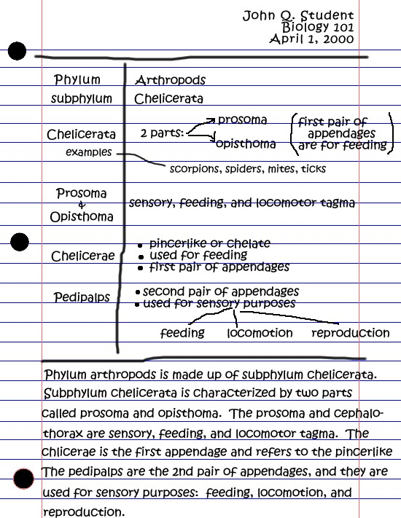

Study Questions:

Describe the two parts of subphylum Chelicerata.
Compare and contrast the types and purposes of appendages in this subphylum.
Give three examples of Chelicerata and identify their phylum.

