Da Capo Conference
Saturday, January 18, 2020
"Music K-4 & so much more!"

Presented by Angie Weisgerber
atester@bpsd.mb.ca

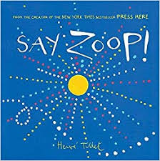 Say Zoop! by Herve Tullet
-Get ready for some fun vocal warm-ups! Your students will have a blast using simple vocal sounds as they explore sound, colour and direction.

Prepare students with a variety of vocal echoes. Encourage students to use hand/arm motions for the echoes.
Introduce the story. Tell students they are going to sing the pictures in the story.
Read the story and sing the pictures.
Where else might we find dots in our everyday lives?
Have students create their own vocal pages using dots/lines/squiggles etc.

Other storybooks to try are…

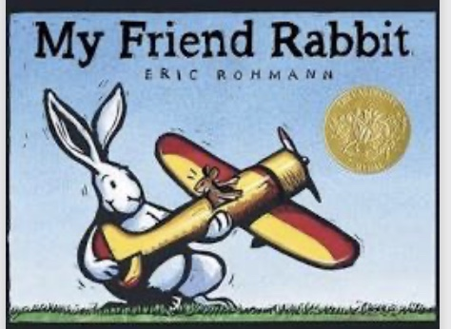
Follow the dotted airplane tracks This book has lots of funny giraffe necks
with your voice! to explore with your voices too!

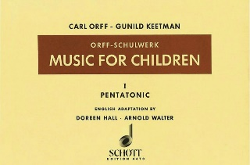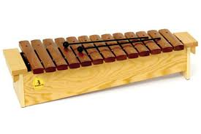

Barred Instruments - Performing a Canon
Music for Children Vol.1 Pentatonic (p.55)
Doreen Hall Ed.
-The compositions of Carl Orff and Gunild Keetman are a wonderful resource for elementary music teachers! Volume I includes many pentatonic melodies, rhythm examples and canons you can explore with your students on the barred instruments. Adding text to a canon is a successful way to teach the rhythm!

Use the following text to teach the melody:
-Speak text rhythmically, echo one measure at a time
Snowflakes swirling all around,
A winter storm is near----.
Grab your parka, grab your sled,
‘Cause winter-time is here!

-HMK Gr. 4 students
-Vocal warm-up: sing the melody using solfege hand signs, students echo
-combine melody with text
-add body percussion (Or have students help you create. Here is what we came up with…)

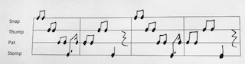

Barred Instruments
-Assign students to barred instruments set in C pentatonic (remove F’s and B’s).
-Students echo teacher phrase by phrase singing the following notes…

C C D D E A G
A G E D D C (gliss)
C C D D E A G
A G E D D C (rest)

-Using fingertips on barred inst., students echo melody by rote.
-Add mallets -echo phrase by phrase.
-Play in unison.
-Add a Bass accomp. C-G-C-G in quarter notes.
-Perform in two-part canon. (have students decide how to divide the instruments)

Challenge the class to try a four-part canon, create an Intro, Coda and decide on a final FORM
Here’s what my students decided on…

FORM: Intro BB (C G C G quarter notes) 8 beats
Melody in unison
Canon: 2x (2 beats apart)
Bass part 1
Altos part 2
Sopranos part 3
Glocks part 4
Coda: ‘Cause wintertime, ‘cause wintertime, ‘cause wintertime is here!”

Other ideas: Perform the rhythm on hand drums.
-unison
-students perform rhythm while teacher plays part of canon at four beats
-divide class, have each group play independently before performing a
two-part canon then four-part canon as a challenge!

Perform the rhythm through mvt.
-as a class create movements for the four phrases of the poem
-divide students into four groups
-unison
-four-part canon
DRUMMING!!!

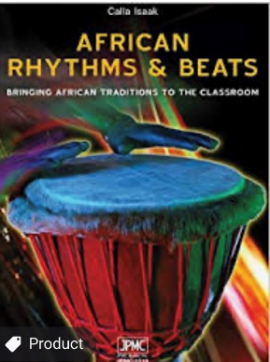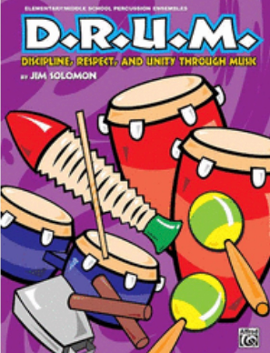

I highly recommend these 2 fantastic resources for your elementary music students.
“African Rhythms & Beats” by Manitoba’s Calla Isaak and “D.R.U.M.” by Jim Solomon.

Drumming things to consider…

- Volume -most beginner drummers like to play LOUD! Students who play too loud won’t be able to maintain their part correctly with other drum voices. Insist students use a moderate volume to hear your lead drum.

- Body Percussion – I have found students are more successful when I prepare patterns through speech and BP before we play on the drums.

- Notation -Add notation after students have experienced many different rhythms. Start by drumming rhythms of songs and rhymes students know, then try adding rhythm cards to reinforce patterns.

- Rests -patterns that end with a rest are difficult for some students. Be careful students don’t rush these patterns. Using hand motions for the “rest” can really help students pulse/feel the silent beat.

- Types of drums -There are so many drums to choose from. Do your research, ask other music teachers what they recommend. I personally have invested in Remo tubanos for my elementary music classroom because they are more durable and more stable for our younger students. I recommend you purchase TUNABLE drums!

Basic Drum Techniques

Hand Position

Tone -edge of the drum, bright/high sound

Bass -whole hand in center of drum, deep/low sound

Stage 1 Rhythmic Vocabulary Patterns

- Walking

- Running

- Snap-Clap

- Shave and a Haircut

- Eenie Meenie

- Chitty Chitty Bang Bang

- Humpty Dumpty

- I Love Chocolate Covered Ice Cream Cones

“Sevens” – Body Percussion to Drums
At Tempo 2019 I went to Artie Almeida’s session where she introduced this fun activity! You can also search YouTube clapping games/sevens.
This would a great addition to the beginning or end of a drum piece!

A = pat 1234567(repeat)
B= pat/clap 1+2+3+4 (repeat)
C= pat/clap/snap 1231231 (repeat)
D= pat/cross/pat/clap/snap/clap/pat “criss-cross” 12321 (repeat)
Parachute FUN!!! 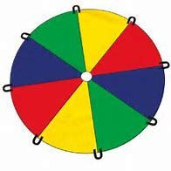
This lesson was inspired by a workshop I attended with Artie Almeida. My grade 3 & 4 students help create the routine.

Musical Selection: March of the Toreadors by Bizet
Focus: Exploring FORM and STEADY BEAT with a parchute.

-students determine the FORM of the piece while listening
(A A B A Interlude C C A Coda)

-explain each section and its motions
A= 24 beats slide to the right “cowboy”, snap 3x, stop
B= “mushrooms” up 234/down 234 (repeat), low “ripples & waves”
Interlude= freeze and get ready
C= “washing machine” LRLR….., big “mushroom” on the glissando
Coda= crouch low & freeze, big lift and everyone under the parachute “tent”

-Have students practice the FORM with actions BEFORE adding the parachute.
-Practice actions with music.
-Now get ready! Don’t forget to establish parachute RULES before adding the parachute!
-Add the parachute and see the big smiles on your students’ faces!

My students absolutely LOVED helping me create this routine. Many of them recognized the music ‘March of the Toreadors’ and now they can analyze the form quickly. This is a great activity to use especially if your school has had a lot of INDOOR RECESSES!!!

Any questions? Feel free to email me
Angie Weisgerber- atester@bpsd.mb.ca

