BUSMEA 2020/2021 Membership Form

Name: _______________________________________
Stream (current or anticipated): Instrumental Choral Elementary Honours/Performance
Year: ________
BU Email: _____________________________________________
BUSMEA members receive:
- Free admission to all clinics
- Reduced fee for Da Capo (annual music education conference hosted by BUSMEA)
- Opportunity to join a provincial organization
- Greater connection to the music education community!
__________________________________________________________________
Payment (E-Transfer Only)
BUSMEA Membership
Regular: $5 _____ (membership with provincial organization)
Security Answer (for E-Transfer): ___________
Provincial Association (please put a checkmark beside the association(s) you are a member of): MBA___ MCA___ MOC___ MCGA___
MBA: https://www.mbband.org/about-us-membership
MCA: https://www.manitobasings.org/membership-registration
MOC: https://orffcanada.ca/membership.html
MCGA: *form attached on https://www.brandonu.ca/busmea/contact-information/
**If interested in TEMPO, there’s a TEMPO registration form that includes provincial association registration/renewal on https://www.mymmea.ca/tempo/**

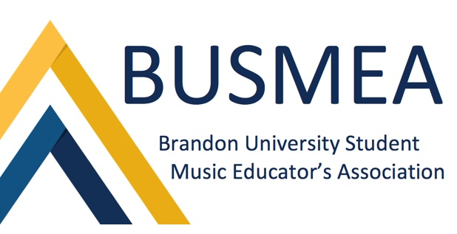
Please email membership form and payment to busmea@brandonu.ca

