Brandon University Junior Kindergarten
December 2019 Newsletter

It’s been a busy month!
Here are some of the experiences the children are interested in:

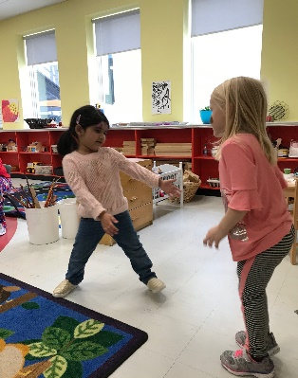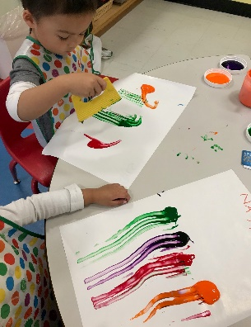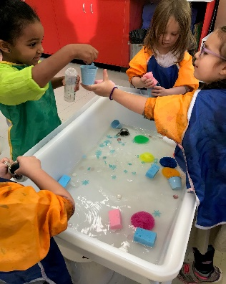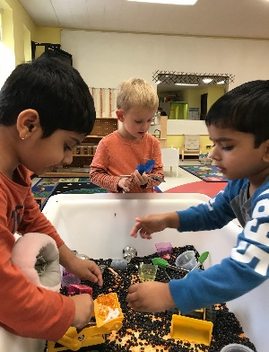
Dance Parties Painting Water Play Sensory Play
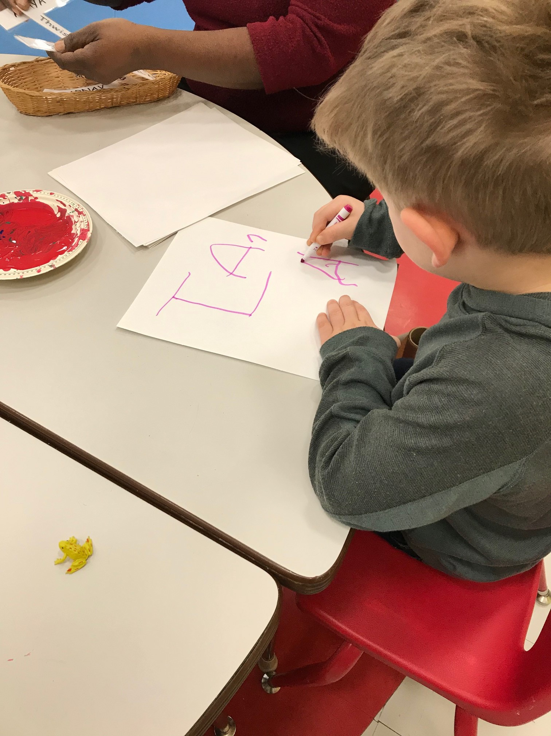
We’ve been working on our handwriting skills. This is a process where not every child is at the same stage, but please don’t worry if they aren’t writing their names yet! We’ve been working on letter recognition, name recognition, fine motor control, and pencil grip. Each child learns at their own pace. Playing with stickers, Lego, playdough, tongs, and other manipulative items helps prepare them for the next step.

Thank you to those who have participated in fundraising, cleaning the classroom, and bringing in plants and loose parts. It’s greatly appreciated! I’d also like to give a special thanks to Rey’s Dad Hongbo for building a reading bench for our room.
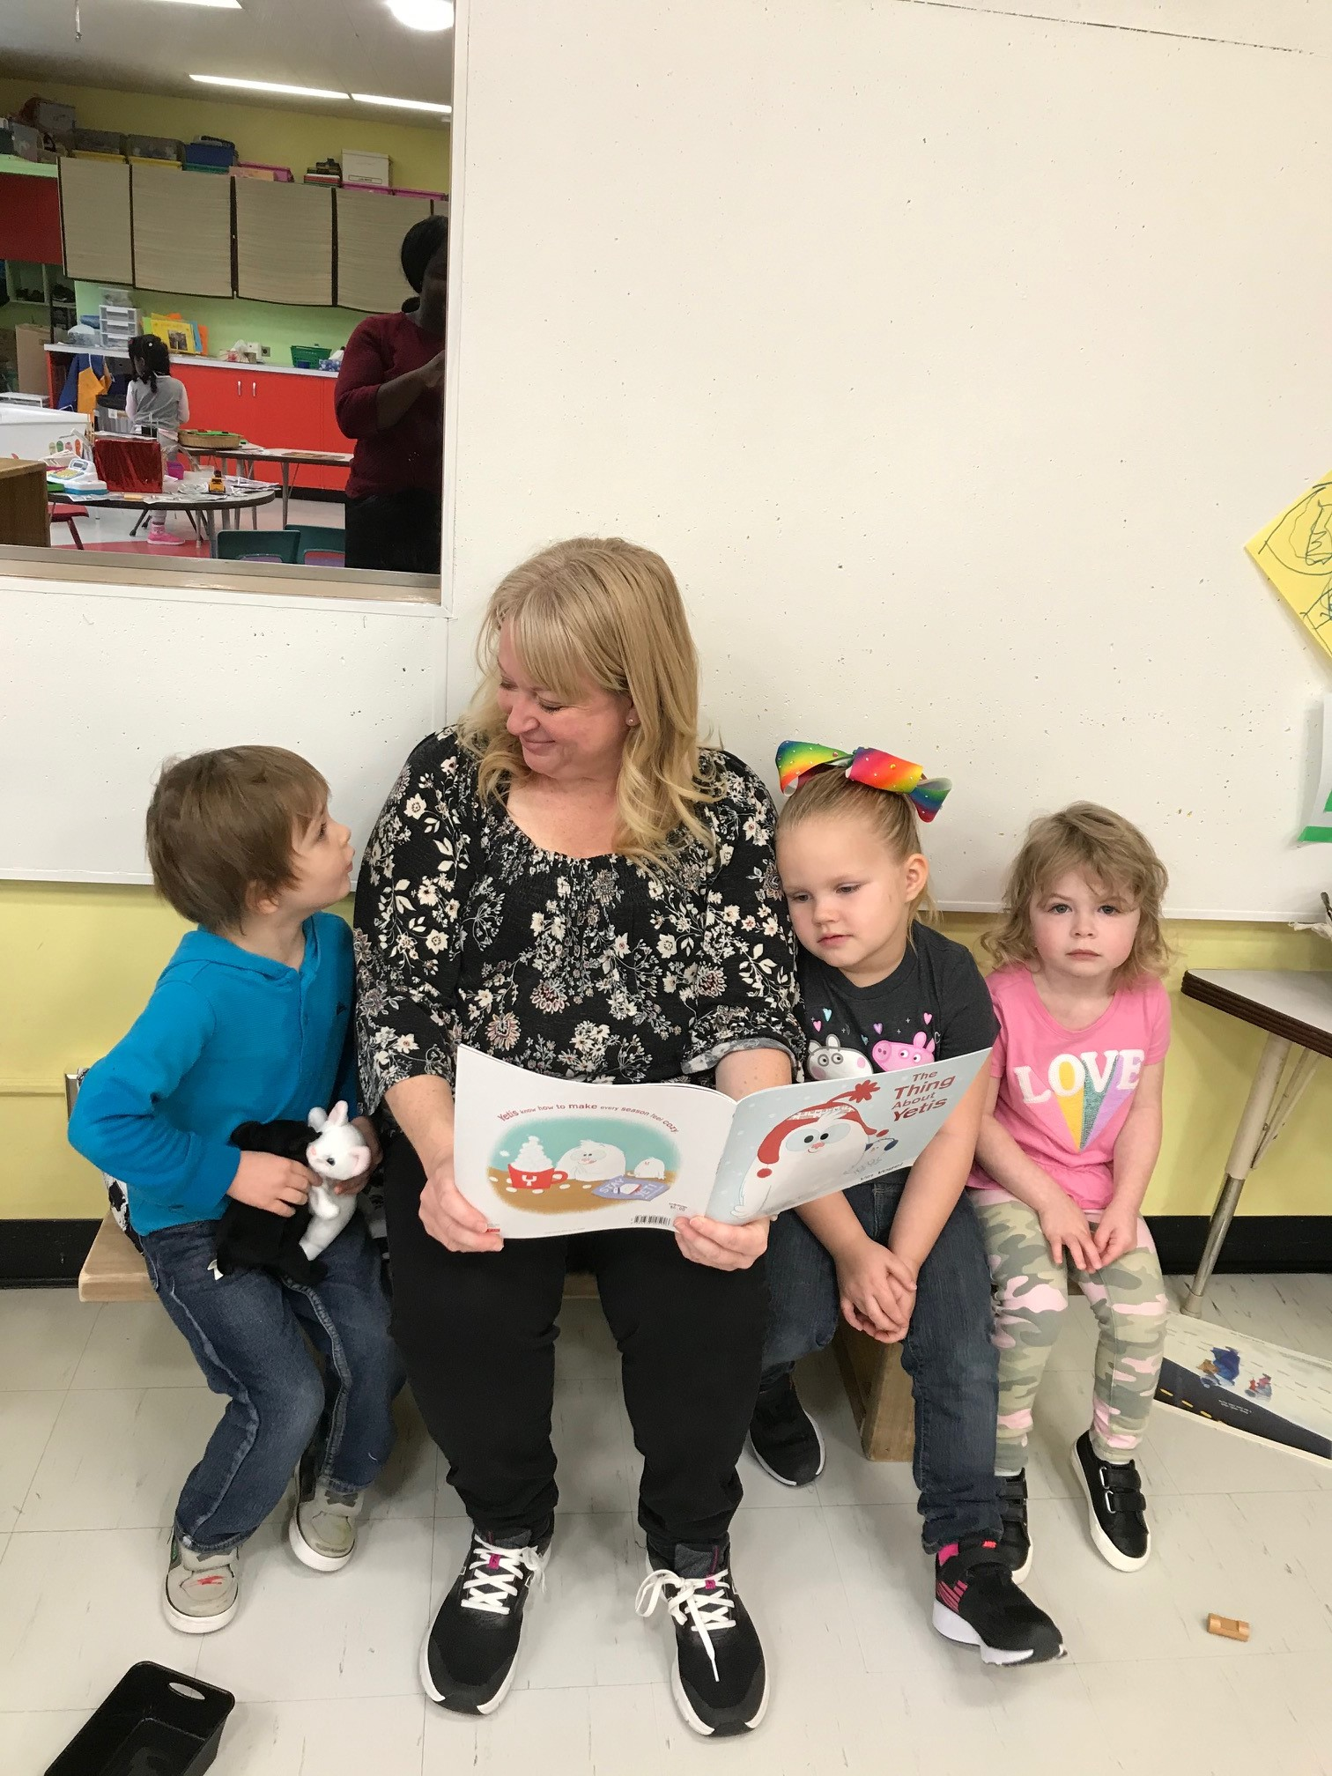

You may have noticed some documentation on the bulletin board from our 2nd year ACC student, Gladys. She’s been introducing new concepts and activities, and will be with us until December 13th. We’ll definitely miss her when she leaves!

We will be having a Winter Celebration Wednesday, December 11th from 4:30 – 6:30 p.m. There will be activities for the children, treats, and a visit from Santa starting at 5. This is a come and go event and is a great way to meet other parents from the program and watch your children interact with each other. Feel free to bring nut-free snacks or treats to share – there’s a sign-up sheet in the classroom.

Not everyone celebrates Christmas in the same way (or at all), so if there is a type of celebration or tradition that your family does, please let me know! We’d love to know more about what’s important to your family.
Birthdays in December: Jack, December 31
Forbidden Flavours fundraising due Friday, Dec. 13th

Scholastics due Friday, Dec.13th.

Last day of class in 2019: Friday, December 20th.
First day of class in 2020” Monday, January 6th.

These last few months with your children have been so amazing! I’m not sure who learns more, me or them! I can’t wait to see what the New Year brings. As always, if you have any questions or comments, please let me know.

Holly 204.727.7420 or orrh@brandonu.ca

Merry Christmas and all the best to you and your family in the New Year!

