BU Junior Kindergarten
February 2020 Newsletter
This Photo by Unknown Author is licensed under CC BY
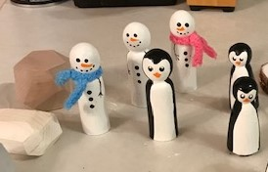
We’ve had a busy month talking about polar bears and penguins, sensory play in the sandbox, and enjoying the large snow hill outside. We’re now investigating music/musical instruments, taking care of babies, and are looking forward to new sensory play ideas.
February is “I Love to Read” month. If you would like to visit your child’s class to read a book, we’d love to have you! The time would be at 11 a.m. or 3 p.m., and you can choose a favorite book to share with us.

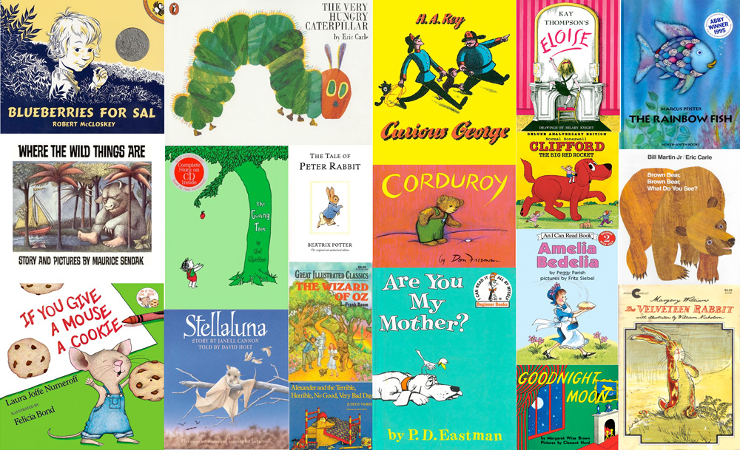
For children who are turning 5 before December 31, 2020, here is a link to registering your child for Kindergarten in the Brandon School Division:
https://www.bsd.ca/Studentsparents/AdmissionsRegistration/KindergartenRegistration/Pages/default.aspx

Please welcome:
BU Education students doing observations on Tuesday and Thursday mornings until the middle of February: Naiomi, Chantal, Bianca and Rachel

ACC: Miss Skyla will be returning for Wednesday morning visits and then for her first practicum in March.
We will be celebrating Valentine’s Day on February 13th and 14th. If your child wishes to hand out Valentine cards to the class, I will have a list by the sign-in book starting next week.

We are planning a potential field trip to Assiniboine Community College for Cardboard Box Day, Friday, February 21. The children are invited by the Early Childhood Education students to investigate and create using only cardboard and loose parts. Details to follow.
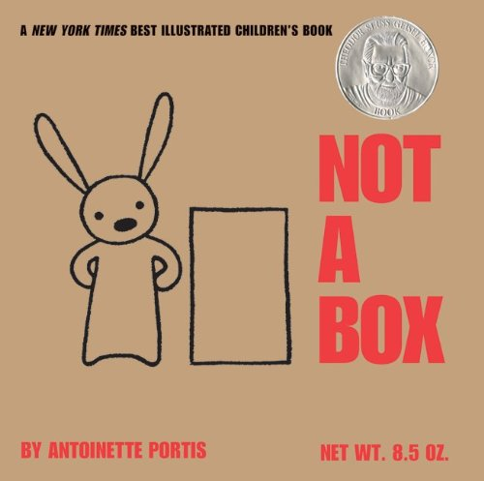

We have a few spaces available if you know anyone looking for a spot in the program. Please pass along my email address or direct potential families to the Brandon University website to view the Parent Handbook.

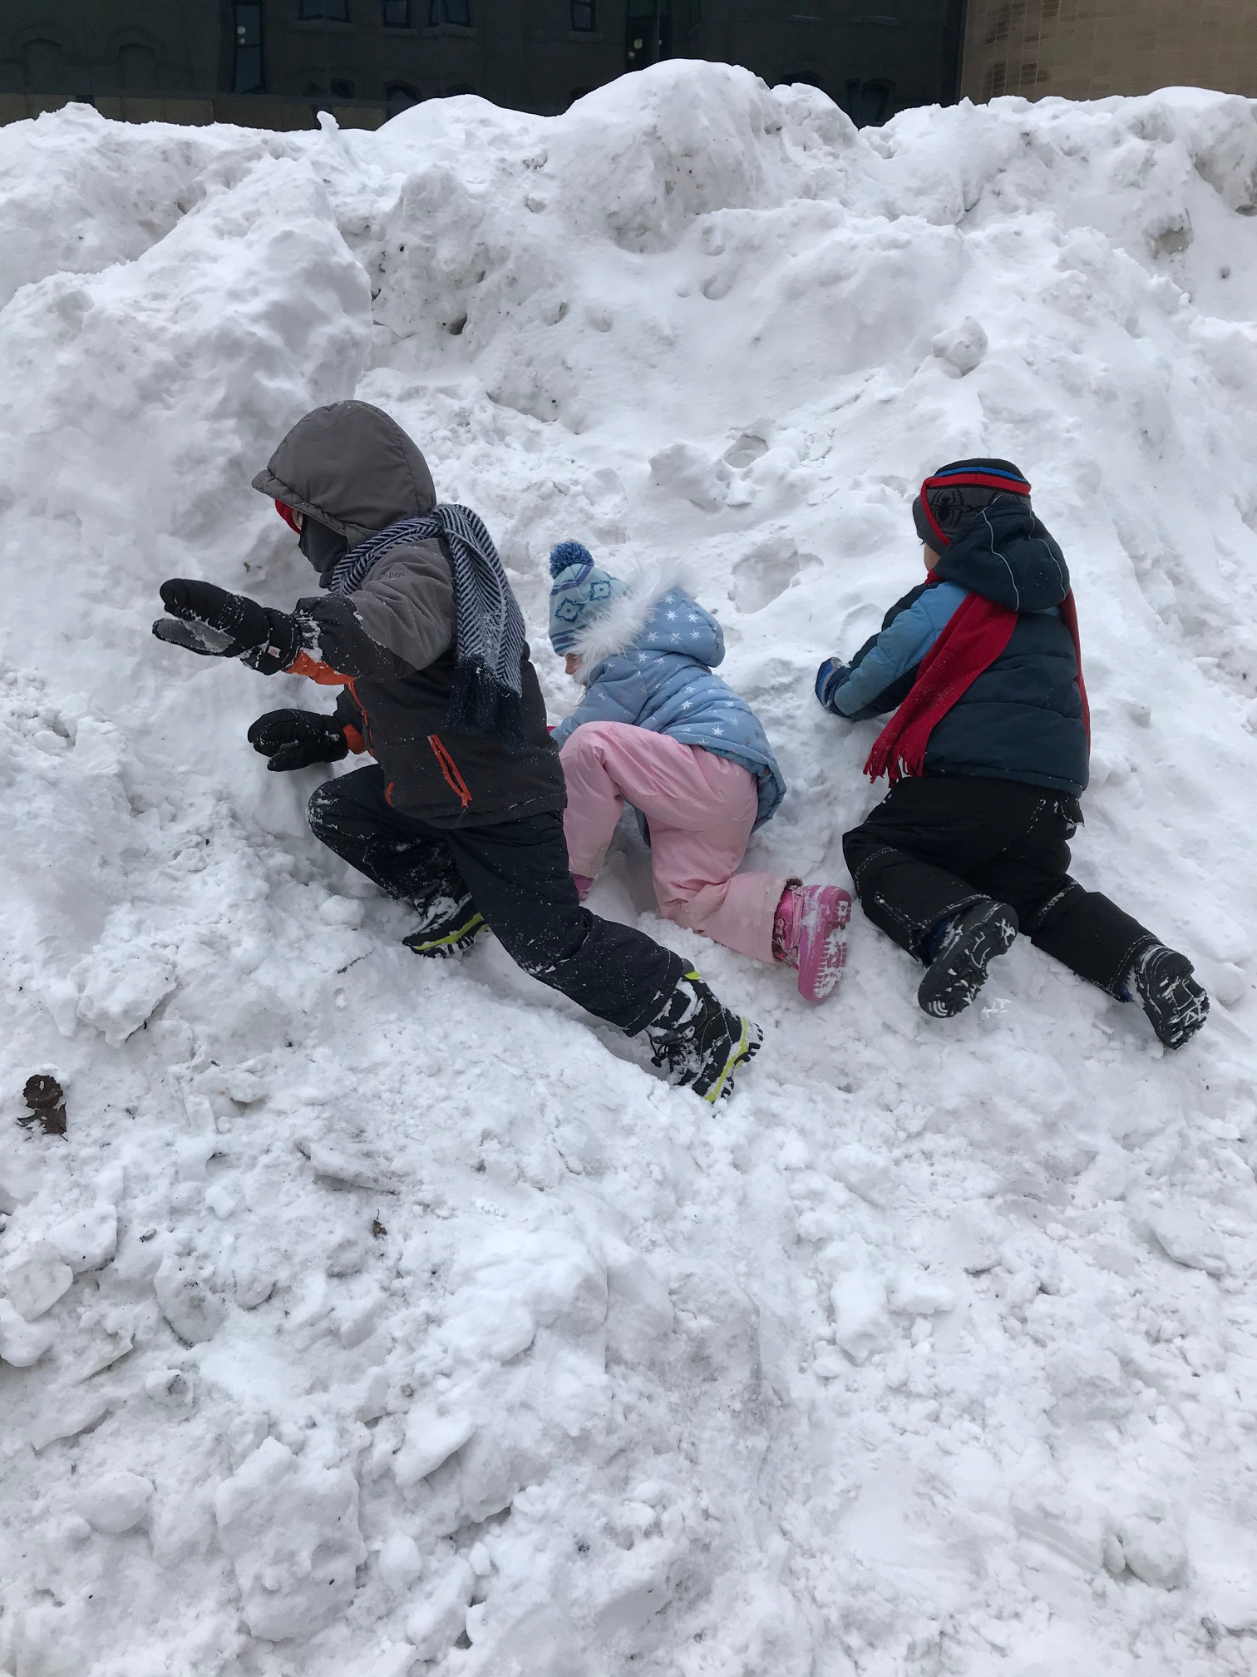
We have been going outside to enjoy the beautiful winter weather as much as possible. Please bring ski pants, winter boots, warm mitts and a hat to keep your child warm and comfortable. If you don’t have ski pants, you can also provide an extra pair of warm pants that we can put on top of their regular pants. If anyone has any ski pants size 4-6 that you’d like to donate, please let me know!
Happy Birthday
Maisey on February 4th
Viaan on February 20th

Questions or comments are always welcome!
Holly orrh@brandonu.ca
