Lesson Plan
Grade/Class |  | Date/Time
Topic/Unit Title |  | Time

Lesson Outcomes / Purpose
Curriculum: Outcomes, Essential Questions, Targeted Learning and Experiences
Utilizing Manitoba curricula list all outcomes, essential questions, descriptions of targeted learning or experiences that will be presented/explored in this lesson.

Specific Learning Outcomes and Evidence of Learning
Expand on the targeted learning and curricular outcomes noted above. Consider referring to the supplemental resource attached to the Unit Planning Template, “Appendices of Verbs” and making use of sentence leads, (“The student(s) will be able…”(TSWBA) and “I can…” statements) to describe what observable evidence of learning students will engage in, and on which they may be assessed. For example:
- Students will categorize… (Cognitive Domain, Analyze)
- Students will design…(Affective Domain)
- I can draw and label the parts of a tree. (Cognitive & Psychomotor Domain, Remember & Simple)
- I can create coding to move my sphero to a 3 – 4 beat (Psychomotor Domain, Complex)

Cross-Curricular/Real World Connections
Note any relevant cross-curricular outcomes, essential questions or experiences or authentic learning present in this lesson.

Assessment Evidence
Description (conversation, observation or product) |  |  | FOR | AS | OF
Materials (ICT considered) |  | Differentiated Instruction & Student Specific Planning
Resources (referenced), handouts, ICT, equipment, etc. Include exemplars / samples  Key Words / Vocabulary |  | 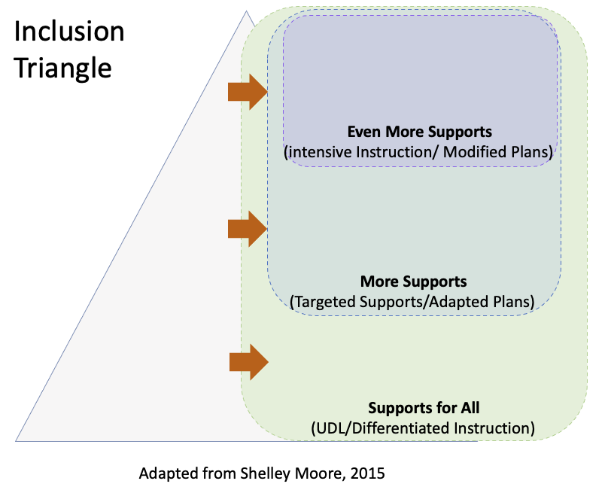  Considering students’ readiness, interests, and learning profile, how will learning tasks for this lesson be differentiated?
Learning Plan
Hook  Activate |  |  |  |  |  | Time
Acquire
Apply

Closure

Reflections about the lesson:

