

Brandon University Junior Kindergarten

Newsletter – September 2019

Welcome!!!!!

A Poem to Share

**W** hen you   
**E** nter this   
**L** ittle room,   
**C** onsider yourself   
**O** ne of   
**M** any special people who **E** njoy learning, laughing and playing together.

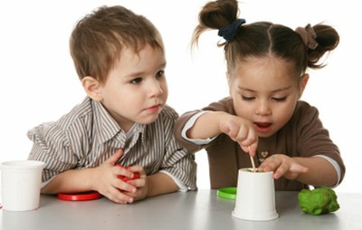

I would like to welcome you to Jr. Kindergarten! I am very excited for this opportunity to get to know your children and to guide them along the pathway of learning. My aim this year is to create a solid foundation for your child to build upon during their school years. By creating positive learning now, they will have a great start to their education!

This year, we’ll be following an emergent curriculum, which means that instead of themes, the children will lead their own learning and I will provide experiences that support their interests. Please watch the parent and documentation boards outside the classroom to see what we’re curious about!

The first week or two will be a time to get to know each other and the program. I can’t wait to meet everyone!

Parent Information Night

Each year, we have a parent Meet-and-Greet evening at the school. It is an informal evening where we can talk about a few basic topics such as: people to fill vacant positions on our Parent Board (we will elect volunteers that evening), fundraising ideas, and questions that you may have. It is a time for our parents to come together and meet each other as well.

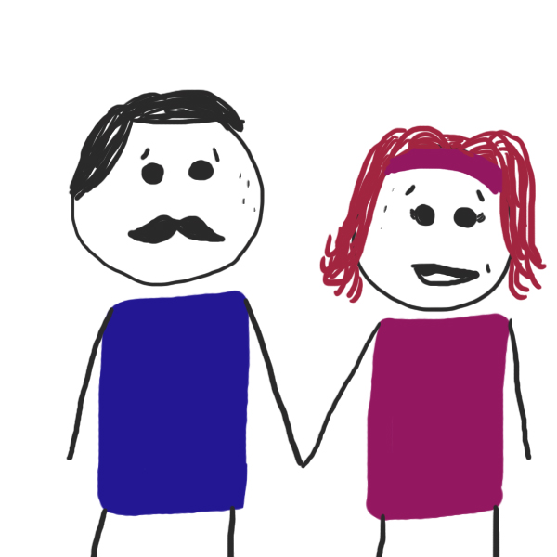

Please plan to attend!

Childcare and snacks will be provided.

Wednesday, September 18th, 2019

5:30

Meet in our classroom

Scholastic Book Orders

Each month you will receive a book order catalogue. Our classroom earns wonderful bonuses the more we sell that we put towards new books and materials for the classroom. However, please do not feel obligated. Cheques are payable to Scholastic Canada.

Starting in October, we will be welcoming students from ACC and BU to our classroom. I am looking forward to the extra set of helping hands ☺ Please join me in making them feel welcome.

I’m looking forward to a fabulous year!

Miss Holly

(204)727.7420 [orrh@brandonu.ca](mailto:orrh@brandonu.ca)

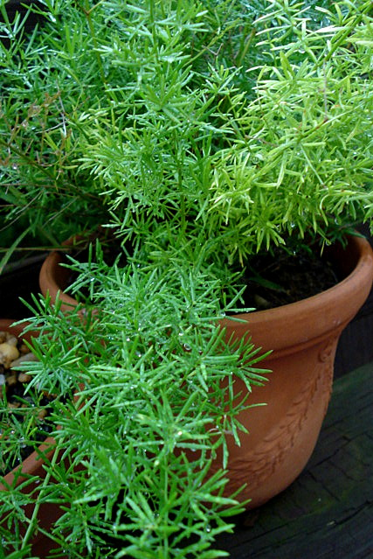

I strongly believe that in order for children to attain their full potential, they need the love and support from their families above and beyond anything else.

I am ready to work with you to ensure this year is a success for your child! If you ever have any questions or concerns, please do not hesitate to call or email me to set up a time to meet.

A bit about me……

I am an ECE III with over 25 years of early learning experience including front-line ECE work, instructing at Assiniboine Community College, and immersing myself in continued professional development. I’m currently working on my Bachelor of Sciences in Early Years Studies.

I love creating engaging experiences for both children and adults, and believe that learning happens best when you’re interested and engaged!

Our classroom is looking for donations of house plants to add natural elements to our environment. Caring for plants is an important learning opportunity as they learn empathy toward living things as well as science concepts.

Check out the list of non-toxic plants on the Parent Bulletin Board.

MC900331294[1]

Just a Reminder that we are a **peanut and nut free** facility and that snacks need to checked for peanut **and** nut ingredients. If you are having trouble finding snacks that are peanut free, please see me for ideas!