

Faculty of Education

We respect the treaties that were made on these lands and acknowledge that Brandon University is located on Treaty 2 Lands, the traditional homelands of the Dakota, Anishanabek, Oji-Cree, Cree and Metis peoples.

Sessional Instructor Welcome and Information Package

A warm welcome to the Brandon University Faculty of Education. Thank you for sharing your expertise with our students as a sessional instructor. We hope you find the following information helpful. Further information and questions can be directed to the following faculty and personnel:

Brandon University Website: [www.brandonu.ca](http://www.brandonu.ca)

Faculty of Education Website: <https://www.brandonu.ca/education/>

Dr. Alysha Farrell, Dean [deandofed@brandonu.ca](mailto:deandofed@brandonu.ca) 204-727-9656

Mr. John Minshull, Director PENT [MinshullJ@brandonu.ca](mailto:MinshullJ@brandonu.ca) 204-727-7378

Ms. Shawna Philpott, Director of Field Experience

[philpotts@brandonu.ca](mailto:philpotts@brandonu.ca) 204-727-9638

Education Faculty Directory: <https://www.brandonu.ca/education/faculty/>

Education Office Staff

| Name | Email | Phone |
| --- | --- | --- |
| [Mrs.](https://www.brandonu.ca/education/staff/) Karen Colquhoun | [facultyed@brandonu.ca](mailto:facultyed@brandonu.ca) | 204-727-9626 |
| [Mrs. Shannon Tomlinson](https://www.brandonu.ca/education/staff/) | [tomlinsons@brandonu.ca](mailto:tomlinsons@brandonu.ca) | 204-727-9647 |
| [Mrs. Ina Schumacher](https://www.brandonu.ca/education/staff/) | [schumacheri@brandonu.ca](mailto:schumacheri@brandonu.ca) | 204-727-7406 |
| [Mrs. Celia Gray](https://www.brandonu.ca/education/staff/) | [grayc@brandonu.ca](mailto:grayc@brandonu.ca) | 204-727-9616 |
| Ms. Bernice Galvin (PENT) | [galvinb@brandonu.ca](mailto:galvinb@brandonu.ca) | 204-727-7371 |
|  |  |  |

Table of Contents

Education Office Staff 1

Initial Meetings Before Teaching 4

Suggestions for Preparing and Teaching At-a-Glance 5

Before teaching: 5

During teaching: 6

At the end of the course: 6

Overview of Education Programs 7

Differences between After Degree (AD) and Integrated Programs (IP) 7

Planning Your Courses 8

Contact Hours 8

Course Outline or Syllabus 9

Professional Standards for Undergraduates 9

Policy for Attendance at Lectures and Practical Work: 9

Acknowledging Indigenous Perspectives 10

Creating a Moodle Website for Your Course 11

Online Course Delivery: ZOOM 12

Class Lists and Submitting Grades 12

Class Lists 12

Course Grade Evaluation and Grade Equivalencies 12

Failing Grades 12

Requests for Incomplete 12

Entering Final Grades 13

Library Resources and Library Instruction 14

Photocopying and Printing 14

Course Textbook Orders 15

Campus Store (Bookstore) 15

Special Order Books 15

Information Sharing 16

Freedom of Information and Protection of Privacy Act (FIPPA) 16

Personal Information 16

Feedback on Assignments, Tests, and Other Student Work 16

Disclosure of Tests, Exam Questions, or other Assessments 17

Student Records 17

Personal Health Information Act (PHIA) 17

Canadian Anti-spam Legislation (CASL) 17

Mail Services 18

Appendix 1 – Faculty of Education Timetables & Program Maps 19

After Degree (AD) and 5th Year Integrated Program 19

Bachelor of Education Year 1-4 Integrated Program Timetable 20

PENT Program Timetable: Spring and Summer 21

B. Ed (After Degree) Early Years Program Map 22

B. Ed (After Degree) Middle Years Program Map 23

B. Ed (After Degree) Senior Years Program Map 24

Integrated Program Map 25

Technical Vocational Program Map (2021-2024 cohort) 26

Overview and Expectations of Undergraduate Programs Field Placements 28

Master of Education – Curriculum and Pedagogy Sample Program Sheet 30

Master of Education – Inclusive Education Sample Program Sheet 31

Master of Education – Educational Guidance and Counselling Sample Program Sheet 32

Master of Education – Educational Administration Sample Program Sheet 33

Appendix 2 – Required Sections of Course Outlines and Suggestions for Course Design 34

Academic Integrity 34

Statement on Accommodation 34

Wellness 35

Suggestions for Course Design 35

Learning Outcomes 35

Instructional Message Design 36

Learning Activities 36

Lesson Plans 37

Universal Design for Learning (UDL) 37

Delivering Instruction 38

Presentation Strategies 38

Recommendations for Engagement in Graduate Courses 39

Assessment Strategies 40

Rubrics 40

Appendix 3 – Moodle FAQs and Moodle Gradebook 41

Moodle Gradebook 43

Appendix 4 – Access Copyright 45

Photocopying and Scanning 45

# Initial Meetings Before Teaching

Depending on your course load, the nature of course delivery (Face-to-face vs online), and if you are a first-time or returning instructor, some or all of the following may be applicable to you. A good starting point would be to meet with the Administrative Assistant in the Education Office (contact information on cover) and review these items as early as possible before your course(s) begin. Procedures are explained in more detail in later sections and the appendixes of this manual.

**All** instructors should first contact **Celia Gray**, who will provide:

* BU email address and temporary password
* Keys for classrooms and an office (if assigned)
* Photocopier code
* Scheduled time of your courses (See Appendix 1 for Education Timetables)
* List of important dates for the term (E.g., First and last dates of classes for each program; dates of field placements; Holidays and breaks)
* Information and assistance regarding employment contract and payroll

For Undergrad courses and PENT, contact **Shannon Tomlinson** for:

* Previous course outlines for the courses you are instructing (if available)
* Course outline templates

For Graduate courses, contact **Ina Schumacher** for:

* List of important dates for the term (E.g., First and last dates of classes, holidays, and breaks)
* Direction for how to apply for Sessional membership in Faculty of Graduate Studies <https://www.brandonu.ca/graduate-studies/faculty-of-graduate-studies-committee-membership-application/>
* Graduate Instructor Policies and Procedures
* Previous Course Outlines (if available)
* Graduate Course Outline Template
* If teaching on-line with Zoom, book conference call times with **Karen Colquhoun**.

For PENT courses, contact **Bernice Galvin** for:

* List of important dates for the term (E.g., First and last dates of classes, holidays, and breaks)
* PENT Instructor Policies and Procedures
* Previous Course Outlines if available
* Course Outline Templates

# Suggestions for Preparing and Teaching At-a-Glance

## Before teaching:

* Create your own password for your BU email account at: <https://staffpasswordreset.brandonu.ca>
* Your username is the first part of your email address.

(E.g., [smithj@brandonu.ca](mailto:smithj@brandonu.ca); Username: smithj)

*You will use this username/email address and password to login to access campus wifi, class lists, grade entry, Moodle, and email in the BU community.

* Directions to access on-campus WIFI can be found here:

<https://www.brandonu.ca/helpdesk/wireless-network/>

* Contact the Department Chair for the courses you are teaching. For graduate level courses, you may also want to contact the Chair of Graduate Studies. If you are unsure which department your courses are listed under, the office staff can direct you. The Department Chair may put you in touch with a specific faculty member as a liaison.
* Create your course outlines prior to the beginning of instruction. Undergraduate instructors will share course outlines with your students on the first day of the course. Graduate course instructors are asked to share their outlines (min. draft) 30 days prior to beginning of term with Ina Schumacher so students have sufficient time to order materials.
* If you are teaching face-to-face, visit the classrooms where you’ll be teaching. All the classrooms have a ceiling mounted projector, but there are some differences in connecting a laptop among the classrooms. Your Faculty Liaison, the office staff, or IT Support can assist you in learning to connect a laptop or work from the desktop in the classroom and/or initiate a ZOOM call if you’re teaching online.
* If you require a textbook for the course and you are before the term deadline, order the text through the BU Bookstore.
* All course related expenses (ie. guest speaker honorarium, volume printing, etc.) must be approved through the Dean’s Office before they are incurred. Please contact Celia Gray ([grayc@brandonu.ca](mailto:grayc@brandonu.ca)) for more information.
* For PENT courses, please contact Bernice Galvin with your textbook requirements and PENT will order directly from the bookstore.

## During teaching:

* You may direct questions or concerns to your Faculty Liaison, Department Chair, office staff, or the Dean.
* If you are unable to make it to campus (e.g., illness, highway closure) and need to cancel a class with short notice contact the office staff to have a cancellation notice and any directions you want to give the class posted on the classroom door:
  + Undergrad: Contact Shannon Tomlinson and CC one other assistant
  + Graduate: Contact Ina Schumacher and CC one other assistant
  + PENT: Contact Bernice Galvin and CC one other assistant
* For IT support (Mon-Fri until 4:30 pm) you can contact:

<https://www.brandonu.ca/helpdesk/>

BU IT Helpdesk (204)571-8500 [helpdesk@brandonu.ca](mailto:helpdesk@brandonu.ca)

* If you are teaching remotely or experience IT issues outside of office hours, make note of the issue and contact the IT support as soon as possible.
* Teaching Evaluation:

Peer Evaluation: You may request the Chair of a department or program (Undergraduate or Graduate) to observe a class and provide written feedback regarding your teaching. This feedback could be applied as evidence of successful teaching or as a reference to growth in your practice in future applications to Brandon University or other post-secondary institutions.

Evaluation by the Dean: Article 11.1 of the BUFA collective agreement talks about formal evaluations and states that “Sessional faculty shall be evaluated in each of the first two (2) academic years of teaching by the Dean or designate to determine competency prior to establishing RFR. Where an evaluation has not been conducted, the sessional Member’s teaching will be deemed competent. Sessional Members who hold RFR should be evaluated every four (4) years.” The Dean’s Office will contact you to set up teaching evaluations.

## At the end of the course:

* Enter your final grades within 5-7 days of the final lecture/exam.

## Overview of Education Programs

Brandon University offers four undergraduate and one graduate level Education programs:

|  |  |  |  |
| --- | --- | --- | --- |
| Program | Typical Length of Program | Program Emphasis | Course Timetable  (Appendix 1) & Dates |
| Bachelor of Education  After Degree  B.Ed. (A.D.) | 2 years | Early Years,  Middle Years or  Senior Years | Education Timetable  A.D. Course Dates |
| Integrated Program (I.P.)  (B.A./B.Ed.  B.Sc./B.Ed.  or  B.P.E.S./B.Ed.) | 5 years | Early-Middle Years  (Education courses taken alongside undergrad degree courses) | Years 1-4  B.A./B.Sc./B.P.E.S. Timetable  B.A./B.Sc./B.P.E.S Course Dates  Year 5  Education Timetable  A.D. Course Dates |
| Bachelor of Music/  Bachelor of Education  Concurrent Program  B.Mus./B.Ed. | 5 years | Early Years Music or  Middle-Senior Instrumental | Education Timetable  A.D. Course Dates |
| Program for the Education of Aboriginal Teachers  (PENT) | 5 Years | Early Years or  Middle Years | PENT Timetable and Course Dates |
| Master of Education  M.Ed. | Maximum 6 years | Inclusive Education,  Guidance & Counselling,  Educational Administration or  Curriculum & Pedagogy | M.Ed. Course Dates  (refer to online registration guide) |

Education courses are scheduled so that a cohort completes coursework together as much as possible throughout their program. However, as students complete required courses and select electives, some classes may have student enrollment from several programs/emphasises. Bear in mind that depending on their year and program, students may have various previous coursework and field experience (undergraduate programs). Your faculty liaison or Administrative Assistants can provide further description of the programs relevant to the students in your courses.

**See Appendix 1 for a course map for all Education programs.**

## Differences between After Degree (AD) and Integrated Programs (IP)

A common question asked is what the difference is between the After Degree and Integrated Programs in Education. There are 4 main differences between the programs:

1. Integrated Program students enter directly into their Education program and do both their B.A., B.Sc., or B.P.E.S. and their B. Ed. simultaneously, while After Degree students complete an undergraduate degree prior to completing their B. Ed. This means that I.P. students are often younger than A.D. students, and have less university experience. As a result, expectations of these two groups of students may be different, depending on what year of the program they are in.
2. The Integrated Program runs on the Arts/Science timetable for the first 4 years of the program since IP students are doing 2 degrees simultaneously. In the 5th year, IP students are in Education full time (like the A.D. students) and operate on the Education Slot Schedule. Not applicable to PENT.
3. The Integrated Program makes use of an e-portfolio throughout the program. Students are expected to add to their e-portfolio in each course. As such, instructors may want to make an e-portfolio reflection one of their assignments for the course. The e-portfolios are housed in a private BU Wordpress site at <https://ed-ip-portfolio.brandonu.ca/>. You can get access to the site (as an instructor) by emailing Patrick Johanneson ([johanneson@brandonu.ca)](mailto:johanneson@brandonu.ca)) or by contacting the helpdesk. As of now, the A.D. program or PENT does not have an e-portfolio requirement for students.
4. The Integrated Program makes use of micro-practicums in year 1 and 2 of the program in winter term courses (Including 03:250 Power, Positionality and Privilege: Schools as Complex Spaces and 01:441 Classroom Management). In these placements, students observe classrooms approximately 4 times and debrief their observations in their education class at BU. There is no evaluative component to the placements, although course instructors in these courses may choose to build their course evaluation around the experiences. If you are teaching one of these courses, contact Shannon Tomlinson at [tomlinsons@brandonu.ca](mailto:tomlinsons@brandonu.ca) for more information. A.D. students do all of their school placements through formal field experience courses, although individual course instructors sometimes create classroom visits as part of their own course structures. Not applicable to PENT.

## Planning Your Courses

The first academic priority in the Brandon University 2015-2020 Academic Plan is:

To distinguish Brandon University as a leading student-centred institution of choice for students. To reach this goal, BU is striving towards more student-centred teaching and learning. Student-centered teaching and learning encourages instructors to use methods that shift the focus of their instruction towards their students. Students become more active in their learning and are given more responsibility for learning activities.

## Contact Hours

In accordance with the Brandon University Collective Agreement with the Faculty Association (BUFA), 3-credit hour courses include at least 36 hours of contact time. If classes are cancelled due to a statutory holiday (e.g., Thanksgiving, Truth & Reconciliation Day, Louis Riel Day), instructors must provide additional contact time to provide missed hours of instruction. In the Faculty of Education, instructors may plan asynchronous activities equivalent to the number of missed contact hours. Prior to the beginning of the term, the Education Office will inform instructors of the number of classes/hours that will be missed in the term. You will be asked to submit your plan to make up missed hours to the office either by submitting your course syllabus (which includes this plan) or completing a separate form if you choose not to submit your syllabus.

## Course Outline or Syllabus

An essential element for course design is the course outline or syllabus. The outline/syllabus is provided to students on the first day of instruction and utilized throughout the course. Brandon University encourages faculty to adopt the provided course outline/syllabus template as a guideline for all courses.

The Faculty of Education and its departments have templates you may use to create your course outline as well as samples of previous course outlines. Check with the Administrative Assistants.

*See Appendix 2 for required sections in each course outline and suggestions for the development of course outlines

## Professional Standards for Undergraduates

Undergraduate students, as pre-professionals, are expected to uphold the professional standards of the Faculty of Education, which reference the academic criteria of undergraduate programs, Brandon University’s academic integrity policy, and set standards for professional conduct:

<https://www.brandonu.ca/education/files/Professional-Standards-Policy-Undergraduate-Program-1.pdf>

If you feel a student is potentially in violation of this policy, you may refer the matter for review of the Professional Standards Committee via the Dean’s Administrative Assistant.

## Policy for Attendance at Lectures and Practical Work:

Policy General Purpose

The Faculty of Education is a professional faculty. In professional faculties, teaching contact hours matter. Class participation is an essential element. Professional faculties are distinct in this way from undergraduate programs, in which participation in class activities may not be required. Students are expected to organize their schedules so that they can attend all classes. When students are present they not only learn from other students and their instructors, but contribute their own experiences and knowledge. Attendance and participation are expected of pre-service professionals. Participation in class activities may be considered in the assigning of a grade.

Policy Guidelines

* As pre-service professionals, the Faculty of Education expects exemplary academic performance from students including:
* Attendance and class participation are expected.
* It is a student’s professional obligation to provide professors with written documentation, in advance where possible for each absence.
* Professors may require students to complete additional assignments to make up for absences.
* Appeals of any disputed course grade are made following the Grade Appeals procedures (see General Calendar Grade Appeals).

Scope of Policy

Applies to all students in Faculty of Education programs.

Reference to Other Policies

The Faculty of Education Professional Standards policy states that:

2.1.2 Students are expected to attend and participate in all classes. Participation in class activities may be considered in the assigning of a grade. (General Calendar. 4.2.1).

2.1.3 If a student must be away, it will be discussed with the instructor before, or if unable to do so, immediately after the absence. (General Calendar 4.2.1).

Note: PENT instructors are asked to keep attendance records for all courses and submit these records to Bernice Galvin at the end of class on Thursday of each week. Although these reports are not utilized for grading purposes, the reports will be forwarded to the funding agencies.

## Acknowledging Indigenous Perspectives

Brandon University is actively workings towards reconciliation between Indigenous and non-Indigenous people in Manitoba, which requires building and maintaining relationships and partnerships. This will establish a strong foundation of mutual respect and appreciation for all cultures. This will require strengthening and supporting meaningful community connections, as an integral part of an ongoing dialogue about our shared history and collective future. This will require consideration of the Truth and Reconciliation Commission of Canada’s Calls to Action related to education issued on June 2, 2015.

Manitoba Collaborative Indigenous Education Blueprint for Universities, Colleges and Public School Boards: Making Excellence in Indigenous Education a Priority

<https://umanitoba.ca/admin/indigenous_connect/media/agamik_PO151363.pdf><https://umanitoba.ca/admin/indigenous_connect/media/agamik_PO151363.pdf>

Truth and Reconciliation Commission of Canada: Calls to Action

<https://www.rcaanc-cirnac.gc.ca/eng/1524504501233/1557513602139>

As part of this consideration, Brandon University faculty are asked to consider the effects of settler colonialism and Indigenous perspectives in their course design and delivery. The following resources offer suggestions to integrate Indigenous perspectives into new and pre-existing curriculum.

<http://p8080-libcat.merlin.mb.ca.libcat.merlin.mb.ca/node/1127><http://p8080-libcat.merlin.mb.ca.libcat.merlin.mb.ca/node/1127>

<https://www.oise.utoronto.ca/deepeningknowledge/>

<https://www.edu.gov.mb.ca/k12/docs/policy/abpersp/index.html><https://www.edu.gov.mb.ca/k12/docs/policy/abpersp/index.html>

Bereavement and grief are difficult times for all of us. For some students, the death of a loved one can require extensive travel, community commitments, and time away from class. Students have the responsibility to let you know what they might need. We encourage you to respond with empathy and to be aware that there are a range of options such as providing extensions, incompletes, etc.

# Creating a Moodle Website for Your Course

Brandon University uses Moodle websites to allow instructors to post their syllabus, course information, post and accept assignments online, manage and post grades.

To request a course:

1. Ensure that you are using Firefox as your browser.  There are known issues using other browsers with Moodle.  Both Moodle and Firefox are open source and therefore the programmers can ensure that they communicate with each other effectively.
2. Follow the Moodle link on the BU Homepage. <https://moodle.brandonu.ca>
3. If this is your first time using Moodle, enter your BU Username and Password into the login box.  You will be prompted to fill out a profile before continuing. Under the description field you can add your bio or simple type “Course Instructor”.
4. From the Moodle website homepage select the “Instructor New Website Request” link under the Moodle Logo at the top.
5. Read the instructions to ensure you need to request a *new* website.

This is an example of the Course Full Name:

01:220 Introduction to Early Childhood Education

This is an example of the Course Short Name:

01:220

Enrolment Key

1. To access your enrolment key:
2. Ensure that you are using Firefox as your browser. *Safari will cache your Novel username and password and try to save it as your enrolment key.  
   Under the ADMINISTRATION Block (on the left-hand side) > Course Administration > Users > Enrolment Methods > Self enrolment (Student)
3. It is recommended to leave all of the other settings as default at B.U.
4. Remember to “Save changes”

Please feel free to contact Glen Gross to book a face-to-face appointment to assist in this process or more information on how to use Moodle: [grossg@brandonu.ca](mailto:grossg@brandonu.ca)

See Appendix 3 for more information regarding Moodle.

# Online Course Delivery: ZOOM

Brandon University uses ZOOM to support on-line course delivery for some courses in the Master of Education program.

<https://www.youtube.com/watch?v=VnyitUU4DUY&feature=youtu.be>

To schedule ZOOM meetings for your course and if training is required for the use of ZOOM contact:

|  |  |
| --- | --- |
| [Mrs.](https://www.brandonu.ca/education/staff/) Julie Ramos Strahl | [ramosstrahlj@brandonu.ca](mailto:ramosstrahlj@brandonu.ca) |

# Class Lists and Submitting Grades

## Class Lists

1. To access your class lists, login using your BU username and password to the BU Information Query Website: <https://webapp.brandonu.ca/pls/dean/f?p=102:101>
2. Click on the tab: Instructors Class Lists to students enrolled in your courses.
3. If you discover that there is a student in your class who is NOT on your class list/grade report, you must advise the student to report to Financial & Registration Services immediately in order to correct the situation.

## Course Grade Evaluation and Grade Equivalencies

A+ 96-100 B+ 80-84 C+ 65-69 D 50-54

A 90-95 B 75-79 C 60-64 F Under 50%

A- 85-89 B- 70-74 C- 55-59

## Failing Grades

Students are required to successfully complete the requirements of a course. If they do not, you give a failing grade of “F” (failure). If the student has a valid reason for missing an examination (illness, disability, or domestic affliction), the student may be given a Deferred Examination.

A grade of “F-AD” may be applied to a student who has been found responsible for an act of Academic Dishonesty in your course. This grade, however, cannot be submitted through the online grading system since documentation confirming the student’s responsibility is required. You should enter a grade of “F” and then submit the student’s signed confirmation of responsibility for Academic Dishonesty to your Dean so that the Dean can approve “F-AD” as the appropriate sanction and communicate this to the Registrar’s Office. There is a separate process to follow if the student has not admitted responsibility for Academic Dishonesty, as outlined in the Academic Dishonesty & Misconduct policy. This policy is available on the Senate Office website at <http://www.brandonu.ca/senate-office/senate-policies/>.

## Requests for Incomplete

A student who is unable to complete all course requirements prior to the last date of examinations for the term in which the course was offered may request a grade of incomplete (INC). Students have a maximum of three (3) months to complete the course work from lastdate of examinations for the term in which the course was offered.

If you need to change from a letter grade to an Incomplete, you must complete a Change of Grade Form, including rationale, have it signed by your Dean, and submit it to the Registrar’s Office.

The student may request an additional three-month extension from the instructor and then the Dean. You can also find more information about Incomplete Term Work in Section 3.12.11 of the [Undergraduate Calendar](https://www.brandonu.ca/calendar/) or Section 3.8.2 of the [Graduate Calendar](https://www.brandonu.ca/calendar/).

In the event a revised grade is not entered by the final date, the default grade originally indicated will stand. Any grade revision after the final date will be accepted only with the written approval of the Registrar.

## Entering Final Grades

1. To enter final grades, login using your BU username and password to the BU Information Query Website: <https://webapp.brandonu.ca/pls/dean/f?p=102:101>
2. Submit your grades online through the BU Information Query screens under the “Class List” tab. You may have already used these screens to download your class list.
3. **Grades cannot be submitted to the Department Chair until every student in that class has a grade entered on the class list.**
4. Check grades carefully before pressing the “Submit Grades” tab. Once you have submitted grades, you cannot change them online.
5. Once you submit the grades, your Department Chair will receive an email informing her or him that the grades have been submitted. After the Department Chair reviews the grades and approves them, the grades go to the Dean of the Faculty/School for final approval.
6. If you discover an error or need to change a grade for some reason, request a “Change of Grade” form from the Education Office.
7. Once the final grade approval is complete, the final grades are available to students through the online student information system. Students receive an email for each grade as it is approved. For this reason, students may see some grades before others are inputted and/or approved.
8. Students will not have access to their online information if they have any outstanding fees owing to Brandon University.

The Senate Policy on the Submission of Regular Session Grades states that:

All regular session **grades must be submitted no later than seven (7) days after the final exam**, or in the case that no exam is scheduled, **seven (7) days after the last lecture.**

If you are instructing a **spring or summer session course,** the time period for the submission of grades is **five (5) days after the exam,** or, if no exam is scheduled, **five (5) days after the last lecture**.

It is important to adhere to this schedule as final grades are required for many time-sensitive processes: confirming students’ eligibility to graduate, assessing academic performance and students’ eligibility to continue at the University, and processing official transcripts for students’ future study and/or employment.

**Grade Entry Instructions** are available at this webpage: <https://www.brandonu.ca/finance/files/Grade-Entry-Instructions-for-Faculty.pdf>

**To read details about Final Grades, go to the online Faculty Handbook at:** <https://www.brandonu.ca/finance/faculty-staff-resources/faculty-handbook/>

You can also find more information about **Course Work and Grading** and **Examinations** in **Sections 3.12 and 3.13 of the** [Undergraduate Calendar](https://www.brandonu.ca/calendar/) **or Sections 3.7 and 3.8 of the** [Graduate Calendar](https://www.brandonu.ca/calendar/).

# Library Resources and Library Instruction

The Brandon University Library strives to develop and maintain a collection that supports the teaching, learning, and research goals of the students, faculty members and staff at Brandon University.  The Library staff provide access to this collection and instruction on how to use the resources as well as provide tools and instruction for the research process.

The Reference Librarian coordinates library tours, in-class information literacy sessions, and also collaborates with faculty to build information literacy skills into their courses.

Library guides are created by library staff to provide online access to information.  The following guides are most relevant to the Faculty of Education:

[Resource Guide for Faculty](https://libguides.brandonu.ca/Faculty)

[How to Use the Library: for Students](https://libguides.brandonu.ca/usethelibrary)

[Education Resources](https://libguides.brandonu.ca/education)

# Photocopying and Printing

The Faculty of Education has copying machines in the main office and in the North-East corner on the second floor. When you arrive on campus, you will be given an **account number.** Enter that number when you make copies. You can copy from a hard copy (paper) or can request IT Services to configure your device to print from a digital copy or receive PDF files scanned by the photocopy machine. Check with your office administrative assistant for more information on policies for photocopying.

See Appendix 4 for further information on Access Copyright

# Course Textbook Orders

## Campus Store (Bookstore)

Brandon University's Campus Store is located in the lower level of the Knowles-Douglas Student Union Building. Its hours of operation are weekdays, 8:30 a.m.-4:30 p.m.

Although primarily a supplier of textbooks and related course materials, Campus Store also offers a wide array of Brandon University apparel, supplies, and technology related items for a one-stop shopping experience in an accessible and welcoming venue.

You can adopt your course materials online from the Campus Store website at [Brandonushop.ca](http://www.bkstr.com/brandonustore/home)**.**

1. At the bottom of the BrandonuShop webpage, you will find several menus to help locate information and services for the bookstore**.**
2. To adopt course materials, locate the **Faculty Services menu**. From this menu, choose the **Online Adoptions** link. The link will take you to the Online Adoptions page, where there are options to sign into the site, or to register as a first-time user.
3. Please contact Campus Store for the password, as well as any related queries or assistance with site navigation at 204-727-9732.
4. Once you sign in, you can enter information to order course materials.

Here are some of the key features associated with the online site:

* Easier ordering by ISBN
* Batch ordering and re-ordering of course materials
* Order status tracking and information
* Latest info about digital update, new additions and course bundles
* Add course materials across multiple sections

In order to allow Campus Store to provide the best possible service to your students, please have your course adoptions to us by the following dates:

* Spring and Summer: March 15th
* Fall Term: May 15th
* Winter Term: October 15th

*If you would like to order a textbook desk copy directly from the publisher it is recommended to do this well in advance of the course start date.

## Special Order Books

Our Special Orders Service at Campus Store provides faculty, students, staff, and the general public with the opportunity to obtain titles from a wide spectrum of publishers and other sources. To inquire about placing an order, contact the course materials manager at Campus Store, by phone at 204-727-9764, fax at 204-726-8205. Indicate whether you wish to be informed of the price and projected arrival date before we order the book.

# Information Sharing

## Freedom of Information and Protection of Privacy Act (FIPPA)[1]

As of June 10, 2006, the Freedom of Information and Protection of Privacy Act (FIPPA) applies to Canadian universities. It has two goals:

* provide access to information held by Brandon University to the public
* protect people’s privacy and personal information.

Two simple rules can help you remember about sharing information:

1. limit the amount of information to what you need to do your job
2. share information only with those who need to know that information to do their jobs.

## Personal Information

Personal information **cannot** be released. Personal information is recorded information about an individual that can identify that individual. Personal information includes, but is not limited to the individual’s:

* name, home address, or home telephone, fax, or email
* age, sex, sexual orientation, or marital or family status
* ancestry, race, colour, nationality, or national or ethnic origin
* religion or creed, or religious belief, association, or activity
* personal health information
* blood type, fingerprints, or other hereditary characteristics
* political beliefs, association, or activity
* education, employment or occupation, or educational, employment, or occupational history
* source of income or financial circumstances, activities, or history
* criminal history, including regulatory offences
* own personal views or opinions, except if they are about another person

The views or opinions expressed about the individual by another person

Any identifying number, symbol, or other particular assigned to the individual.

## Feedback on Assignments, Tests, and Other Student Work

Grades and student numbers are considered students’ personal information and they need to be protected. Grades should not be posted in public spaces, regardless of class size. If you want to let students see how their marks compare to others in the class, you can provide class averages and a list of other students’ marks. You must exclude names, student numbers, and other personal information.

Student exams and assignments should be returned only to the student who submitted the assignment or test, unless you have written permission from the student. You might also use the Gradebook option in Moodle to make scores and grades available to students. Do **not** leave any material that contributes to a student’s grade in a public place for pick up. Use locks, password protection, and/or encryption for personal information.

## Disclosure of Tests, Exam Questions, or other Assessments

If disclosure undermines the effectiveness or fairness of an examination, testing procedure, or other means of evaluation, the university may refuse to disclose records.

## Student Records

Students have the right to inspect their academic record and to challenge contents, which they believe to be inaccurate. If a student asks to access his or her records, you can respond informally and allow the access. If you think that a student cannot see records (for example, evaluative/opinion materials), advise her/him to make a formal request to the FIPPA Access and Privacy Coordinator who can be contacted at 204-727-9**7**07.

## Personal Health Information Act (PHIA)

The Personal Health Information Act (PHIA) became law on December 11, 1997. It protects Manitobans’ rights to access their own personal health information and to have that information protected from inappropriate collection, use, disclosure, retention, and destruction. (Quote from Act.)

PHIA and The Freedom of Information and Protection of Privacy Act (FIPPA) are the key components of Manitoba’s access and privacy legislative framework. These two acts were drafted simultaneously to ensure consistency in the application of access and privacy principles across Manitoba. The acts share a similar philosophy, purpose and structure. (Quote from Act).

Personal Health Information means recorded information about an identifiable individual that relates to:[2]

* the individual’s health, or health care history, including genetic information about the individual
* the provision of health care to the individual
* payment for health care provided to the individual
* the Public Health Information Number (PHIN) and any other identifying number, symbol, or particular assigned to an individual
* any identifying information about the individual that is collected in the course of, and is incidental to, the provision of health care or payment for health care.

For more information go to: <http://www.gov.mb.ca/health/phia/>

# Canadian Anti-spam Legislation (CASL)

The Canadian Anti-spam Legislation (CASL) requires organizations, including universities, to obtain consent before sending **commercial electronic messages** to individuals and other organizations. A commercial electronic message is any electronic message that encourages participation in a commercial activity.

CASL also requires that any commercial electronic messages:

* have consent either implied or expressed consent from the recipient to send that type of message
* identify the sender of the message including detailed contact information
* provide a mechanism to unsubscribe so that the recipient can opt-out from receiving future messages.

# Mail Services

Mail Services handles all of the incoming and outgoing mail of the University. Some specialty services are available:

* Registered mail
* Expedited post
* Express post
* Parcel post.

The Mail Services area acts as the central depot for incoming special deliveries such as Purolator, CanPar, UPS, and FedEx. Items are received by the Mail & Print Services staff and delivered to special locations on campus by Physical Plant staff.

If you are expecting a time or product sensitive delivery, please notify Mail & Print Services staff. Mail Services at (204) 727-9627 or by email at: [print@brandonu.ca](mailto:print@brandonu.ca)

# Appendix 1 – Faculty of Education Timetables & Program Maps

## After Degree (AD) and 5th Year Integrated Program

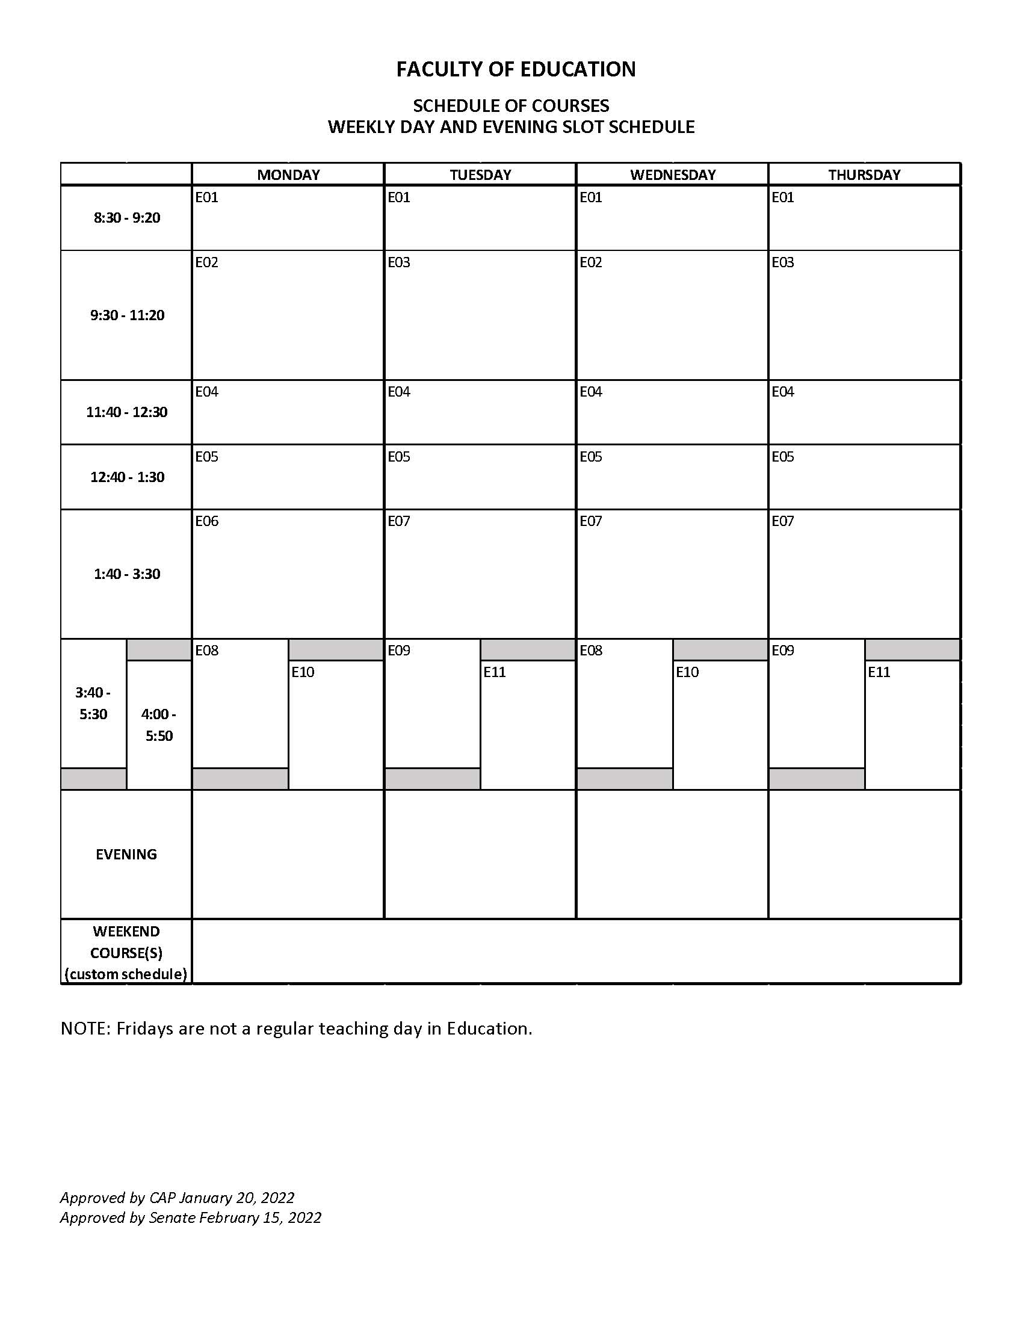

## Bachelor of Education Year 1-4 Integrated Program Timetable



## PENT Program Timetable: Spring and Summer

The PENT timetable is produced annually and is available at the following link:

<https://www.brandonu.ca/pent/>

PENT operates on the following slot schedule:

Slot A – 9:00 – 11:30 AM

Slot B – 1:30 – 4:00 PM

Slot C – 5:00 – 7:30 PM

A typical PENT course runs Monday to Thursday for four weeks.

## B. Ed (After Degree) Early Years Program Map



## B. Ed (After Degree) Middle Years Program Map



## B. Ed (After Degree) Senior Years Program Map



## Integrated Program Map

|  |  |  |  |  |  |
| --- | --- | --- | --- | --- | --- |
| **Year** | **1** | **2** | **3** | **4** | **5** |
| **Theme** | **Who am I?**  *Autobiography & Positionality* | **Who are My Students?**  *Child Development, Seeing and Responding to the Individual Child* | **What is Inquiry?**  *Methods, Assessment, Judgment, Survival* | **Who are We?**  *Community, Social Justice* | **What does it Mean to be a Reflective Teacher?**  *e-portfolio Presentation/Interview* |
| **Field-Experience** | Embedded in Seminar 1 & Seminar 2  (0 weeks) | Embedded in Classroom Management  (0 weeks) | Beginning last week in April or first week in May  01:271  (6 weeks) | Beginning last week in April or first week in May  01:371  (6 weeks) | 13 weeks (similar to AD program)  (13 weeks)  01:474 (Fall)  01:475 (Winter) |
| **Fall Term Course/s** | Teacher Identity: Becoming Tomorrow’s Teacher | Child Development and the Learning Process | ELA Methods | Teaching Aboriginal Studies | Using ICT  Student Literacy Interventions  Math Methods  Social Studies Methods |
| **Winter Term Course/s** | Power, Privilege and Positionality: Schools as Complex Spaces | Classroom Management | Evaluation and Assessment | Children with Exceptionalities | Integrated Program Capstone Course  Electives (2)  Science Methods |

Courses offered in both IP and AD programs Courses in IP program only

## Technical Vocational Program Map (2021-2024 cohort)





## Overview and Expectations of Undergraduate Programs Field Placements

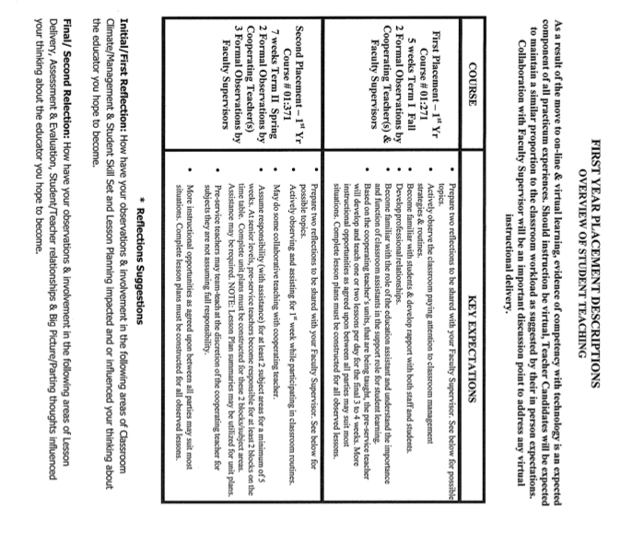

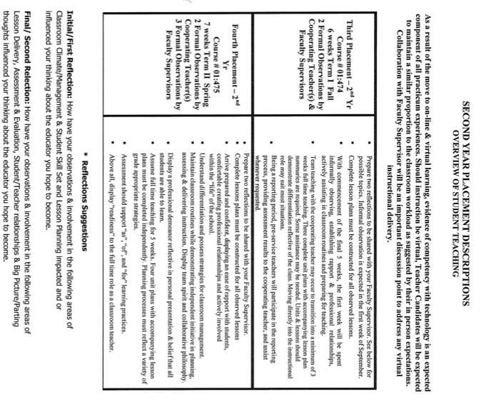

## Master of Education – Curriculum and Pedagogy Sample Program Sheet

6 credit hours Educational Core

|  |  |  |  |
| --- | --- | --- | --- |
| **Course number and name** | | **Date completed** | **Grade** |
| 07:752 | Overview of Educational Issues |  |  |
| 07.714 | Introduction to Educational Research Methodologies |  |  |

**12 credit hours Curriculum and Pedagogy Core**

|  |  |  |  |
| --- | --- | --- | --- |
| **Course number and name** | | **Date completed** | **Grade** |
| 02:780 | Curriculum Foundations |  |  |
| 02.781 | Innovative Pedagogies in Education |  |  |
| 02:782 | Curriculum Planning and Implementation |  |  |
| 02:783 | Contemporary Approaches to Curriculum Studies |  |  |

**9 credit hours Electives within Curriculum and Pedagogy**

|  |  |  |  |
| --- | --- | --- | --- |
| **Course number and name** | | **Date completed** | **Grade** |
| xx:7xx | Approved elective |  |  |
| xx:7xx | Approved elective |  |  |
| xx:7xx | Approved elective |  |  |

Students will complete the program by **One** of the following **Two** routes:

Note: All students begin in the course route. Students may be able to move to a thesis route once they have successfully completed 15 credit hours (including the 2 core courses: 07.752 & 07.714), and approval from the Department of Curriculum and Pedagogy.

|  |  |  |  |  |  |
| --- | --- | --- | --- | --- | --- |
| A | 9 credit hours | | Course Route |  | |
| **Course number and name** | | | **Date completed** | **Grade** |
| Required | 07:750 | Graduate Summative Seminar (3 cr. hrs.) |  |  |
| Elective | xx:7xx | Approved elective |  |  |
| Elective | xx:7xx | Approved elective |  |  |

|  |  |  |  |  |  |
| --- | --- | --- | --- | --- | --- |
| B | 12 credit hours | | Thesis Route |  | |
| **Course number and name** | | | **Date completed** | **Grade** |
| Required | xx.7xx | Approved research elective (3 cr. hrs.) |  |  |
| Required | 07:770 | Thesis (9 cr.hrs.) |  |  |

## Master of Education – Inclusive Education Sample Program Sheet

6 credit hours Educational Core

|  |  |  |  |
| --- | --- | --- | --- |
| **Course number and name** | | **Date completed** | **Grade** |
| 07:752 | Overview of Educational Issues |  |  |
| 07.714 | Introduction to Educational Research Methodologies |  |  |

**18 credit hours Inclusive Education Specialization**

|  |  |  |  |
| --- | --- | --- | --- |
| **Course number and name** | | **Date completed** | **Grade** |
| 04:706 | Theory and Practice of Standardized Assessment |  |  | |
| 04:750 | Theories of Inclusive Education |  |  | |
| 04:751 | Practices of Inclusive Education |  |  | |
| 04:756 | Education of Children with Behavioural Disorders I |  |  | |
| 04:757 | Education of Children with Behavioural Disorders II |  |  | |
| 04:761 | Assessment in Inclusive Education |  |  | |

Students will complete the program by **One** of the following **Two** routes:

Note: All students begin in the course route. Students may be able to move to a thesis route provided they have 15 credit hours of academic excellence and approval from the Department of Educational Psychology and Student Services.

|  |  |  |  |  |  |
| --- | --- | --- | --- | --- | --- |
| A | 12 credit hours | | Course Route |  | |
| **Course number and name** | | | **Date completed** | **Grade** |
| Required | 07:750 | Graduate Summative Seminar (3 cr. hrs.) |  |  |
| Elective | xx.7xx | Approved elective |  |  |
| Elective | xx.7xx | Approved elective |  |  |
| Elective | xx.7xx | Approved elective |  |  |

|  |  |  |  |  |  |
| --- | --- | --- | --- | --- | --- |
| B | 12 credit hours | | Thesis Route |  | |
| **Course number and name** | | | **Date completed** | **Grade** |
| Required | xx.7xx | Approved research elective (3 cr. hrs.) |  |  |
| Required | 07:770 | Thesis (9 cr.hrs.) |  |  |

## Master of Education – Educational Guidance and Counselling Sample Program Sheet

6 credit hours Educational Core

|  |  |  |  |
| --- | --- | --- | --- |
| **Course number and name** | | **Date completed** | **Grade** |
| 07:752 | Overview of Educational Issues |  |  |
| 07.714 | Introduction to Educational Research Methodologies |  |  |

**21 credit hours Guidance and Counselling Specialization**

|  |  |  |  |
| --- | --- | --- | --- |
| **Course number and name** | | **Date completed** | **Grade** |
| 04.704 | Counselling Interventions |  |  | |
| 04:708 | Introduction to Counselling: Helping Relationships |  |  | |
| 04:709 | Theories of Counselling and Psychotherapy |  |  | |
| 04:733 | Theory and Practice of Group Process and Counselling |  |  | |
| 04:768 | Ethical, Legal and Cultural Issues for Counsellors |  |  | |
| 04:772 | Practicum in Counselling I *(after 30 credit hours)* |  |  | |
| 04.774 | Expressive Therapies |  |  | |

Students will complete the program by **Course** or **Thesis** route:

Note: All students begin in the course route. Students may be able to move to a thesis route provided they have 15 credit hours of academic excellence and approval from the Department of Educational Psychology and Student Services.

|  |  |  |  |  |  |
| --- | --- | --- | --- | --- | --- |
| A | 9 credit hours | | Course Route |  | |
| **Course number and name** | | | **Date completed** | **Grade** |
| Required | 07:750 | Graduate Summative Seminar (3 cr. hrs.) |  |  |
| Elective | xx.7xx | Approved Elective |  |  |
| Elective | xx.7xx | Approved Elective |  |  |

|  |  |  |  |  |  |
| --- | --- | --- | --- | --- | --- |
| **B** | **12 credit hours** | | **Thesis Route** |  | |
| **Course number and name** | | | **Date completed** | **Grade** |
| Required | xx.7xx | Approved research elective (3 cr. hrs.) |  |  |
| Required | 07:770 | Thesis (9 cr.hrs.) |  |  |

## Master of Education – Educational Administration Sample Program Sheet

6 credit hours Educational Core

|  |  |  |  |
| --- | --- | --- | --- |
| **Course number and name** | | **Date completed** | **Grade** |
| 07:752 | Overview of Educational Issues |  |  |
| 07.714 | Introduction to Educational Research Methodologies |  |  |

**15 credit hours Administration Specialization**

|  |  |  |  |  |
| --- | --- | --- | --- | --- |
| **Course number and name** | | | **Date completed** | **Grade** |
| Required | 01:752 | Introduction to Educational Administration |  |  |
| Required | 01:755 | Administrative Leadership in Ed. Institutions |  |  |
| Required | 01:757 | Supervisory Policy and Practice |  |  |
| Required | 01:758 | School Administration and the Law |  |  |
| Required | 02:780 | Curriculum Foundations |  |  |

Students will complete the program by **One** of the following **Two** routes:

Note: All students begin in the course route. Students may be able to move to a thesis route once they have successfully completed 15 credit hours (including the 2 core courses: 07.752 & 07.714), and obtain approval from the Department of Leadership and Educational Administration.

|  |  |  |  |  |  |
| --- | --- | --- | --- | --- | --- |
| A | 15 credit hours | | Course Route |  | |
| **Course number and name** | | | **Date completed** | **Grade** |
| Required | 07:750 | Graduate Summative Seminar (3 cr. hrs.) |  |  |
| Elective | xx.7xx | Approved elective |  |  |
| Elective | xx.7xx | Approved elective |  |  |
| Elective | xx.7xx | Approved elective |  |  |
| Elective | xx.7xx | Approved elective |  |  |

|  |  |  |  |  |  |
| --- | --- | --- | --- | --- | --- |
| B | 15 credit hours | | Thesis Route |  | |
| **Course number and name** | | | **Date completed** | **Grade** |
| Elective | xx:7xx | Approved elective (3 cr. hrs.) |  |  |
| Required | xx.7xx | Approved research elective (3 cr. hrs.) |  |  |
| Required | 07:770 | Thesis (9 cr.hrs.) |  |  |

# Appendix 2 – Required Sections of Course Outlines and Suggestions for Course Design

## Academic Integrity

The Brandon University Academic Integrity Policy underlines the importance of all members of the BU community respecting and upholding the fundamental values of honesty, trust, fairness, respect, responsibility, and courage (ICAI, 2014) in every academic activity. Students are responsible for ensuring they understand and adhere to these values.

Activities that depart from these values include, but are not limited to, the following: plagiarism, cheating, academic interference, falsification, and aiding others to depart from academic integrity.

Students found responsible for having departed from academic integrity will be subject to remedies and/or sanctions. Depending on the scope and impact of the departure as well as the student’s level of study and past academic integrity history, remedies and sanctions range from mandated educational activities through failure on an assignment/failure in the course to expulsion from the University and revocation of credentials/degrees granted.

All departures from academic integrity will be recorded in the BU Academic Integrity Repository, and certain sanctions will result in a notation on the student’s transcript.

The full Academic Integrity Policy, including definitions of academic integrity’s fundamental values, examples of activities that depart from academic integrity, and processes undertaken in cases of suspected departures from academic integrity, is available at [www.brandonu.ca/senate](http://www.brandonu.ca/senate)‐office/senate‐policies.

## Statement on Accommodation

Brandon University values diversity and inclusion, recognizing disability as an aspect of diversity. Our shared goal is to create learning environments that are accessible, equitable, and inclusive for all students. Student Accessibility Services (SAS) works with students who have permanent, chronic, or temporary disabilities. SAS supports students by developing an individualized plan of accommodation, helping students understand their learning needs, and assisting faculty with provision of accommodations for students registered with SAS.

If you have, or think you may have, a disability (e.g. mental health, attentional, learning, vision, hearing, physical, medical, or temporary), you are invited to contact Student Accessibility Services to arrange a confidential discussion at (204) 727-9759 or [magnussonm@brandonu.ca](mailto:magnussonm@brandonu.ca).

Additional information is available on the Student Accessibility Services website <https://www.brandonu.ca/student-services/student-accessibility-services/>

If you are registered with SAS and have a letter requesting accommodations, you are encouraged to contact the instructor early in the term to discuss the accommodations outlined in your letter.

## Wellness

Positive well-being is highly correlated to learning and student success.  Wellness is a combination of physical, social, spiritual and mental health.  Personal Counsellors at Brandon University are dedicated to providing support to students’ wellness, primarily their mental well-being, through prevention activities, early identification and timely interventions using a holistic lens.

Please contact the Personal Counsellors in the Student Services Department at 204-727-9737 or visit Room 102 A.E. McKenzie Building to make an appointment.  There are crisis counselling appointments available daily.

If you believe that you or someone else is in imminent danger of harm call 911.

Sexualized Violence Education and Prevention Coordinator:  204-727-7498

24-hour crisis supports:

Over 18 years of age Under 18 years of age

Mobile Crisis Unit:   Child and Adolescent Treatment Centre:

204-725-4411  204-578-2700

Klinic Sexual Assault Crisis Line: 1-888-292-7565

## Suggestions for Course Design

### Learning Outcomes

Start with the end in mind. As a part of becoming more student-centred, instructors are encouraged to identify the knowledge, skills, attitudes and judgments that students will need to demonstrate by the end of the course. These will be the Learning Outcomes. Learning Outcomes can help you determine how and what to assess, which will help you to develop the learning activities.

Learning Outcomes are made up of three components:

1. One action verb that defines the level of learning (identify, explain, analyze, create). What do you want your students to know or be able to know, be able to do, or have changed by the end of the lesson or course?
2. Content description specifies learning to be demonstrated. What discipline-specific behaviour will you measure?
3. Context within which discipline-specific criteria will be applied to learning demonstrated.What quality measurement will indicate degree of success?

Focus on the observable student demonstration needed to show learning. Some instructors use the SMART method to help shape their outcomes. Are your Learning Outcomes Specific, Measurable, Achievable, Relevant and Time-limited?

The Higher Education Quality Council of Ontario has assembled a good collection of resources. <http://www.heqco.ca/en-ca/OurPriorities/LearningOutcomes/Pages/Learning-Outcomes-Assessment-Resource-Room.aspx>

Here is a useful link to a downloadable list of verbs:   
<http://www.fresnostate.edu/academics/oie/documents/assesments/Blooms%20Level.pdf>

If you would like more information on the importance of learning outcomes, how to write them, and how to use them to organize your course and plan your course assessments and evaluations, contact the CTLT.

### Instructional Message Design

The latest neuroscience research aligns with the experience of veteran teachers. W**e learn best by relating to what we already know.** In addition, you may find the following principles of instructional message design useful as you organize your teaching.[3]

* When learning is **more meaningful,** itis acquired more readily and is retained longer. Use familiar examples, images, photos, or diagrams to hook into to previous learning.
* Presenting an **advance organizer** gives students a place to put new information; gives information a structure and helps learning become more meaningful. The organizer may also describe relationships and underlying principles that help learning.
* Learning is highly **dependent on its consequences.** Pleasant, interesting, tension-reducing, useful, instrumental, rewarding, and informative consequences produce more efficient and lasting learning.
* **Inform learners of errors** to match the structure of the advance organizer. Focus on **the correct responses** to support learning.
* **Spaced or distributed practice** results in greater learning than mass practice. Consider adding practice at the end of each “chunk” (7±2 pieces) of new information.
* The **primacy-recency effect** says that cues encountered at first and at end within an instructional unit tend to be better remembered than cues in the middle. Place the information that is most important for your learners at the beginning or the end of a lesson.

### Learning Activities

An important part of student-centred teaching and learning is the activities you choose to meet your learning outcomes. Following is a list of activities to consider:

* writing
* journals, blogging for reflection
* one-minute papers to summarize what they learned
* write advertisements or pamphlets to inform the public.
* concept or mind mapping for students to show the relationships of what they learned
* case studies to apply what they learned related to a situation
* debates
* group problem solving
* experiential learning (applying knowledge in real-life settings)
* simulations and/or games
* other options for reporting besides writing a paper
* design a website
* produce a video
* compile a portfolio.

### Lesson Plans

There are hundreds of templates, guidelines, and checklists for planning lessons. As you gain experience with teaching, you will find one that meets your needs. The following table shows an **example of a lessons plan** that you may find helpful.[4]

|  |  |
| --- | --- |
| **Stage** | **Brief Description** |
| **1. Engage Capture their attention** | Lead into the lesson in a way that sets the tone for the class, For example:  ▪ tell a story  ▪ ask a provocative question  ▪ present a challenge  ▪ share a current news item  ▪ show a short video  ▪ review a concept from last class and explain how it relates to this lesson. |
| **2. Set the stage – the “Big Picture”** | Share the day’s learning outcome(s) or guiding question(s) with the students to give them the big picture for the day. |
| **3. Establish base** | Find out what (some) students may already know about the topic. You can use this as a base to gauge a shared starting point. It is a way to involve students and lead them from the familiar to the unfamiliar. |
| **4. Activate new content** | Present a manageable amount of information at a time (on concept/idea). Make sure materials are logically organized, clarify links to previous or upcoming material, identify transitions, and use questions to get students speaking. |
| **5. Summarize** | Summarize the key points of the lesson in an engaging way. Connect the lesson with what comes next and leave them with a question for the next class. |
| **6. Get feedback** | Motivate students through engaging activities. In this portion of the class, give students the chance to apply what you have just explained. There are many ways to evaluate whether the learning outcome and content have been understood. You can use individual or group activities. It can be written work or accomplished through a discussion. Making sure they have learned this material will help prepare them for the next lesson. |

### 

### Universal Design for Learning (UDL)

UDL is a set of principles and practices for developing curricula and classrooms to enable all individuals to access equal opportunities to learn. UDL provides a framework for creating curricula that meets learner’s needs from the start. The framework reduces barriers and optimizes levels of challenge and support to meet the needs of all students.

The CTLT Resources page has many links to important and current information on Universal Design for Learning. <https://www.brandonu.ca/ctlt/centre-for-teaching-learning-and-technology/resources/universal-design/>

### 

### Delivering Instruction

You have many choices for the way you deliver your instruction. You might have face-to-face presentations, as in lecturing. You might also choose among a variety of delivery methods. As you switch your method of delivery, you are breaking up your instruction into smaller parts. Based on the guidelines for learning, this should improve student learning.

Here are some suggestions for other ways to present information:

* short YouTube videos
* audio recording or clips
* online animations and simulations
* flip charts for discussions.

### Presentation Strategies

Presentation software, like PowerPoint can be helpful in organizing presentations, but when used incorrectly, it can be dreadfully boring. It is better to use your slides to grab and hold the audience’s attention. Keep your slides simple. The following are suggestions for slide presentations:

* The slides should highlight the important points of your content, not be a script.
* Check the amount of information on a slide – general rules of thumb are:
* **3-5 words per line, 3 lines per slide**
* Font size 32-40 pt. for headings and 24-28 pt.
* Keep the **colours and designs simple and visible:**
  + use good contrasting colours: yellow font on blue background, or white font on black background are two examples
* Use animations and graphics only to reinforce your points
* Avoid too much colour or complex backgrounds
* Ensure diagrams are clear and ALL labels are visible from a distance.
* Use **consistent and parallel structure** on slides.
* Use hyperlinks to bring in Internet connections (always test in the classroom before presenting).

### Recommendations for Engagement in Graduate Courses

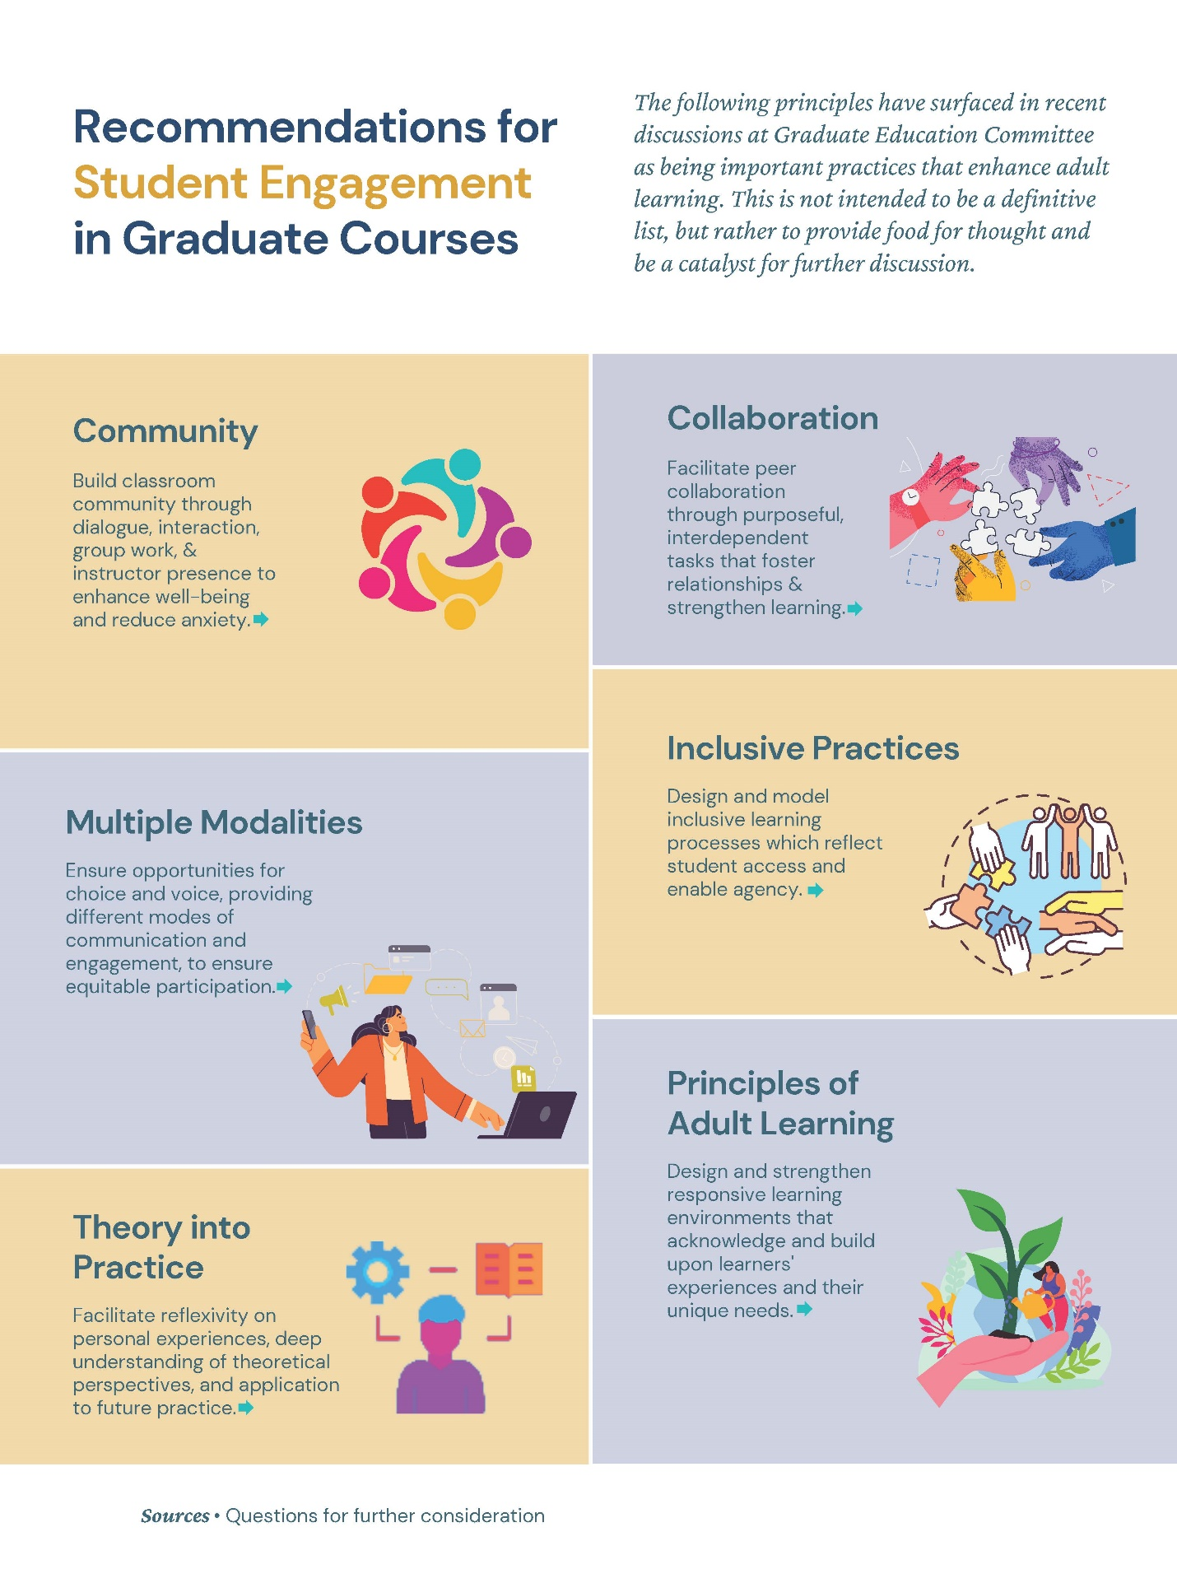

### Assessment Strategies

Student-centred teaching bases assessment strategies on the learning outcomes. Your Learning Outcomes have set the stage for your assessments. How and to what degree will your students demonstrate the objectives you set? Many of the activities you use during your instruction may be used as a part of your assessment.

### Rubrics

Many teachers use rubrics to help establish criteria for grading and clarify expectations for students. Rubrics use a matrix format to articulate the expectations for an assignment. Down the left side of the matrix, the teacher identifies the critical attributes of the assignment. Along the top of the matrix the teacher identifies the levels of quality from excellent to poor. Within each cell of the rubric are the descriptions and the score for matching the identified task and the quality level.

Rubrics also provide learning guidelines for students. They guide students to understand what is expected for each assignment and to evaluate their own work. The following is an **example of a basic rubric for a writing assignment.** This may not meet your requirements for an assignment. You decide on the criteria, scale and the description of each cell. Rubrics can also be used in marking from within Moodle.

Sample Rubric

|  |  |  |  |  |
| --- | --- | --- | --- | --- |
| **Criteria/Scale** | **Exceeds Requirements**  **4** | **Meets Requirements**  **3** | **Needs Improvement**  **2** | **Unacceptable**  **1** |
| * **Structure** * **Organization** * **Flow of thought** * **Transitions** * **Form** | * logically and clearly organized * easily followed * variety and thoughtful transitions * clear structure format | * mostly organized * usually easily followed * basic transitions * structured format | * some level of organization * many digressions, ambiguities, and irrelevances * rambling format | * lack of organization * difficult to follow * poor transitions * no format |
| * **Grammar/ mechanics** * **Sentence structure** * **Punctuation/ mechanics** | * uses complex sentences * few punctuation or mechanical errors | * uses compound sentences * too many punctuation and/or mechanical errors | * compound sentences * many punctuation * and/or mechanical errors | * simple sentences * too many grammar, structure, punctuation, and mechanical errors |
| * **Language** * **Vocabulary** * **Tone** | * sophisticated, appropriate vocabulary correctly used for subject * tone clear, consistent and appropriate for audience | * vocabulary varied, specific, and appropriate * subject specific vocabulary * tone emerges and is generally appropriate | * proper vocabulary though sentences may be simple * infrequent subject specific vocabulary * tone exhibits some level of sensitivity | * unsophisticated vocabulary not used properly * very simple sentences * lacking use of subject specific vocabulary |
| * **Content/ information** * **Clarity of purpose** * **Critical and original thought** * **Use of examples** | * well-developed central idea/clarity of purpose * abundance of evidence of critical and careful thought and analysis * vivid and specific examples with tight focus | * evident central idea and clarity of purpose throughout * evidence of careful thought and analysis * good, relevant examples and evidence | * vague or too broad central idea * some evidence of critical and careful thought and analysis * some examples and evidence, but vague | * central idea missing * clarity of purpose absent * no critical, careful thought or analysis * too few or NO examples and evidence |

# Appendix 3 – Moodle FAQs and Moodle Gradebook

**Moodle FAQs – Please see each section below**

1. How do I request a website for my course?

2. Where is my enrolment key?

3. How do I remove students from my Moodle website?

4. How do I add/remove instructors or non-editing instructors (graders) to my course?

5. How can I observe copyright when posting information in my course website? (Please contact Chris Hurst (687) directly with any questions: [hurst@brandonu.ca](mailto:hurst@brandonu.ca))

**1. Website Requests**

 Websites allow you to post your syllabus, course information, accept assignments online and post grades.

To request a course:

 1. Ensure that you are using Firefox as your browser.  There are known issues using other browsers with Moodle.  Both Moodle and Firefox are open source and therefore the programmers can ensure that they communicate with each other effectively.

2. Follow the Moodle link on the BU Homepage.

3. If this is your first time using Moodle, enter your Novell Username and Password into the login box.  You will be prompted to fill out a profile before continuing. Under the description field you can add your bio or simply type “Course Instructor”.

4. From the Moodle website homepage select the “Instructor New Website Request” link under the Moodle Logo at the top.

5. Read the instructions to ensure you need to request a *new* website.

This is an example of the Course Full Name:

**01:220 Introduction to Early Childhood Education**

This is an example of the Course Short Name:

**01:220**

Please feel free to contact me back to book a face-to-face appointment.

**2. Enrolment Key**

To access your enrolment key:

1. Ensure that you are using Firefox as your browser. *Safari will cache your Novel username and password and try to save it as your enrolment key.

2. Under the ADMINISTRATION Block (on the left-hand side) > Course Administration > Users > Enrolment Methods > Self enrolment (Student)

 3. It is recommend to leave all of the other settings as default at B.U.

4. Remember to “Save changes”

**3. Removing All Students from your Moodle Website**

*These instructions reset your entire website.  Please contact me back if you aren’t completely sure this is what you want to do.

Students will remain active in your Moodle courses until you reset them.  Moodle doesn't do this automatically for you according to the semesters.  This is to allow you to provide early access to your website or account for extensions without having to contact anyone.

Locate the ADMINISTRATION Block (by default it is on the left-hand side unless you moved it). Under the Course Administration section select the “Reset” link.  There is a button at the very bottom of the resulting page labelled “Select default”.  Choose this option and then select “Student” under ROLES.  Lastly select the button labelled “Reset course” at the very bottom of the screen.

**4. Manually adding/removing instructors or non-editing instructors (graders)**

1. Under the Administration Block select Settings > Users > Enrolled Users > Enrol Users

2. change the roll at the top of the topic box to the permissions you wish to grant (instructor/non-editing instructor/student)

3. type the name in the Search box at the bottom of the popup box – and then select the “Enroll” button beside their name

4. select the “Finish enrolling users” button

*You can also manually remove someone completely by selecting the X in the furthest column to the right in the row beside their name

**5. Scanning to Moodle under the Access Copyright License (Please contact Chris Hurst [687] directly with any questions:**[**hurstc@brandonu.ca**](mailto:hurstc@brandonu.ca)**)**

Under the terms of the AUCC model license which Brandon University has signed with Access Copyright, you can scan printed material and upload the scans to Moodle under the following conditions:

1. The amount of material scanned can be no more than the following:  
either    A. twenty per cent (20%) of a work from the repertoire of Access Copyright or  
               B. an entire newspaper or periodical article from the repertoire of Access Copyright, or  
                C. an entire page of a newspaper or periodical from the repertoire of Access Copyright, or  
D. a single short story, play, poem, essay or article from a Published Work that contains other Published Works from the repertoire of Access Copyright, or  
E. an entire entry from an encyclopaedia, annotated bibliography, dictionary or similar reference work from the repertoire of Access Copyright, or  
F. an entire reproduction of an artistic work (including any drawing, painting, print, photograph or other reproduction of a work of sculpture, architectural work or work of artistic craftsmanship) from a Published Work that contains other Published Works from the repertoire of Access Copyright, or  
G. one chapter, provided it is no more than twenty per cent (20%) of a book from the repertoire of Access Copyright

2. When the scanned material is posted to Moodle, the material can not be posted so that is accessible by anyone except Brandon University students, faculty and staff. If the scanned material is for the students of a particular class, then the material should be posted so that only students in that class have access to that material.

3. The scanned material can not be posted to any other site where it could be accessed by anyone except Brandon University students, faculty and staff.

4. If the material you are posting to Moodle is the electronic equivalent of a course pack, Access Copyright requests that you put the following link on the home page of the Moodle course:

<http://www.accesscopyright.ca/media/24287/aucc_model_licence_schedule_b_v2.pdf>

To determine if a work is in the repertoire of Access Copyright, you can use Access Copyright’s Repertoire Look-Up Tool at <http://www.accesscopyright.ca/look-up-tool>

The above restrictions do not apply to any work where any of the following four conditions apply:  
                (a) you hold the copyright   
                (b) you have received permission to scan from the copyright holder (if the students and faculty of the university already has access to the material, then permission may already exist, please check with the library)  
                (c) copyright protection has expired or never did apply (i.e., items in the public domain)   
                (d) the material is open access material (it was published in open access publications, works placed in Institutional Repositories or other repositories such as [www.cnx.org](http://www.cnx.org) and works under Creative Commons licenses)

## Moodle Gradebook

The Gradebook is the most powerful tool in Moodle. It can perform complex calculations to suit any grading scheme. It doesn’t however act exactly like Excel. We recommend the following link for more information:

<https://docs.moodle.org/35/en/Grading_quick_guide>

There are two different ways the items you are evaluating can appear in your Gradebook. The first is when you add an Activity to your website on the main page (i.e. Assignment, Quiz, Journal). You can specify in the activity settings that it will be graded and Moodle will automatically create a column in the Gradebook. When you grade the Activity the mark will be linked and appear in the Gradebook. The second way is to create a “Grade Item” directly in the Gradebook. This can be for something that you are evaluating, but not using an Activity for in Moodle. An example is giving a grade for participation or a presentation that is given in class.

It is important to note that Moodle distinguishes between “points” and the item “weight”. You may for instance have a midterm that you are marking out of 75 points but it is only worth 25% of the final grade in the course. The percentage is the item weight. It is also possible to give bonus marks as you can set a maximum grade for an assignment and simply give the student 80 out of 75 for example.

In the Gradebook you can also create Categories. We recommend only using Categories if you need for example to take the top 2 marks out if 3 items.

If you would like to schedule a one-on-one appointment with Glen Gross to help you with your specific Gradebook setup please contact him at: [grossg@brandonu.ca](mailto:grossg@brandonu.ca)

# Appendix 4 – Access Copyright

Brandon University’s license with Access Copyright extends the university community’s ability to photocopy, scan, and print material beyond the scope of fair dealing. Scanned copies of articles or book chapters can be stored on a hard drive, USB stick or any secure location on the Brandon University network. Scanned copies can also be uploaded to Moodle or sent by email to any other students and faculty at institutions that have signed agreements with Access Copyright. The license also allows for the creation of course packs. For the full details about how much copying and scanning can be done under the Access Copyright license, go to the following webpage.

**Access Copyright Digital and Copying Guidelines:**

<https://www.accesscopyright.ca/media/1039/access_premium_poster.pdf>

<http://libguides.brandonu.ca/copyright>

Copyright questions may be directed to 204-727-9483.

## Photocopying and Scanning

If you wish to photocopy in the Library and bill it to your department, see the circulation desk. Please be aware that all copying must be done in compliance with Canadian copyright law. Under the terms of the Access Premium license, which Brandon University has signed with Access Copyright, you can scan printed material and upload the scans under the following conditions:

1. You can copy up to 20% of a book or an entire article (20 to 25% on a pay-per-use basis) from a magazine, journal or newspaper. This can include a complete chapter, short story, poem, or an entire artistic work.
2. When the scanned material is posted to Moodle, the material cannot be posted so that it is accessible by anyone except Brandon University students, faculty, and staff. If the scanned material is for the students of a particular class, then the material should be posted so that only students in that class have access to that material.
3. The scanned material cannot be posted to any other site where it could be accessed by anyone except Brandon University students, faculty and staff.
4. If the material you are posting to Moodle is the electronic equivalent of a course pack, Access Copyright requests that you put the following link on the home page of the Moodle course: <https://www.accesscopyright.ca/media/1039/access_premium_poster.pdf>

To determine if a work is in the repertoire of Access Copyright, use **Access Copyright’s Repertoire Look-Up Tool** at <https://portal.accesscopyright.ca/cportal/licences/EPWorkSearch.aspx>

The above restrictions do not apply to any work where any of the following four conditions apply:

1. You hold the copyright
2. You have received permission to scan from the copyright holder (if the students and faculty of the university already has access to the material, then permission may already exist, please check with the library)
3. Copyright protection has expired or never did apply (i.e., items in the public domain)
4. The material is open access material (it was published in open access publications, works placed in Institutional Repositories or other repositories such as [www.cnx.org](http://www.cnx.org) and works under Creative Commons licenses).

1. Manitoba FIPPA for Public Bodies Resource Manual. Retried June 22, 2015 from <http://www.gov.mb.ca/chc/fippa/public_bodies/resource_manual/index.html>
2. *University of Manitoba, Office of Fair Practices and Legal Affairs*, *Access and Privacy*, Personal Health Information webpage accessed, June 22, 2015. <http://umanitoba.ca/access_and_privacy/PHI.html>
3. Fleming, M. & Levie, H. (Eds.) (1993) *Instructional Message Design: Principles from the Behavioral Sciences*. Englewood Cliffs, NJ: Educational Technology Publications.
4. Adapted from *Lesson Planning Class by CLAASS* from Carleton University