Unit Plan – Grade(s), Subject Area(s), Theme or Topic
This template is to assist you with the considerations involved and in the organization of the material/resources and processes you can use to construct a unit of study.
Duration of Unit:
Summary of Unit: (Considering Universal Design for Learning, Backwards Planning, Inquiry, a variety of Learning Experiences and Assessments, and Evaluation – provide a summary of the unit you have constructed).

Curriculum: Outcomes, Essential Questions, Targeted Learning and Experiences
Utilizing Manitoba curricula list all outcomes, essential questions, descriptions of targeted learning or experiences that will be presented / explored through this unit.

Specific Learning Outcomes and Evidence of Learning
Expand on the learning tasks and curricular outcomes noted above, identifying the targeted learning for the unit. Consider referring to the attached “Appendices of Verbs” to use in the following sentence leads to describe what observable evidence of learning will be assessed. For example:
- Students will categorize… (Cognitive Domain, Analyze)
- Students will demonstrate…(Psychomotor Domain, Complex)
- Students will design…(Affective Domain)
- ….

Overview of Unit Assessment
Formal Assessment
General Description of Assessed Tasks, Processes or Contexts  E.g., pre-unit quiz, project, presentation, skill demonstration, end of unit test, student self-reflection | Specific Learning Outcomes  List the specific learning outcomes by number from the previous section that are examined in this assessment | Triangulation of Assessment Data  Indicate source(s) of data included in this assessment that will add to a body of evidence representing learning through the unit |  |  | Assessment AS, FOR and OF Learning  Indicate type(s) for each assessment  See Assessment Appendix for clarity of “For, As & Of” Learning
 |  | Conversation | Observation | Products | As | For | Of  Briefly describe how learning will be graded, categorized or described. All assessment instruments (e.g., rubrics, checklists, quizzes, marking criteria) must be completed and attached  with lessons plans in next section.
Informal Assessment
Describe what types of informal assessments AS, FOR, or OF learning you will conduct through the unit (e.g., observing and offering students feedback during work on a project, monitoring class discussion, conferencing with individual students, exit slips,etc.). Describe how this data will be recorded, organized and applied to learning through the unit.

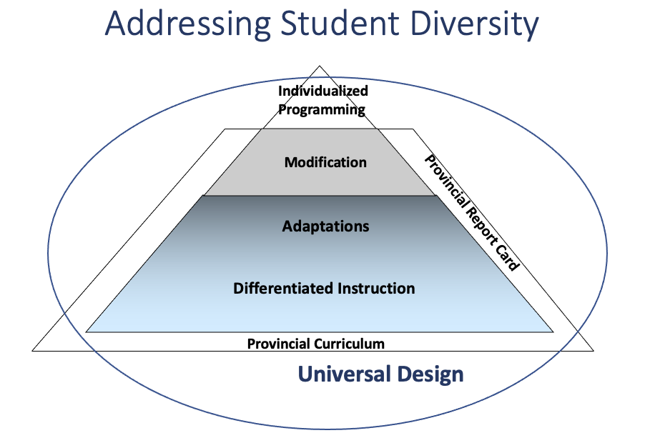

Universal Design for Learning Considerations:
With difference and diversity in mind from the beginning of your unit planning process, consider how you will provide multiple means of engagement, representation and action and expression for all.

Principles of Differentiation:
How will the unit be delivered? (Respectful tasks, quality instruction, flexible groupings, continual assessment, community building, etc.)

Differentiated Instruction:
According to students’ readiness, interests, and learning profile, how will you differentiate learning tasks based on the content, process, products, affect and environment of students?

Student Specific Planning:
What considerations have you made for students who require Adaptations, Modifications or who have specific programming plans (IEP’s, BIP’s, etc).

Learning Plan
Learning Activities:

Your Unit should include lesson summaries for each lesson being considered and contain any comprehensive lesson plans utilized for an observed lesson, along with your assessment plan/unit test, etc.

Some units may have cross-curricular connections. This unit has curricular connectors in the following subjects:

Subject Area |  | Relevant Curricular Outcomes, Essential Questions or Experiences
English Language Arts
Mathematics
Science
Social Studies
Physical Education / Health
Information and
Communication Technologies
Music / The Arts
French/Additional Language

Learning Resources/Sources will be used to support the implementation of this Unit

Primary Sources (Field Trips, Experts, Artifacts, etc.):

Secondary Sources (Text Set, Multimedia, Print, Web, etc.):

Post-Unit Reflection
What worked? What didn’t? What would you adjust the next time teaching this unit? What did you learn during the unit? (e.g., growth in teaching practice, new pedagogy or assessment strategies, deeper understanding of topic, broader awareness of student(s) as learners, etc.)

"Appendices of Verbs"
Remember  arrange quote  cite read  define recite  describe recognize  draw record  duplicate relate  identify recall  indicate repeat  label reproduce  list select  match state  memorize tabulate  name tell  point trace  order write  outline | Understand  associate generalize  classify give example  compare identify  compute indicate infer  contrast interpret  convert locate  defend paraphrase  describe predict  differentiate report  discuss recognize  distinguish restate rewrite  estimate review  explain express select  extend summarize  extrapolate translate | Apply  apply order  calculate practice  change predict  choose prepare  complete produce  compute relate  demonstrate report  discover restate  dramatize review  employ schedule  examine show  illustrate sketch  interpolate solve  interpret translate  manipulate use  modify utilize  operate write
Analyze  analyze identify  appraise illustrate  breakdown infer  calculate inspect  categorize inventory  compare model  contrast outline  criticize point out  debate question  diagram relate  differentiate select  discriminate separate  distinguish subdivide  examine summarize  experiment test | Evaluate  appraise judge  argue justify  assess interpret  attach measure  choose rank  compare relate  conclude predict  contrast rate  critique recommend  defend review  describe revise  determine score  diagnose select  discriminate summarize  estimate support  evaluate test  explain value  grade | Create  arrange organize  assemble plan  categorical prepare  collect prescribe  combine produce  comply propose  compose rearrange  construct reconstruct  create relate  design reorganize  detect revise  develop rewrite  devise set up  explain specify  formulate summarize  generate synthesize  generalize tell  integrate write  manage
VERB LIST FOR WRITING EDUCATIONAL OBJECTIVES
Cognitive Domain
Psychomotor Domain
Simple  add expel pipet shake  adjust filter place smear  agitate guide plot smell  aspirate handle pour stain  cleanse imitate prepare start  collect invert prick stop  combine label puncture stopper  copy lyse record streak  dilute mark repeat tilt  dispose measure rinse titrate  drain mix scrape transfer  draw mount seal use  duplicate obtain select wash  emulsify pass set up wipe | Complex  build incise palpate  calibrate inject percuss  construct inoculate perform  create make produce  demonstrate maintain remove  exercise manipulate suture  illustrate operate
Affective domain
Accept  Adopt  Advocate  Annotate  Ask  Attempt  Attend  Challenge  Choose  Consult  Delay  Design  Dispute  Evaluate  Exemplify | Initiate  Investigate  Join  Keep (preserve)  Obey  Object  Offer  Organize  Participate  Persevere  Propose  Promote  Qualify  Query  Questions | Read  Realize  Recommend  Reflect  Reject  Seek  Select  Specify  Share  Suggest Support  Test  Try  Visit  Volunteer  Weigh (judge)
VERBS TO BE AVOIDED WHEN WRITING OBJECTIVES
appreciate  be acquainted with  be aware of  be familiar with believe comprehend | enjoy  fully appreciate  grasp the significance of have faith in  know  learn | really understand realize  remember sympathize with understand

CHECKLIST QUESTIONS FOR WRITING LEARNING OBJECTIVES
      - Observable - Does the learning objective identify what students will be able to do after the topic is covered?
      - Measurable - Is it clear how you would test achievement of the learning objective? Can students reasonably determine from the objective whether or not they have achieved it?
      - Achievable - Can the objective be realistically accomplished at the end of the class/course?
      - Clear & specific - Do chosen verbs have a clear meaning?
      - Alignment with expectations - Is the verb aligned with the level of cognitive understanding expected of students? Could you expect a higher level of understanding?
Source:
- Verbs: Duke University Community and Family Medicine Faculty Development Module
- Checklist Questions: Carl Wieman Science Education Initiative

Definitions | l. Remembering | ll. Understanding | Ill. Applying | IV. Analyzing | V. Evaluating | VI. Creating
Bloom's  Definition | Exhibit memory of previously learned material by recalling facts terms, basic concepts, and answers. | Demonstrate understanding of facts and ideas by organizing, comparing, translating, interpreting, giving descriptions, and stating main ideas. | Solve problems to new situations by applying acquired knowledge, facts, techniques and rules in a different way. | Examine and break information into parts by identifying motives or causes. Make inferences and find evidence to support generalizations. | Present and defend opinions by making judgments about information, validity of ideas, or quality of work based on a set of criteria. | Compile information together in a different way by combining elements in a new pattern or proposing alternative solutions.
Verbs | - Choose  - Define  - Find  - How  - Label  - List  - Match  - Name  - Omit  - Recall  - Relate  - Select  - Show  - Spell  - Tell  - What  - When  - Where  - Which  - Who  - Why | - Classify  - Compare  - Contrast  - Demonstrate  - Explain  - Extend  - Illustrate  - Infer  - Interpret  - Outline  - Relate  - Rephrase  - Show  - Summarize  - Translate | - Apply  - Build  - Choose  - Construct  - Develop  - Experiment with  - Identify  - Interview  - Make use of  - Model  - Organize  - Plan  - Select  - Solve  - Utilize | - Analyze  - Assume  - Categorize  - Classify  - Compare  - Conclusion  - Contrast  - Discover  - Dissect  - Distinguish  - Divide  - Examine  - Function  - Inference  - Inspect  - List  - Motive  - Relationships  - Simplify  - Survey  - Take part in  - Test for  - Theme | - Agree  - Appraise  - Assess  - Award  - Choose  - Compare  - Conclude  - Criteria  - Criticize  - Decide  - Deduct  - Defend  - Determine  - Disprove  - Estimate  - Evaluate  - Explain  - Importance  - Influence  - Interpret  - Judge  - Justify  - Mark  - Measure  - Opinion  - Perceive  - Prioritize  - Prove  - Rate  - Recommend  - Rule on  - Select  - Support  - Value | - Adapt  - Change  - Choose  - Combine  - Compile  - Compose  - Construct  - Create  - Delete  - Design  - Develop  - Discuss  - Elaborate  - Estimate  - Formulate  - Happen  - Imagine  - Improve  - Invent  - Make up  - Maximize  - Minimize  - Modify  - Original  - Originate  - Plan  - Predict  - Propose  - Solution  - Solve  - Suppose  - Test  - Theory
REVISED Bloom's Taxonomy Action Verbs
Anderson, L. W., & Krathwohl, D. R. (2001). A taxonomy for learning, teaching, and assessing, Abridged Edition. Boston, MA: Allyn and Bacon.

Rethinking Classroom Assessment with Purpose in Mind
Appendix 2

Overview of Planning Assessment
This appendix provides a summary of the tables in Chapters 3, 4, and 5 (Section Il) of this document.
 | Assessment for Learning | Assessment as Learning | Assessment of Learning
Why Assess? | to enable teachers to determine next steps in advancing student learning | to guide and provide opportunities for each student to monitor and critically reflect on their learning and identify next steps | to certify or inform parents or others of student’s proficiency in relation to curriculum learning outcomes
Assess What? | each student's progress and learning needs in relation to the curricular outcomes | each student's thinking about their learning, what strategies they use to support or challenge that learning, and the mechanisms they use to adjust and advance their learning | the extent to which students can apply the key concepts, knowledge, skills. and attitudes related to the curriculum outcomes
What  Methods? | a range of methods in different modes that make students' skills and understanding visible | a range of methods in different modes that elicit students' learning and metacognitive processes | a range of methods in different modes that assess both product and process
Ensuring Quality | - accuracy and consistency of observations and interpretations of student learning  - clear, detailed learning expectations  - accurate, detailed notes for descriptive feedback to each student | - accuracy and consistency of student's self-reflection, self-monitoring, and self-adjustment  - engagement of the student in considering and challenging his or her thinking  - students record their own learning | - accuracy, and fairness of judgments based on high-quality information  - clear. detailed learning expectations  - fair and accurate summative reporting
Using the  Information | - provide each student with accurate descriptive feedback 10 further their learning  - differentiate instruction by continually checking where each student is in relation to curricular outcomes  - provide parents or guardians with descriptive feedback about student learning and ideas for support | - provide each student with accurate, descriptive feedback that will help them develop independent learning habits  - have each student focus on the task and their learning (not on getting the right answer)  - provide each student with ideas for adjusting. rethinking, and articulating their learning  - provide the conditions for the teacher and student to discuss alternatives  - students report about their learning | - indicate each student’s level of learning  - provide the foundation for discussions on placement or promotion  - report fair, accurate,. and detailed information that can be used to decide the next steps in a student's learning

https://www.edu.gov.mb.ca/k12/assess/wncp/index.html
Rethinking Classroom Assessment with Purpose in Mind • 85
"Assessment Appendix"
Assessment "FOR" Learning
- Formative
- Descriptive Feedback
- Used to plan instruction and further learning
- Performed by teacher (sometimes with students)
- Continuous

Assessment "AS" Learning
- Self-assessment
- Metacognitive awareness
- Used to empower students to consider their learning & set goals
- Continuous
Assessment "OF" Learning
- Summative
- Usually done at the end of a unit by teacher
- Used to grade/rank/judge/evaluate students
- Less emphasis on improvement / feedback

