BUILDING FOR A BRIGHT FUTURE
STRATEGIC ACADEMIC PLAN
2014-2019

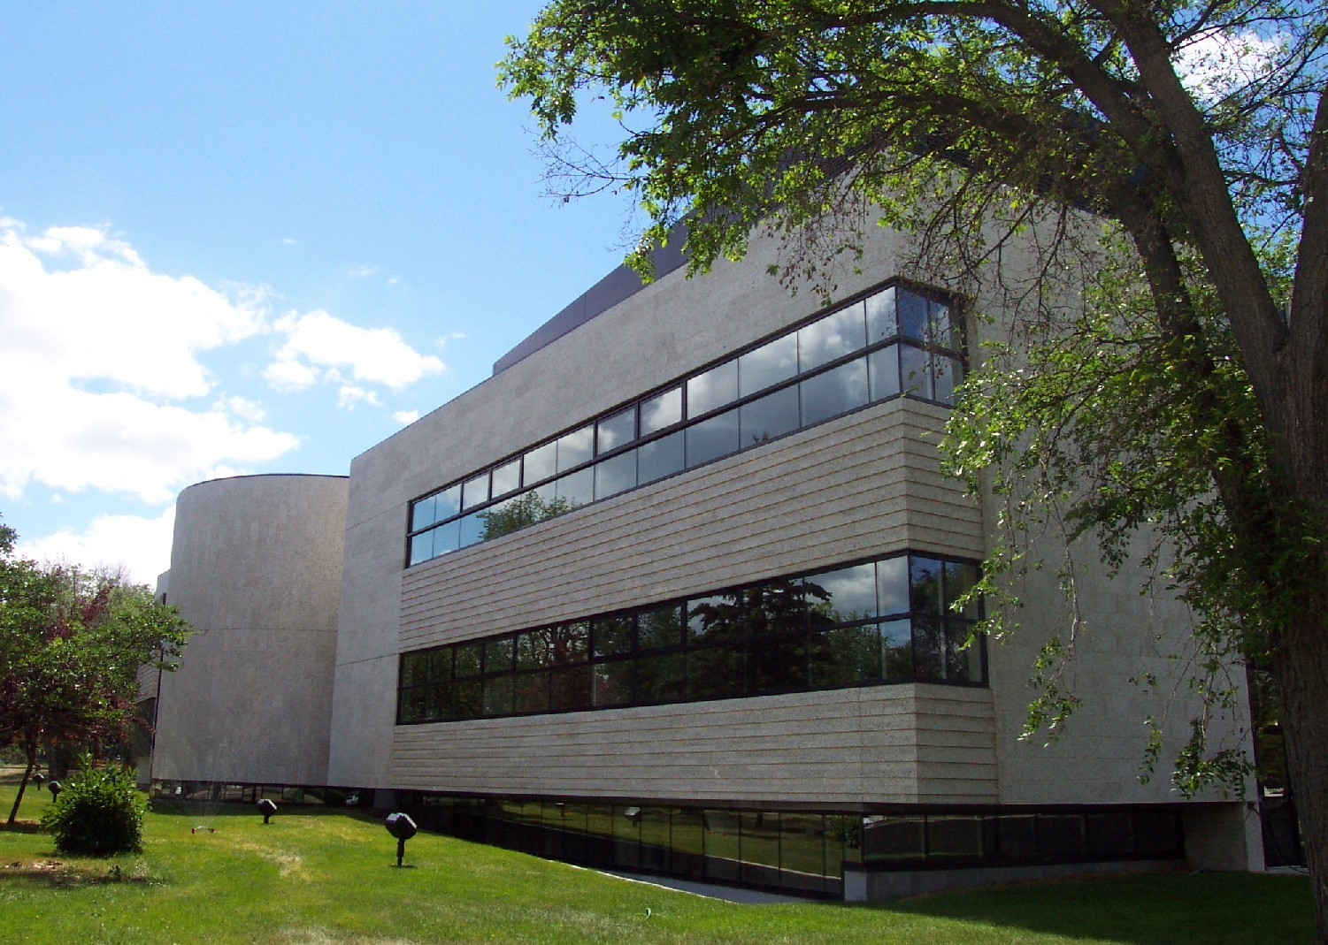

Faculty of Health Studies
(Approved at Health Studies Faculty Council
January 27, 2015)

Background
The Faculty of Health Studies has a long and stellar history at Brandon University. Nursing and Psychiatric Nursing programs came to Brandon University in 1986 with the announcement of funding for two post-diploma programs. These programs were originally housed in the Faculty of Science in the Department of Nursing and Health Studies located in McMaster Hall. The two-year programs admitted students who were already Registered Nurses and Registered Psychiatric Nurses and upon successful completion provided them with a Bachelor of Science in Nursing (BScN) or a Bachelor of Science in Mental Health (BScMH) degree.
In 1995, Canada’s first baccalaureate program in psychiatric nursing (BScPN) joined the two post-diploma programs at Brandon University. Physically this program remained at the Nurses’ Residence at the Brandon Mental Health centre until 1998 where the Psychiatric Nursing Diploma program had been housed since 1920. In 1997, the School of Health Studies was established and in September 1998 it moved into the renovated School of Health Studies Building on the Brandon University campus (formally the Music Building and Student Services).
In 1998, the School began to offer the first two years of its Bachelor of Psychiatric Nursing program by distance to Winnipeg in collaboration with the University of Winnipeg. Students could complete the psychiatric nursing courses through distance delivery and their required Arts and Science courses at the University of Winnipeg.
In March 2001, the province announced $5 million to expand nursing programs in Manitoba and establish the 4-year BN degree to Brandon University. In September 2003, the new Health Studies Complex was officially opened just in time to welcome faculty, staff and students to the new Bachelor of Nursing program.
In 2005, additional funding was received to expand the student capacity for the BScPN in Winnipeg. This included hiring additional faculty and staff and securing permanent space. Renovations took place early in 2006 to the lower level of the Rice Centre building. The new space included two classrooms, student lounge, faculty and staff offices and lounge, a counseling room, a laboratory and computer area. The official opening was on August 28, 2006 and classes began a week later.
In 2010, Brandon University was granted approval to establish a Masters of Psychiatric Nursing (MPN) program – the first of its kind in North America. In January 2011, the program admitted 13 students on a part-time and full-time basis. The program has a total of eight full time seats available for students. The MPN program is designed for professionals who are seeking advanced practice roles in administration, clinical practice, or nursing education. In June 2012, the School of Health Studies was approved by Senate to become the Faculty of Health Studies.
This Building for a Bright Future document outlines the mission, philosophy, guiding principles, and strategic goals and priorities for the Faculty of Health Studies over the next five years. These strategic goals and priorities are consistent with those of the University Academic Plan.
Mission Statement
The Faculty of Health Studies is committed to:
- the preparation of graduates at the baccalaureate level who will practice Nursing and Psychiatric Nursing safely and effectively during interactions with individuals, families, groups, and communities;
- student centered education;
- high quality, online graduate education;
- the generation of new knowledge through research that is relevant to professional practice; and,
- make a contribution to the vitality of the university and other communities.

Philosophy
Nursing and Psychiatric Nursing are theory based professions based upon scientific principles, humanistic and ethical premises, and the art of caring. Each profession requires skillful use of interpersonal processes and collaboration for the purposes of health promotion, maintenance, and restoration. Cultural diversity is respected and valued. Both professions rely on critical thinking and problem solving in clinical, administrative, research, and educational practice.
Education in Nursing and Psychiatric Nursing reflects the standards of each profession. The goal of this education is to promote acquisition, development, synthesis, and critical analysis of knowledge, attitudes, and abilities essential to the provision of evidence-based health care.

Guiding Principles
To accomplish its mission, members of the Faculty of Health Studies aspire to the following principles as we strive to fulfill the goals of the University Academic Plan:
- to provide students with a learning environment in which they may develop intellectually, emotionally, and socially;
- to promote the pursuit, advancement, and dissemination of knowledge;
- to pursue a high level of subject matter knowledge and ensure course content is current, accurate, and representative;
- to use instructional methods and strategies that, according to best evidence, are effective in helping students achieve course objectives and expected learning outcomes;
- to ensure the assessment of students is valid, open, fair, and congruent with course objectives and expected learning outcomes;
- to work respectfully and co-operatively with colleagues and students in the interest of fostering student development;
- to work collaboratively and in partnership with health authorities, regulatory bodies, other nursing education providers, and the Brandon and Winnipeg communities to promote high quality nursing education;
- to be aware of, respectful of, and attentive to goals, policies, and standards of practice expected of educators by Brandon University and professional regulatory bodies; and,
- to encourage a climate of freedom, responsibility, and mutual respect in pursuit of these principles.

Critical Issues
The Faculty of Health Studies is facing several critical issues in the coming years. These issues present themselves as both an opportunity and a threat. These issues include:
- recruiting and retaining qualified faculty including succession planning;
- securing clinical placements that address the needs of our students and programs;
- clinical supervision approaches that have long term sustainability;
- continuing to be responsive to the needs of citizens in south western Manitoba including Aboriginal communities;
- research and scholarship in light of teaching responsibilities;
- managing and communicating with multi-site program locations;
- budget restrictions that impact quality programming; and
- changing student demographics.

Key Academic Priorities
The faculty and staff of the Faculty of Health Studies developed this Strategic Academic Plan to address challenges and opportunities facing our academic programs, students, faculty, and employers of our graduates. At the April 2014 Strategic Planning Day, participants articulated several key priorities for the Faculty of Health Studies over the next 5 year period.

- To provide excellent, student centered education in all academic programs.
- To establish community and clinical partners that will have a positive, deliberate, and reciprocal relationship with the Faculty of Health Studies.
- To create and foster partnerships and collaborations to deliver health studies education that is responsive to the needs and context of the health sector.
- To create and foster collaborations with partners within Brandon University, the community, and the health sector to pursue practice-relevant research and scholarship that are responsive to the needs and context of the health sector.
- To establish a governance structure and accountability framework that is responsive to the needs of the faculty and students.
- To participate in a plan of action to implement a psychologically safe and well workplace.

NOTE: Each objective below has been connected to an academic priority in the University Academic Plan with which it most closely integrates or aligns.

Our Strategic Direction: 2014-2019
Strategic  Priorities | Objectives | Action (When & By Whom) | Measurable Outcome Indicator(s)
1.Excellence in Nursing/Psychiatric  Nursing Education  2. Reciprocal Community Relationships  3. Partnerships in Nursing/  Psychiatric Nursing Education  4. Practice-Relevant Research  5. Faculty Governance and Accountability  6.Workplace Wellness | To create program options for Health Studies students to remain at BU if not admitted to BN and/or BScPN programs.  (Academic Priority A – iv; E -i) | Establish a committee to create a Bachelor of Health Studies statement of intent. (Winter 2015 – D.Care)  Investigate possible Joint BHS programming with the University of Manitoba (Winter 2015 - D. Care)  Full proposal submitted to Education and Advanced Leaning (EAL) (Fall 2015 – D Care) | Statement of Intent (SOI) will be approved by Faculty Council, Senate, and submitted to EAL.  EAL will approve the SOI and full proposal.  BHS implemented in September 2016.
 | To promote inter-professional education in Health Studies.  (Academic Priority A - i) | Establish a joint Curriculum Committee to establish common first year for the BN/BScPN programs. (Fall 2014 – D. Care) | Common first year curriculum will be approved by Health Studies Faculty Council and Senate.  Students will commence common first year in September 2016.
 | To articulate clear degree level expectations in the BN and BScPN programs.  (Academic Priority A - iii) | Student Advisors in the BN and BScPN programs will develop degree planning documents that provide clear degree expectations. (Fall 2014 – T. Collyer and C. Demas)  Post degree level expectations on Health Studies website (January – J. Ramsay) | Degree level expectations document will be completed and posted on the Health Studies website.
 | To review admission criteria and processes for entry into BN and BScPN programs.  (Academic Priority A - i) | Investigate best practice admission criteria and processes in nursing education in Canada (Winter 2015 – Admissions Committee) | New admission criteria for entry into 2nd year of BN and BScPN programs will be in place by September 2017
 | To establish criteria and processes for the admission of Aboriginal students into BN and BScPN programs.  (Academic Priority D - i) | Establish a committee to investigate and develop an Aboriginal admission category and processes. (Winter 2015 – D. Care) | Aboriginal admission category and process will be developed and approved by Health Studies Faculty Council, CAP, and Senate.
 | BScPN program will be fully approved by the regulatory body (CRPNM).  (Academic Priority E - iii) | Self-study report developed (January 2015 – N. Ek)  On site review by external examiner (February 2015) | Full program approval will be received from the College of Registered Psychiatric Nurses of Manitoba (April 2015)
 | BN Program will be fully approved by the regulatory body (CRNM).  (Academic Priority E - iii) | Self-study report developed  On site visit by external reviewer (Fall 2017) | Full program approval will be received from the College of Registered Nurses of Manitoba (December 2017)
 | Graduates and employers will express high degrees of satisfaction with the program.  (Academic Priority A - i) | Survey of graduates (September/October 2014 – D. Care)  Initiate a survey of graduates through the MCNHR (Fall 2015 – D. Care)  Conduct focus groups with employers of BN and BScPN graduates (Fall 2016 – TBA) | BScPN and BN graduates will express high degrees of satisfaction with the programs of study.  Employers of graduates will express high satisfaction with the programs of study.
 | To establish a graduate degree in Nursing with a teaching and learning focus.  (Academic Priority B - iii) | Initial discussions between the Dean of Nursing (UM) and Dean of Health Studies (BU)  December 2015 – D. Care  Establish a committee to create a Master of Nursing statement of intent (SOI). (Spring 2015 – D.Care)  Full proposal submitted to EAL (Winter 2016 – D. Care) | Statement of Intent will be approved by Faculty Council, Senate, and submitted to Education and Advanced Learning (EAL).  EAL will approve SOI and full proposal  MN implemented in September 2017.
 | To establish BU, community, and health sector partnership opportunities.  (Academic Priority C - iv) | Identify potential partnerships (February 2015 - D. Care, Department Chairs, faculty) | Partnership agreements will be established.
 | To establish cross appointments to BU and/or Health Studies.  (Academic Priority C - iii) | Discuss nil appointment options with the President and Chief Executive Officer of Human Resources (April 2015 – D. Care) | Nil appointments will be offered to key stakeholders.
 | To establish a communication strategy to connect with key stakeholders.  (Academic Priority C - iv) | Discuss communication strategies with the Communication Department of BU (March 2015 – D. Care) | Regular and focused communication will be established with our key stakeholders.
 | To create opportunities for teaching and curriculum planning collaborations with partners.  (Academic Priority C - v) | Invite community partners to participate in curriculum planning activities. BN and BScPN Advisory Committees to review terms of reference (February 2015 – Advisory Committees) | Community partners will be engaged in curriculum planning.  Curricula in BN and BScPN programs will be responsive to the needs of our key stakeholders.
 | To support clinical instructors and preceptors in their orientation and professional/  continuing competence development.  (Academic Priority C - iv) | Develop a clinical instructor preceptor orientation and online (Moodle) handbook (June 2015- ad hoc Committee)  Develop a Clinical Teaching course in the MPN – Education Stream and/or a Certificate course (Fall 2015) | Clinical preceptors will be oriented to the role and will have opportunities for professional and continuing competency development.
 | To provide community access to Health Studies courses.  (Academic Priority C - v) | Review BN and BScPN curricula to determine what courses could be open for auditing purposes (June 2015 – Curriculum Committees)
 | To develop an articulation agreement with UCN for LPN to BN and BScPN programs at BU.  (Academic Priority A – vii) | Review the UCN LPN Diploma program curriculum (May 2015 – Curriculum Committees) | An articulation agreement will be established between UCN and BU.
 | To collaborate with Prairie Mountain Health Authority, University of Manitoba, and Assiniboine Community College on establishing a high fidelity simulation lab.  (Academic Priority A – i; C - v) | Discussion with partners about the feasibility of establishing a high fidelity laboratory (December 2014 – D. Care | High fidelity simulation laboratory will be established.
 | To pursue practice-relevant research and scholarship that is responsive to the needs and context of the health sector.  (Academic Priority B - i) | Identify possible BU, community, and health sector research partners. (December 2014 – Research Committee, D. Care and D. Epp)  Develop a research communication plan to create and sustain research collaborations (December 2014-D. Epp) | Research partnerships and collaborations will be established.  Collaborative, interdisciplinary research projects will be written and funded.
 | Build infrastructure and capacity for research in Health Studies.  (Academic Priority B - i) | Secure permanent funding for Research Facilitator position (April 2015 – D. Care and VPA Office)  Develop an internal peer review process for grant applications (March 2015 – Research Committee/D. Epp)  Establish a Centre or Office of Health Studies Research (January 2016 – D. Care)  Create endowment funds for research support (January 2017 – Dean/Institutional Advancement) | Research Facilitator role will be permanently funded.  Centre or Office of Health Studies Research will be established.
 | To increase faculty research capacity and knowledge dissemination productivity.  (Academic Priority B - i) | Secure permanent funding for Faculty of Health Studies seed grants (April 2015 – D. Care)  Foster external collaborations (April 2015 – Research Committee/D. Epp)  Develop a faculty research mentorship plan (April 2015 – Research Committee/D. Epp) | Increased number of research grants submitted by HS faculty.  Increased number of funded research projects by HS faculty.
 | To improve faculty outcomes for knowledge translation.  (Academic Priority B - i) | Establish a research/scholarship data base (January 2015 – D. Epp)  Plan dissemination activities (December 2014 – D. Epp)  Initiate a publication support workshop (March 2015 – D. Epp)  Initiate a grant writing seminar (January 2015 – D. Epp)  Initiate a presentation support workshop (June 2015 – D. Epp) | Increased number of publications and presentations by HS faculty.
 | To create a Health Studies governance structure and accountability framework that is response to the needs of the faculty, programs, students, and potential employers.  (Academic Priority F - i) | Develop new and revise existing position descriptions so roles are clearly defined (April 2015 – D. Care and Chairs)  Conduct performance reviews based upon accurate role descriptions (April 2015- D. Care)  Develop a role description for an Associate Dean position (January 2015 – D. Care and Chairs)  Advertise for an Associate Dean position (April 2015 – D. Care)  Faculty of Health Studies committee structure formalized and aligned with strategic priorities (March 2015 – D. Care and Chairs) | A performance management plan will be established in consultation with Human Resources.  Associate Dean role description will be developed.  Associate Dean of Health Studies in place (December, 2015)
 | To successfully fill all faculty positions.  (Academic Priority E - i) | Faculty recruitment, retention, and recognition strategy developed and implemented (June 2015 – D. Care and Chairs)  Complete the HS website: Join Us in Health Studies (January 2015 – J. Ramsay)  Conduct exit interviews with all faculty and staff who retire or terminate their employment (Ongoing – D. Care) | All faculty positions will be filled.
 | Faculty of Health Studies will engage with the broader University plan to create a psychologically safe and well workplace.  (Academic Priority F –i; D - v) | Create and implement a Health Studies psychological wellness plan of action (December 2014 – Wellness Committee)  Complement university-wide initiatives with actions specific to Health Studies concerns  Repeat Guarding Minds survey (2016 – University Wellness Committee) | Provide diverse representation on the University Wellness Committee (nursing, psychiatric nursing, Winnipeg site, and support staff).  Establish a Health Studies Wellness Committee to promote uptake of university initiatives, identify complementary actions within Health Studies, and develop implementation plans.  Establish mechanisms for communicating about/promoting participation in university- wide activities (e.g. Reports through Faculty Council; Health Studies newsletter).  Health Studies faculty, staff, and students will experience respect and civility in the workplace as evidenced by improved scores on the Guarding Minds@Work survey

