Using Mendeley for Academic Writing
Pete Whittington, Dept. of Geography
Health Studies Workshop
24 April 2018

What is Mendeley?
Mendeley is a desktop and web program that was originally created by some German PhD students circa 2008. It was purchased by Elsevier in 2013, much to the annoyance of some members of the academic community. The program is typically used for managing and sharing research papers, discovering research data and collaborating online. It also acts a bit of a social network.

An important point: No reference manager software is perfect, nor is any automated import system. There will be some manual correcting required. However, once your reference is imported correctly, you should never have to do it again. This is where the time is saved.

Installing Mendeley
- Download and install Mendeley desktop app
  - www.mendeley.com/download-desktop/
- Create an account and sign in
- You will likely be presented with two options
  - Add an existing reference library (e.g., EndNote)
  - Install the Microsoft Word plugin
- Install browser (Chrome for me) plugin
  - Just google “Mendeley [browser you use] plugin” and it’ll likely be the first link

Getting references into Mendeley
- Interface in the Windows desktop app
  - Left side has navigation pane, similar to Windows Explorer, or Finder
  - Main window has your library (likely empty to start)
  - Right side has details of the selected paper from the library
  - You can click on a reference within the main window and load the PDF
- Importing a citation via browser plugin
  - scholar.google.com or your choice for library
  - On the page that is displaying the paper you wish to import, click the Mendeley icon
    - See last page of this document for screen captures of this process
    - Note: for google.scholar.com searches, many will appear, so you will need to select the reference that you want
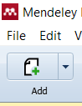
- Importing a citation via direct PDF import
  - Click the “Add” icon in the upper left, and select the PDF (or folder containing many PDFs so that you don’t have do it for each individual file) to add to your library (see right)
- At this point, you might need to manually correct/change/edit the automated import. Once the citation is correct, you shouldn’t need to do it again.

Cite while you write in Microsoft Word

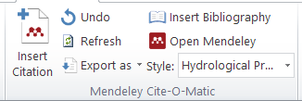
Locate the Mendeley Cite-O-Matic tool, likely under the References tab of the ribbon

- Adding an author, or multiple authors
  - Click on “Insert Citation” and either type the name/keywords your know, or click “go to Mendeley”
    - If you want to add a second (or more) reference to the same line, put your cursor in the citation and repeat the previous process
- Adding additional information to an in-text citation
  - If you need to add additional information (such as “see” or “page XX”) you can do this by clicking on the authors name within the citation

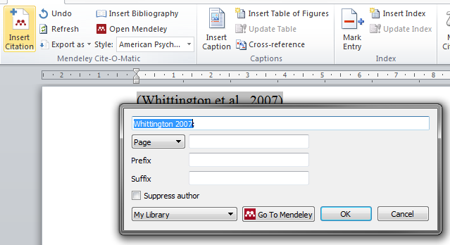
- Omit names so only the date is in brackets
  - Click the “Suppress author” box (see above)
- Create a reference list
  - Click on the “Insert Bibliography” button within the Mendeley Cite-O-Matic
  - In the “Style” box, select the journal that you wish to use

Space for notes:

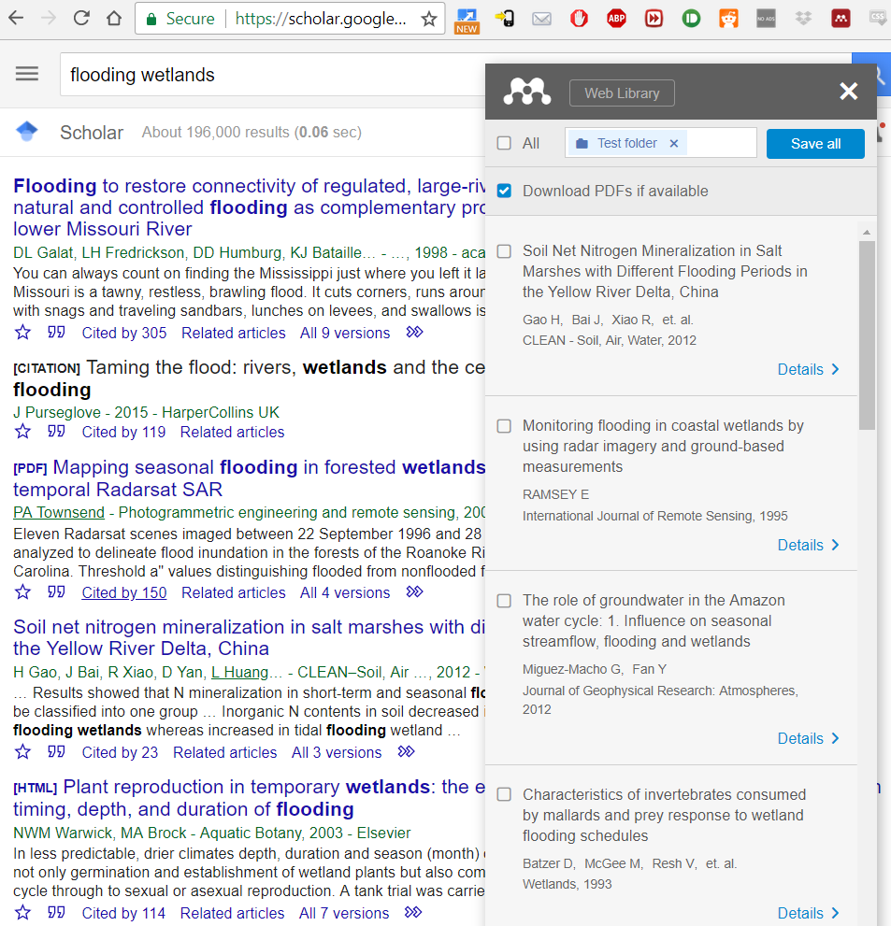

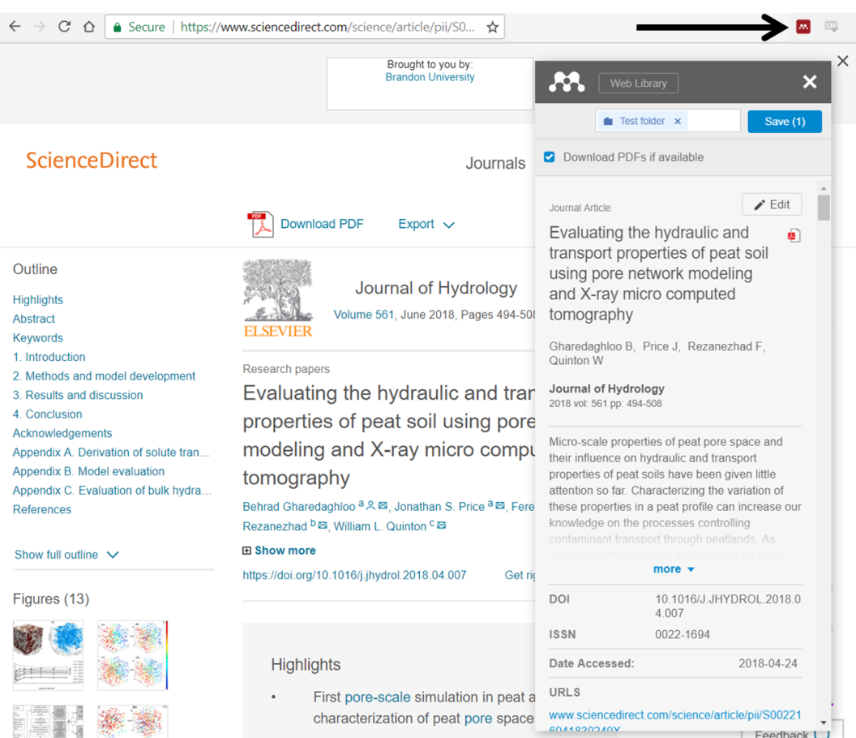
Examples of browser plugin (Chrome) with Google Scholar, and Science Direct

