FACULTY OF HEALTH STUDIES

Department of Psychiatric Nursing

270-18th Street Brandon, Manitoba R7A 6A9

B105-491 Portage Ave Winnipeg, Manitoba R3B 2E4

www.brandonu.ca

Sessional Instructor Orientation Manual

2019 – Revised by Lorna Canada-Vanegas Mesa, Andrea Thomson

2017 - Revised by Jan Marie Graham, Karen Clements, Karen Doty-Sweetnam, Nadine Smith

Contents
Department of Psychiatric Nursing 1
Welcome – Getting Started 2
About the Guide 2
Philosophical Framework 2
Preamble 2
Psychiatric Nursing Metaparadigm Concepts: 2
Mental Wellness 2
Who can help? 6
The Teaching and Resource Guide 7
Department of Psychiatric Nursing Staff and Faculty 8
The Psychiatric Nursing Programs 8
Department policies 8
ISMP’s List of Abbreviations, Symbols, and Dose Designations 9
Assignments, Evaluation and Marks 9
Certificate of Exemplary Student Support 9

Welcome – Getting Started

Welcome to Brandon University (BU), Faculty of Health Studies, Department of Psychiatric Nursing. We hope that you have an enriching and positive experience.

About the Guide

This guide provides information regarding the faculty and staff, curriculum, and policies that can be accessed through links to the BU website. Simply hold the control key while clicking the mouse to find detailed information.

Philosophical Framework

Preamble

Our philosophical framework is a guide for practice, scholarship, research, and education. This framework is a guide for curriculum development and a measure against which we can evaluate educational practice. Our philosophical beliefs form a framework upon which we can build and articulate a better understanding of psychiatric nursing practice and develop psychiatric nursing knowledge. Three constructs standout for scholarly development: wellness; relationship; and social justice. Our philosophical framework serves as a collective vision and aspiration. It also serves as a vehicle for open, respectful discussion and debate as we work together toward psychiatric nursing education and scholarship excellence.

Psychiatric Nursing Metaparadigm Concepts:
- Mental wellness
- Individuals, families, and communities
- Psychiatric nursing
  - Psychiatric Nursing Education
- Environment
- Relationship

Mental Wellness

Mental wellness is living a life one defines as meaningful, satisfying, and making a contribution within one’s community.

Mental wellness is possible for all. Individuals, families, and communities can experience mental wellness in the presence of illness, disability, disorder, or disease.

Psychiatric nurses, individuals, families, and communities have the knowledge, skills, and values to promote, achieve, and maintain health mental wellness, individually and collaboratively.

Mental wellness encompasses the whole (individual, family, or community) in integral interaction with their biological, psychological, social, spiritual, and environmental contexts.

Mental wellness is defined and constructed by individuals, families, and communities within the context of social relationships.

INDIVIDUAL, FAMILY, & COMMUNITY

We all share a common humanity.

Individuals, families, and communities have unique capacities, vulnerabilities, beliefs, and values.

Individuals, families, and communities are in a continuous process of learning and changing.

Every individual, family, and community needs supportive relationships with others, community, and the environment to achieve, regain, and maintain their self-determined health and mental wellness.

PSYCHIATRIC NURSING

Psychiatric nursing is a discipline with distinct sets of knowledge, skills, and values, as well as the capacity to produce research and generate knowledge distinct to the discipline.

Psychiatric nursing eclectically incorporates a range theoretical frameworks as appropriate to a variety of practice settings and the unique needs of individuals, families, and communities.

The distinct nature of the psychiatric nursing therapeutic relationship and the psychiatric nursing therapeutic use of self are fundamental to the discipline of psychiatric nursing.

Psychiatric nursing encompasses a unique combination of health, mental wellness and relationship expertise along with expertise in collaborative care within biomedical and psychiatric models.

The discipline of psychiatric nursing has specialized knowledge, skills, and values necessary for working collaboratively with individuals, families, and communities toward the promotion, achievement, and maintenance of health and mental wellness.

Psychiatric nursing advocates for the rights and resources necessary for the health and mental wellness of individuals, families, and communities.

Psychiatric nursing is a self-regulating profession that operates within a professional ethical framework and adheres to professional standards and legal requirements.

PSYCHIATRIC NURSING EDUCATION

Psychiatric nursing education develops entry level competencies, critical thinking skills, and leadership skills for use in:

  - Four domains of practice (clinical, education, administration, and research);
  - Advocacy for individuals, families, communities;
  - System and social change;
  - Protecting the welfare of the public;
  - Promoting and advancing health and mental/wellness.

Psychiatric nursing education prepares students for value-based, person-centred, empowerment promoting, recovery oriented psychiatric nursing practice directly applicable to and learned within interaction with individuals, families, and communities in practice settings.

Psychiatric nursing education assists in the personal growth and development of students, building self-awareness and adaptability based on the uniqueness of each student.

Psychiatric nursing education collaborates with students to build skills for life long learning in order to support continued development of knowledge and skills as required throughout their psychiatric nursing careers.

Psychiatric nursing education is a collaborative process involving various parties, each with specific roles and responsibilities (e.g., students, faculty, university, community).

Psychiatric nursing education is guided by a professional and personal ethics, social awareness, and social responsibility.

As psychiatric nursing educators we model good psychiatric nursing practice— therapeutic use of self, therapeutic relationship, therapeutic milieu, person-centred approach, and healthy self-care—as appropriate to an education context while working with our students and each other.

Psychiatric nursing education includes creating and maintaining a safe working and learning environment.

ENVIRONMENT

The health and mental wellness of individuals, families, and communities are dependent upon unique, complex relationships with social and natural environments.

The environment itself can be therapeutic, including human constructed, social, and natural environments.

Psychiatric nurses and psychiatric nurse educators have a responsibility to maintain environments that are safe, respectful, and promote health and mental wellness.

The social determinants of health and issues of social justice and power must be considered and addressed within all relationships and situations.

Psychiatric nurses and psychiatric nurse educators have responsibilities and obligations toward the care and health of natural and social environments.

RELATIONSHIP

Everything is in relationship. There is no thing, person, or idea that exists outside of relationship.

Psychiatric nurses and psychiatric nurse educators understand all knowledge, skills, beliefs, and practices through the lens of relationships.

The overarching ‘relationship’ in the diagram below does not represent the ‘therapeutic relationship’. Beliefs about the therapeutic relationship are contained within the concept of ‘psychiatric nursing’.

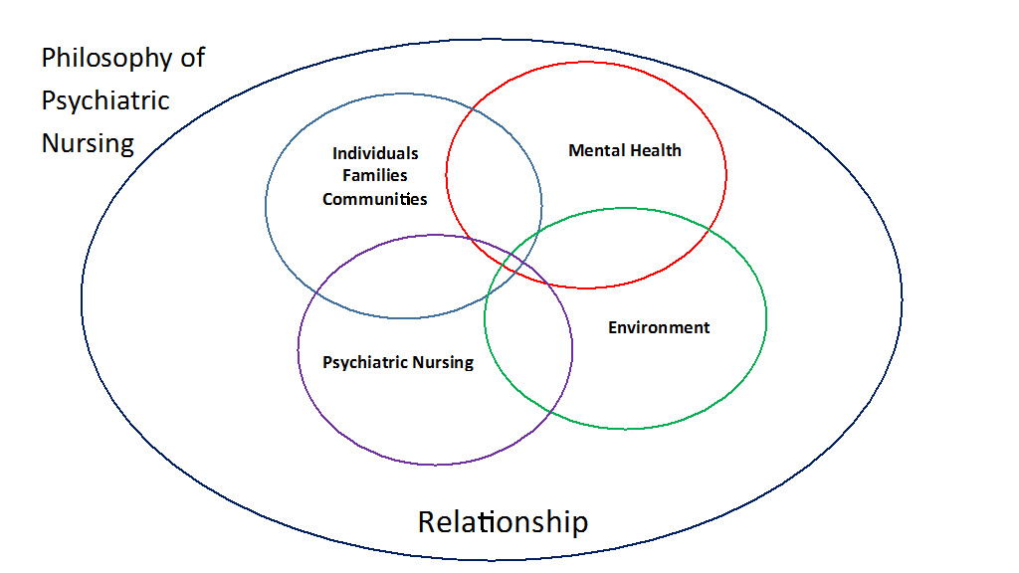

Who can help?
- Dr. John Moraros, Dean of the Faculty of Health Studies.
Tel: 204-727-7456, Email: morarosJ@brandonu.ca
Dr. Moraros can assist with any issues or questions related to your contract.
- Michelle McFarlin provides administrative support to Dr. Moraros.
Tel: 204-727-7459, Email: mcfarlinm@brandonu.ca
- Lorna Canada Vanegas-Mesa, Department Chair Tel: 204-571-8559, Email: canadal@brandonu.ca

Office assistants at the Brandon and Winnipeg campus will assist with obtaining keys, accessing the Sessional Office, setting up an email account, photocopying and obtaining a nametag.
- Brandon Campus: Amber Barbeau
Tel: 204-727-7409, Email: barbeaua@brandonu.ca
- Winnipeg Campus: Joy Henault
Tel: 204-772-0377, Email: henaultj@brandonu.ca

In addition, various faculty hold roles to support students and arrange clinical and practicum placements within the BScPN program.

Brandon Campus
- Michelle Hood, Student Advisor
Tel: 204-727-7403, Email: hoodm@brandonu.ca
- Jacquelyn Pentney, Clinical Placement Coordinator
Tel: 204-727-9601, Email: pentneyj@brandonu.ca

Winnipeg Campus
- Melanie Gessell, Student Advisor
Tel: 204-772-0377, Ext. 884, Email: gessellm@brandonu.ca
- Betty Wedgewood, Clinical Placement Coordinator and Instructional Associate
Tel: (204) 772-0377, Ext. 890, Email: wedgewoodb@brandonu.ca

Online Supports:
The Helpdesk provides first level support for technology related questions.
- Email: helpdesk@brandonu.ca
- Tel: On campus, extension 500. Off campus, 204-571-8500.
- Hours: Monday to Friday 08:30 to 16:30

Moodle:
Many instructors use Moodle to enhance their teaching and to address diverse student needs. Moodle websites help you manage courses. You can share your syllabus (course outline), course information, accept assignments online, post grades, engage in online discussions, and other learning activities.
- Glen Gross, Moodle Administrator
Tel: 204-727-9781, Email: grossg@brandonu.ca

The Teaching and Resource Guide

The Teaching and Resource Guide includes important information regarding resources, processes and policies that support teaching. The answers to many frequently asked questions may be located within this guide.

https://www.brandonu.ca/ctlt/teaching-resource-guide/

Examples of information found in the guide include:
- Using Moodle
- Planning Courses
- Academic Integrity
- Accessibility and Accommodation
- Submitting Final Grades
- Helpful Links
- Assistances with IT.

Department of Psychiatric Nursing Staff and Faculty

For a complete list of current staff and faculty, https://www.brandonu.ca/health- studies/faculty-and-staff/.

The Psychiatric Nursing Programs

The department offers an entry level Bachelor of Science in Psychiatric Nursing (BScPN) and a Master of Psychiatric Nursing (MPN). The curriculum and courses are available in the Brandon University Calendar https://www.brandonu.ca/calendar/

Department Policies

Department policies are available through the following link. https://www.brandonu.ca/health-studies/programs/bscpn/b-sc-p-n-policies/

Policies are revised and updated on an ongoing basis. Please review the BScPN student policies.

In circumstances where a student is experiencing difficulty in clinical and/or lab settings a Performance Improvement Plan (PIP) may be utilized. A PIP is a is a template used to identify areas for improvement and strategies to address areas for improvement. Please review the Students Experiencing Difficulty in Clinical/Lab Settings Policy and speak with the Course Leader in regards to initiating a PIP.

ISMP’s List of Abbreviations, Symbols, and Dose Designations

To view the list please visit:
https://www.brandonu.ca/health-studies/files/2017/07/errorproneabbreviations.pdf

Assignments, Evaluation and Marks

Sessional Instructors may be required to mark assignments related to the clinical course and evaluate student progress at mid-term and end of term.

If you are teaching a lab or clinical, the Course Leader will provide a copy of the course syllabus, discuss and review assignments, marking guidelines, clinical evaluations, and any other course requirements. The syllabus provides a description of any assignments and due dates. The Course Leader will provide a rubric, matrix, or marking template and will be available to meet with you to discuss the assignment, marking, and expectations. Student performance in the clinical setting is evaluated using a standardized Clinical Evaluation Form.

Sessional Instructors who are employed as the Course Leader are encouraged to review the resources provided within the Teaching Resource Guide in regards to finalizing a Course Syllabus, creating assignment rubrics, and submitting a final grade. https://www.brandonu.ca/ctlt/teaching-resource-guide/

Certificate of Exemplary Student Support

The Department of Psychiatric Nursing values clinical staff (e.g. RPNs, RNs, Mental Health Workers, Social Workers, etc.) who support the education of BScPN students and wishes to acknowledge their contribution by awarding a Certificate of Appreciation for that support. This Certificate is distinct from the Champion of Student Learning Award which is for preceptors.

Front-line clinical staff members who are eligible for nomination of this Certificate are learner-centred, challenge the students to think critically, supportive to students, and exemplify excellence in client care.

For more information please visit:
https://www.brandonu.ca/health-studies/files/2017/07/Exemplary-Support-for-Students-Narrative.pdf

