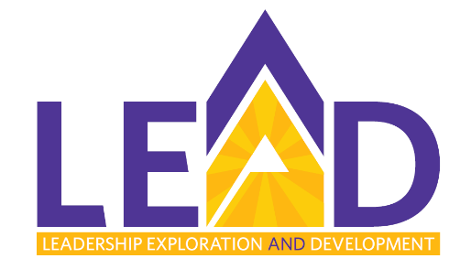

LEAD at Brandon University
Call for Nominations
Brandon University (BU) and Assiniboine Community College (ACC) are excited to once again be offering the LEAD program and are currently seeking nominations. The LEAD program is a shared, internal leadership development program that aims to provide new and existing leaders an opportunity to build their leadership capacity and prepare high potential individuals for positions of increasing responsibility and leadership.
Nominee Profile
Eight individuals will be selected from both BU and ACC, for a total of 16 participants. Participants will be required to make a commitment to all components of the program including completion of the Myers-Briggs Type Indicator (MBTI) and LEAD 360° questionnaires, retreat and workshop participation, pre-readings or preparation for each workshop (maximum of 30 minutes), and capstone activity.
The ideal candidate for the LEAD program will be a(n):
Existing Leader
- Interested in building on their existing leadership knowledge, skills, and aptitude for leading self and others

New Leader
- Hired or promoted into a leadership role at BU
- Seeking to build their knowledge, skills, and aptitude for leading self and others in the context of BU
High Potential Employee
- With a track record for being a strong performer with the aptitude to lead others (performance AND leadership potential are both strong)
- Who aspires to a leadership position
- Endorsed by senior leadership for participation in the LEAD program
Nomination Process & Timelines
- Nominations are invited from members of the President’s Advisory Council (PAC).
- The deadline for nominations is Wednesday, June 8, 2022.
- Nominations are submitted in the form of a completed LEAD 2022-2023 Participant Nomination Form (next page)
- Completed forms are sent to:
Erica Brown, Learning & Organizational Development Program Manager
Room 316, Clark Hall – Brandon University
browne@brandonu.ca
- Nominations will be reviewed by the President’s Executive Council for final determination. Those who put forward nominations will be notified of the successful candidates no later than June 24, 2022.

LEAD 2022-2023
Participant Nomination Form

To nominate an individual for the LEAD program, please complete Sections 1 – 3 below and submit the completed form to Erica Brown at browne@brandonu.ca or Room 316, Clark Hall by Wednesday, June 8, 2022.

1. Nominee Profile
Name of Nominee:
Position Title:
Current Faculty/Department:
Email:

2. Sponsor Profile
Your Name:
Position Title:
Email:

3. Sponsor’s Words of Support for Nomination
In a paragraph or two, provide your insights into why this individual would be an ideal candidate for the LEAD program.

