PSAC (Public Service Alliance of Canada) Posting Procedures

Vacancy Posting Procedure

A PSAC student vacancy template can be found on the Human Resources website at http://www.brandonu.ca/hr/forms/ . As per Article 11.03 all vacancies will need to include the following information: date of posting, job title, classification, job duties (*be sure to include the wording “and other related duties as assigned”*), required qualifications, title and course number (where applicable), estimate of the number of positions available, hours of work, estimated total hours of work per appointment, application deadline and procedure for submitting applications, starting date, salary, hiring department, length of appointment, indication that it is a unionized position and the bargaining agent is PSAC, and the University’s Employment Equity statement. Remember all vacancies need to be posted for a minimum of 7 calendar days.

Email the draft posting to Human Resources before distributing it for verifying the posting contains all the necessary information. You can email the posting to cruisea@brandonu.ca. Once verified, you can continue with the printing and distribution of the posting.

Hard copies of the vacancy are to be copied on goldenrod paper and distributed to designated areas on campus. A Distribution Contact List can be found on the website address listed above. The vacancy will need to be posted to the Brandon University website.

Posting to Brandon University Website

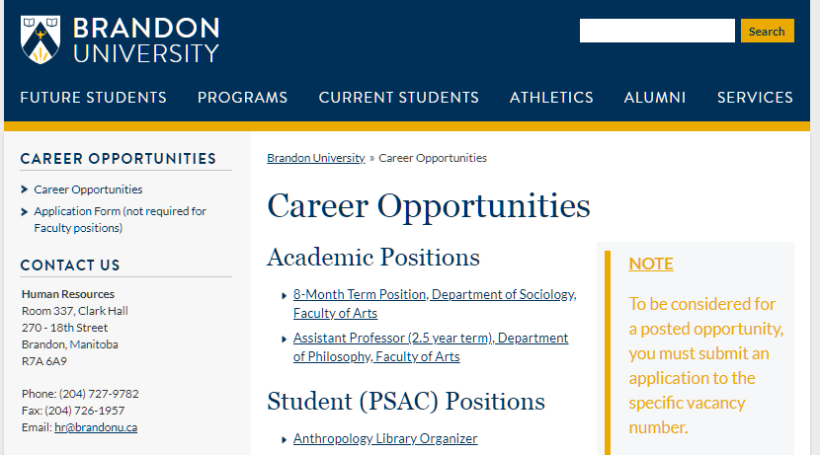

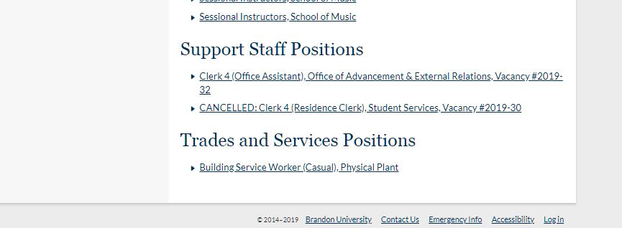

Go to the Career Opportunities page at https://www.brandonu.ca/jobs/ and click on Log in found at the bottom right corner. Sign in using your network username and password. Contact HR if you cannot log in as your access may not be activated.

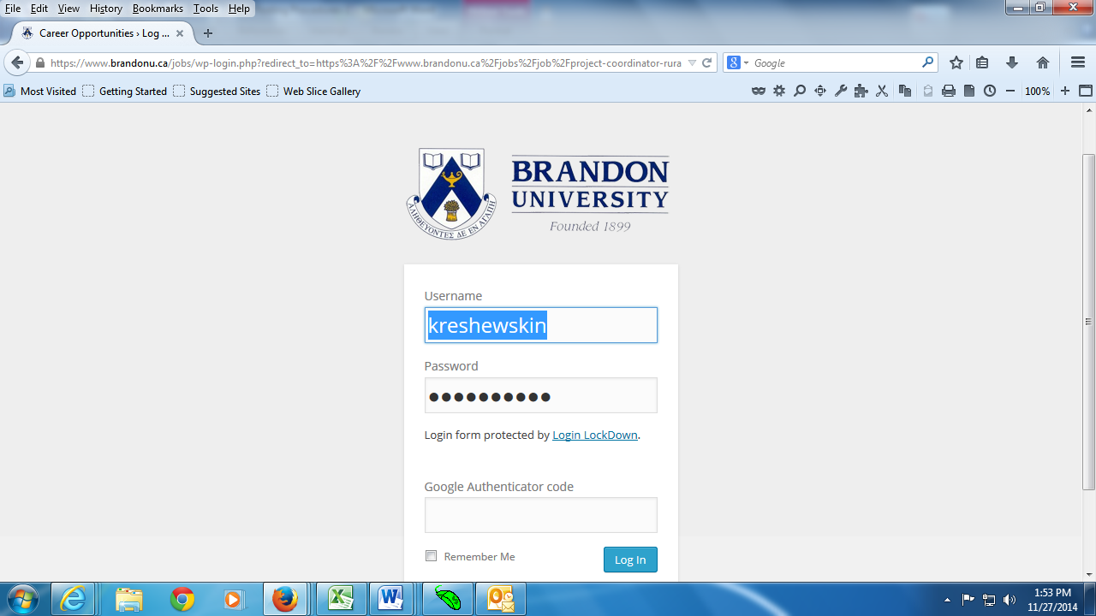

Once logged in, on the left side under Admin Tools, Click on Edit this Page

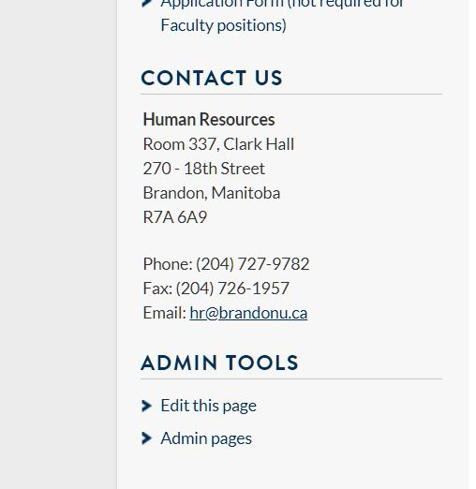

Under Jobs, click on the Add New button

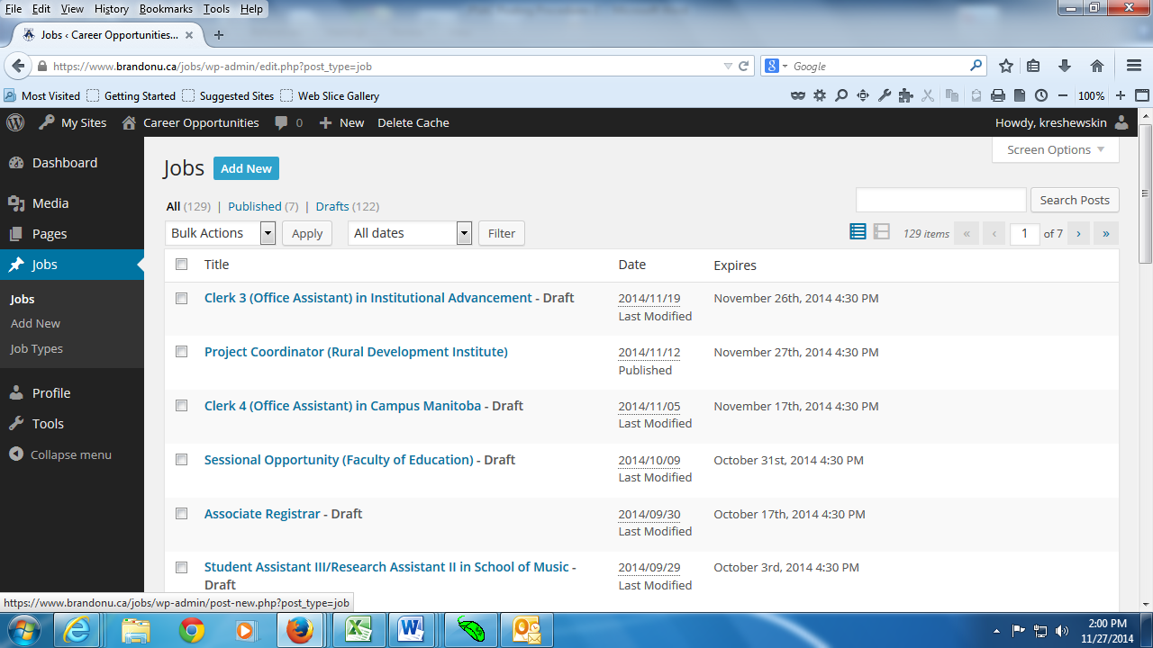

Add your title and cut and paste your vacancy information into the blank box.

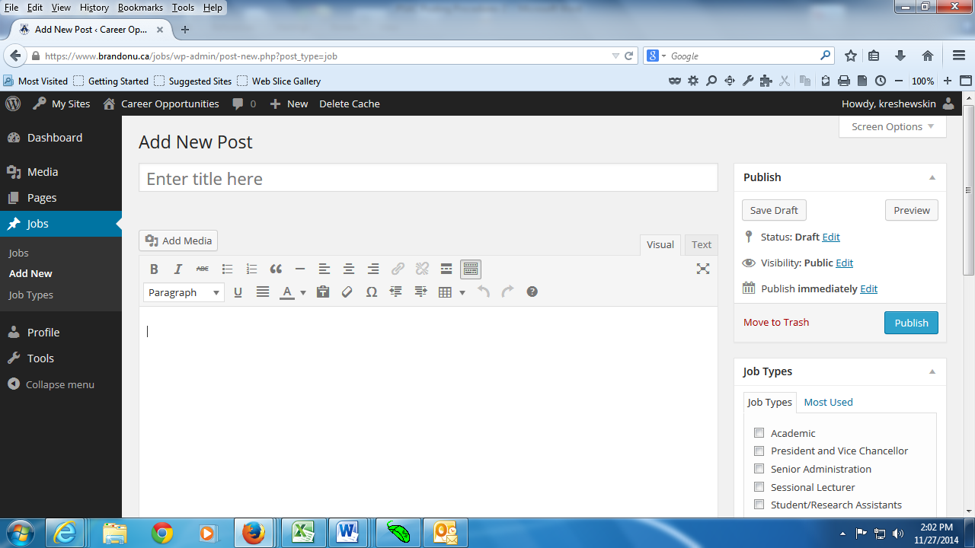

Check the Student (PSAC) box

Beneath Job Types, you will find Post Expirator. Indicate that you want to Enable Post Expiration on the closing date at 4:30pm/16:30hrs and leave it to expire in Draft format.
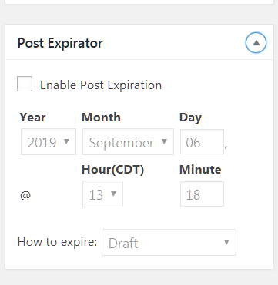

Click on the Publish button to complete this process. You can now click the Preview button to view your vacancy. You can toggle back and forth to make changes. Any time you edit your work, remember to click on the Publish button so your changes go live.

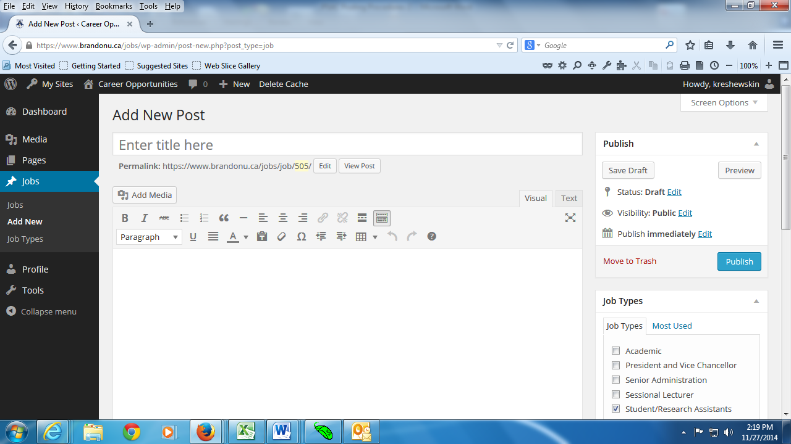

How Do I set up an employee on EmpCenter?
Box #1 of a payroll information time sheet will need to be completed, signed appropriately and forwarded onto Payroll who will set up the employee on EmpCenter as well as the delegation so hiring supervisors can have access to the employee’s time sheet.

How do I log onto EmpCenter?
Students will be able to log onto EmpCenter using their student email and password. If you are not a registered student, Payroll will work with Information Technology Services to have an account created for the employee. This information will be shared with the hiring supervisor.
The hiring supervisor will use their Novell username and password to log onto EmpCenter.

