BU Centre for Aboriginal & Rural Education Studies
  - Book Collection – Indigenous Stories and Research
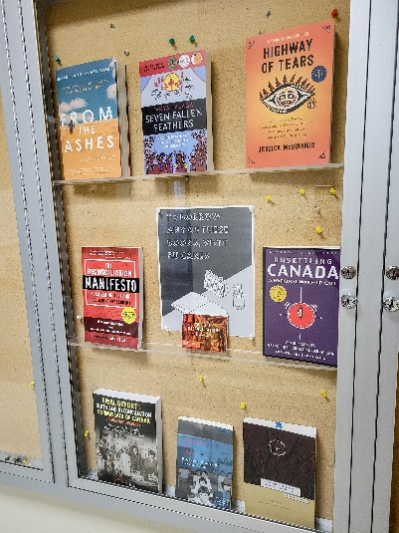 | - From the Ashes: My Story of Being Métis, Homeless, and Finding My Way by Jesse Thistle  - Seven Fallen Feathers by Tanya Talaga  - Highway of Tears by Jessica McDiarmid  - The Reconciliation Manifesto: Recovering the Land, Rebuilding the Economy by Arthur Manual & Grand Chief Ronald M. Derrickson  - Unsettling the Land: A National Wake-up Call by Arthur Manual & Grand Chief Ronald M. Derrickson with Forward from Naomi Klien  - Final Report: Truth & Reconciliation Commission of Canada (Volume 1) from Truth & Reconciliation Commission of Canada  - Speaking My Truth: Reflections on Reconciliation & Residential School from Aboriginal Healing Foundation
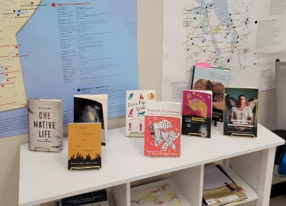 | - One Native Life by Richard Wagamese  - Lifting Hearts Off The Ground: Declaring Indigenous Rights in Poetry by Lyla June Johnston & Joy De Vito  - Peace Pipe Dreams: The Truth about Lies About Indians by Darrell Dennis  - Research Is Ceremony: Indigenous Research Methods by Shawn Wilson  - Decolonizing Methodologies by Linda Tuhiwai Smith  - Indigenous Men and Masculinities by Robert Alexander Innes and Kim Anderson  - Handbook of Critical and Indigenous Methodologies by Norman Denzin, Yvonna Lincoln and Linda Tuhiwai Smith  - Shifting our Focus to Anti-Oppressive Education by Chris Brown

