
INTENT TO SMUDGE
NOTICE

A smudging ceremony will be taking place in this area today from:
[start time] to [end time]
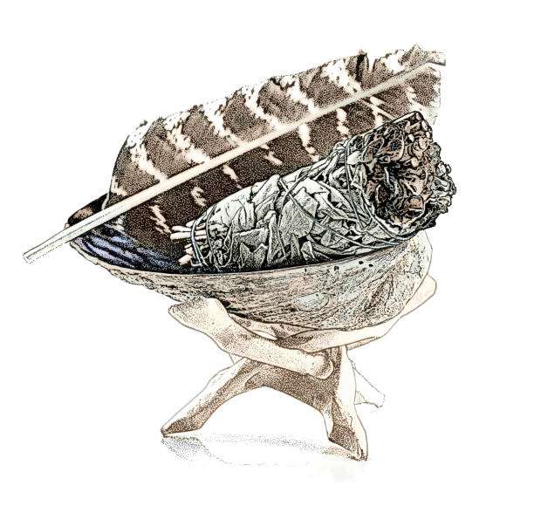

Smudging is a tradition in many Indigenous cultures, which involves the burning of one or more of the four sacred medicines (sage, cedar, sweetgrass, and tobacco.)

As per Brandon University’s Guidelines for Indoor Indigenous Ceremonies Policy, Brandon University recognizes smudging, pipe ceremonies, and kullik burning as an integral part of Indigenous peoples’ way of life. As such, they are permitted on campus.
Note: Under the Province of Manitoba’s The Non-Smokers Health Protection and Vapour Products Act, smudging and the use of tobacco in pipe ceremonies indoor are permitted.

