Faculty of Education Graduate Studies Program

07:755 (GRED 7013) Practicum in Community-Based Research

Course Description

Pre-requisites: 07.714 Introduction to Educational Research Methodologies OR permission of the Chair of Graduate Studies, and availability of a BU faculty supervisor.
This practicum component is designed to provide graduate students with experience in and theoretical understandings of community-based research through participation in ongoing research within the Faculty of Education and/or the Centre for Aboriginal and Rural Education
Studies (CARES). The experience is intended to allow the student the opportunity to explore research in applied settings.
More about this course (excerpted from Faculty of Education Practicum Guidelines)
The purpose of the Practicum is to provide opportunities for the student to integrate theoretical frameworks discussed in class and practical experience in a field-related site. Students in a practicum benefit most when they are engaged in roles that they aspire to in their career advancement. Normally, the Practicum involves 72 contact hours at the field site and is supervised by a person at the site and a supervisor from the University. Students who register for the Practicum will have completed all or most of the required courses in their specialization area.

This course is intended to provide educators in our graduate program the opportunity to become involved with community-based research as a way to apply the knowledge and theory they are learning within a research placement. Most of the research conducted by faculty members within the Faculty of Education can be considered community-based, as it happens in schools and organizations in order to benefit the community. Community-based research uses multiple methodologies, and builds on and applies knowledge students have gained from their coursework. This course offers thesis students the necessary preparation to see the application of research within their professional fields and offers both course-based and thesis-route students the knowledge and skills to conduct research individually and collaboratively within professional contexts. Examples of how a practicum in community-based research can be structured are included in Appendix A.

Foundational Learning Outcomes/ Essential Learning
The foundational learning outcomes/essential learning for this course are largely determined by the student in consultation with their Faculty Supervisor and/or Field Supervisor. In general objectives include, but not limited to:

- Reading and research into an area of interest in the area of specialization.

- Application of learning from the core courses in the specialization to a community-based research project.

General Description of the Practicum

Practicum Procedure

- The student notifies the Graduate Studies Office of their intent to register for the Practicum in Community-Based Research course, and is provided with a Practicum Supervision Form. The student should then meet with the Graduate Studies Chair to discuss the practicum and to identify potential Faculty Supervisor(s).

- The Graduate Studies Chair will approach potential supervisors to determine if they would be willing and interested to supervise the practicum. The practicum request will then be scheduled for discussion at the next GEC meeting. At that time, GEC will be asked to approve the practicum and identify the practicum supervisor. Note that any practicum is dependent on finding a suitable Faculty Supervisor. In some cases, the Faculty Supervisor and the Field Supervisor roles may be filled by the same person.

- The Faculty Supervisor will normally approve the practicum placement if the following conditions are met:
  - The student can demonstrate that they will be able to acquire the minimum of 72 hours of contact time.
  - A suitable Field Supervisor can be identified who will be willing and able to mentor the student and maintain contact with the Faculty Supervisor on a regular basis during the Practicum. A Field Supervisor with at least a Master’s Degree is preferable, but not required.

- The student, the Faculty Supervisor, and, if desired, the Field Supervisor will meet together before the start of the Practicum to discuss individual responsibilities and expectations related to the practicum including the frequency of progress reports and final assessment process. This meeting can take place face to face or by email, telephone, video conference, etc. At the end of this meeting, the Practicum Supervision form is completed and signed. This form represents a contractual agreement between the three (or more) parties.
- The student, in consultation with the Faculty and Field Supervisor, will develop goals for the practicum using the Goals of the Practicum form. This form will indicate overall goals, procedures and outcomes and will be discussed with the Field Supervisor and the Faculty Supervisor, to ensure three-way understanding and agreement before the practicum begins.

- The student is expected to keep a weekly log book/ reflective journal and will be in regular contact with the Faculty Supervisor.

- The Faculty Supervisor will submit a final grade of Pass / Fail when all requirements of the practicum have been completed.

- See Appendix B for a visual representation of CBR practicum procedures. See Appendix C for a description of the role of BU CARES in the CBR Practicum.

Required Elements to Begin the Field Practicum

- Course Work: Students typically will have successfully completed 07:714 or equivalent in the graduate program.

- Code of Professional Conduct: Prior to the start of the practicum, the student and the Faculty Supervisor will have an opportunity to review any relevant guidelines for professional conduct and confidentiality, for example the BUREC protocol. Disclosure of confidential information obtained during the practicum experience, except as outlined in the pledge of confidentiality or required by law or agency policy, will result in immediate termination of the practicum. In the event that the student is outside of an agency that scrutinizes past criminal and abuse registration, students may be required to submit a criminal record check and a child abuse registry check that indicates no past wrongdoing.

Practicum Roles and Responsibilities

The student’s responsibilities shall include:

- Developing a set of goals for the practicum that can be discussed with the Faculty Advisor and the Field Supervisor.
- Working through the practicum as a professional commitment.
- Completing the necessary documentation to qualify for participation in practicum (where applicable).
- Taking direction from the Field Supervisor on all aspects of the practicum.
- Consulting on a regular basis with the Faculty Supervisor.
- Completing a log that documents the required hours (72) and details the professional activities on a regular basis.
- Completing research outcomes as agreed upon by the team.
- Acting in accordance with the professional guidelines as set out in the context in which the practicum takes place.
- Acting in accordance with school / agency policy, legislation, and research protocols and regulations at all times.
- Providing the Field Supervisor and Faculty Supervisor with access to log book/ reflective journal at regular intervals to serve as a basis for ongoing assessment of progress.
- Meeting with the Faculty Supervisor at the conclusion of the practicum to discuss goals
attainment and final evaluation.

The faculty advisor’s responsibilities shall include:

- Meeting with the student before the start of the practicum to discuss goals, scheduling, and agency/school requirements for the practicum.
- Consulting on a regular basis with the Field Supervisor.
- Providing regular feedback, consultation and assistance to the student.
- Evaluating progress throughout the practicum, completing a summative evaluation at the end of the placement, and submitting a final grade to the Graduate Studies Office.
- Terminating the practicum if, at any time, circumstances warrant this measure.

The field supervisor’s responsibilities shall include:

- Orienting the practicum student to the policies and procedures of the school / school division / agency;
- Providing opportunities for practicum students to develop skills through participation in the range of roles and functions that are common to the expectations as set out in the practicum plan.
- Providing continuous feedback to the student on their progress.
- Raise any concerns regarding the practicum to the Faculty Supervisor.
- To provide confirmation to the Faculty Supervisor that the hours have been completed.

Course Assignments
One portion of the course assignment is a journal or learning log. The structure and format of final assignment(s) for the practicum will be determined by the student and Faculty Supervisor when the practicum is set up and the supervision form is signed, but may result in knowledge mobilization activities.

Course Grade

Practicum courses are grades on a Pass/Fail basis.
Academic dishonesty will result in a final grade of F-AD (Fail-Academic Dishonesty)
(refer to the Graduate Calendar, section 3.9: Academic Dishonesty and Misconduct)

Statement on Accommodation

Brandon University values diversity and inclusion, recognizing disability as an aspect of diversity. Our shared goal is to create learning environments that are accessible, equitable, and inclusive for all students. The Student Accessibility Services (SAS) office works with students who have permanent, chronic, or temporary disabilities. SAS will provide and/or arrange reasonable accommodations. If you have, or think you may have, a disability (e.g. mental health, attentional, learning, vision, hearing, physical, medical, or temporary), you are invited to contact Student Accessibility Services to arrange a confidential discussion at (204) 727-9759 or
email malyonm@brandonu.ca. If you are registered with SAS and have a letter requesting accommodations, you are encouraged to contact the instructor early in the term to discuss the accommodations outline in your letter. Additional information is available at the Student Accessibility Services website.

Personal Counselling Support

Positive well-being is highly correlated to learning and student success. Wellness is a combination of physical, social, spiritual and mental health. Personal Counsellors at Brandon University are dedicated to providing support to students’ wellness, primarily their mental well- being, through prevention activities, early identification and timely interventions using a holistic lens.
Please contact the Personal Counsellors in the Student Services Department at 204-727-9737 or visit Room 102 A.E. McKenzie Building to make an appointment. There are crisis counselling appointments available daily.

If you believe that you or someone else is in imminent danger of harm call 911.
Sexualized Violence Education and Prevention Coordinator: 204-727-7498 24 hour crisis supports:
Over 18 years of age: Under 18 years of age:
Mobile Crisis Unit Child and Adolescent Treatment Centre
204-725-4411 204-578-2700
Klinic Sexual Assault Crisis Line: 1-888-292-7565

Practicum Supervision Forms can be found on the Graduate Studies website.

Appendix A: Examples of CBR Practicum Structures

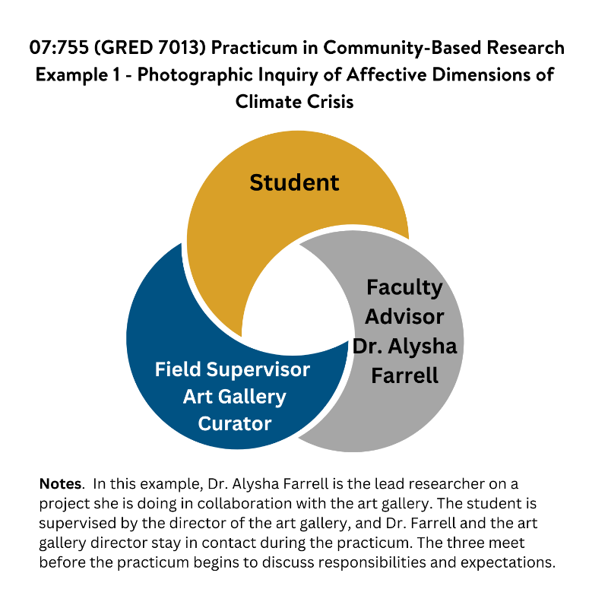
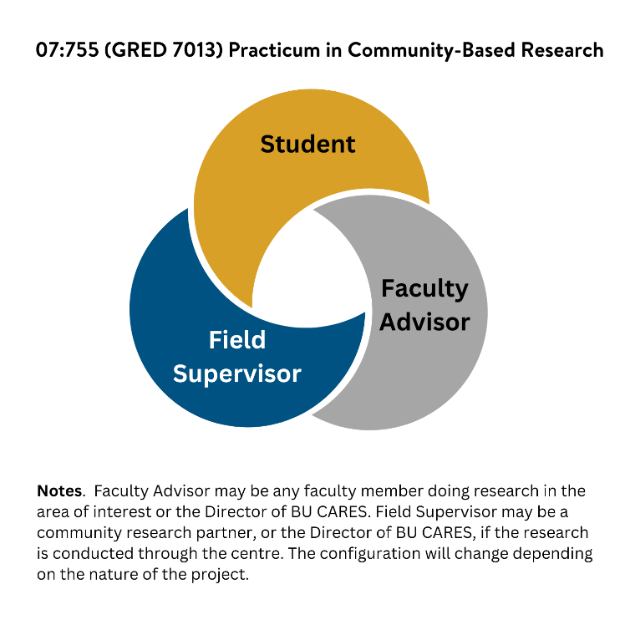
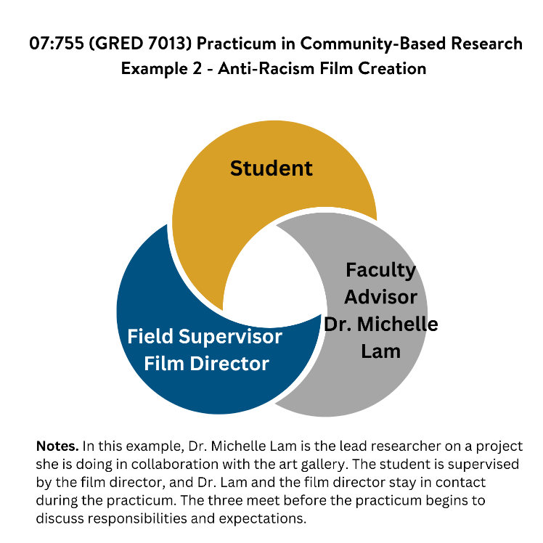
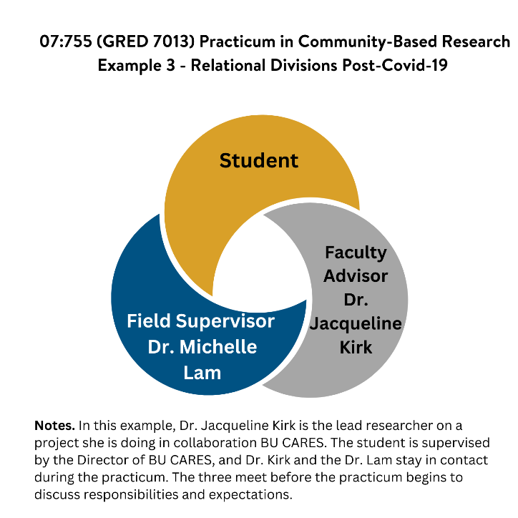

Appendix B: Flowchart for CBR Practicum Procedures

The full procedures for a community-based practicum are detailed on pages 2-3 above. However, the following visualization may be helpful:

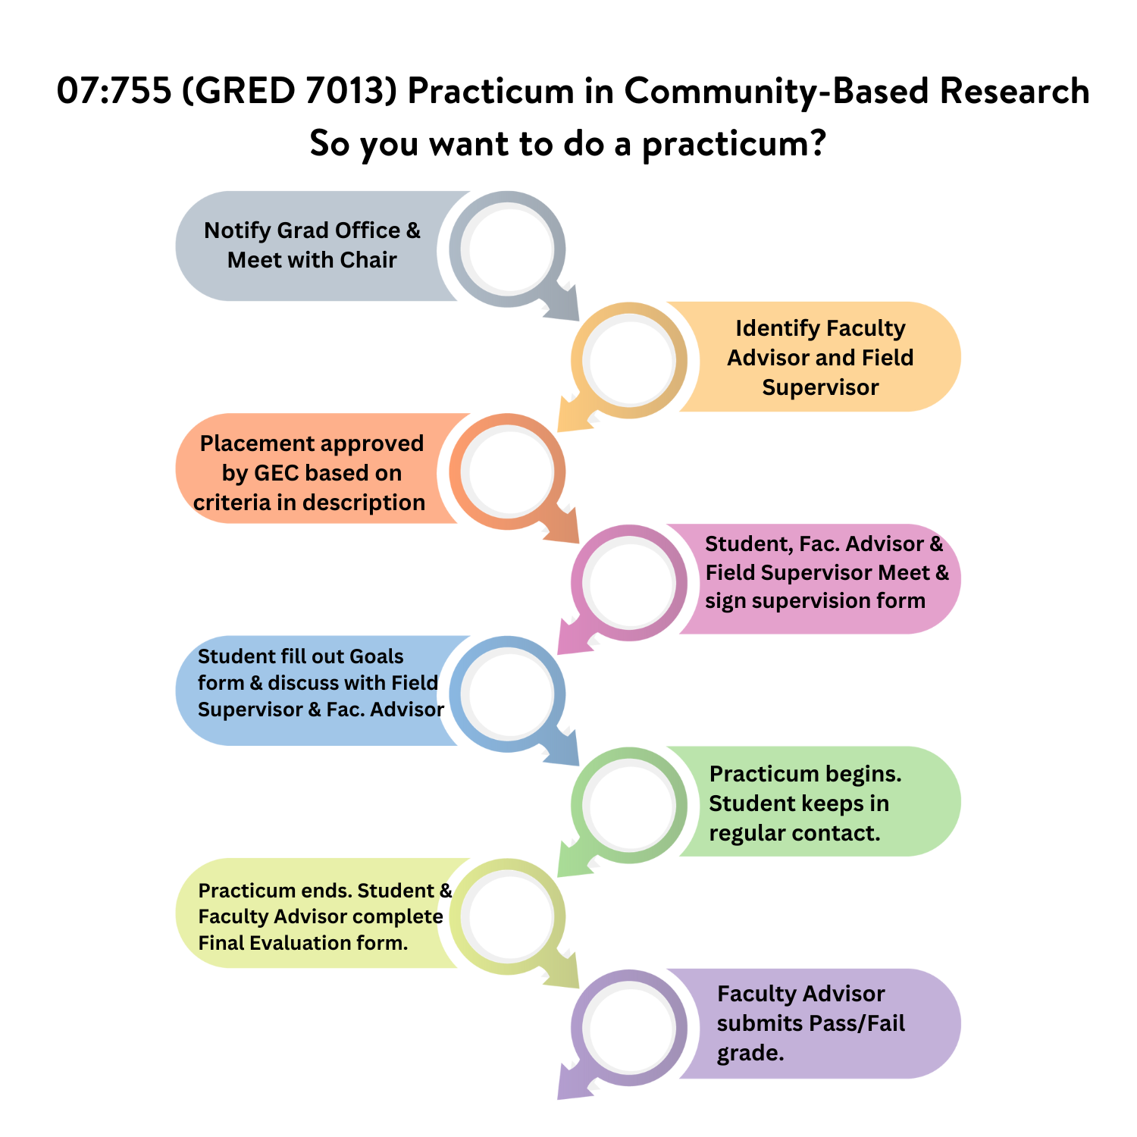

Appendix C: The Role of BU CARES in Supporting CBR Practicum Placements

BU CARES is an applied research centre established in 2008 and housed in the Faculty of Education at Brandon University. BU CARES helps identify and answer research questions generated collaboratively with community partners, develop faculty and graduate student research capacity, facilitate connections between university researchers and community members, and promote research related to rural and Indigenous education.

For your practicum, the role of BU CARES will depend on the nature of the project. When the project is run through the Centre, the Director or other personnel in the Centre may be directly supervising either as Faculty Advisors or Field Supervisors. If there are multiple students conducting practicums at the same time, BU CARES may become a place for students to meet and discuss learning together. BU CARES may also organize a forum for knowledge mobilization or may include practicum students in ongoing podcasts, newsletters, social media, website, or speaker series. The Centre may display posters, infographics, or other visuals produced by practicum students in the Centre and/or on the website and social media streams.

For more information about current projects being run through the centre, please visit: www.bucares.ca.

