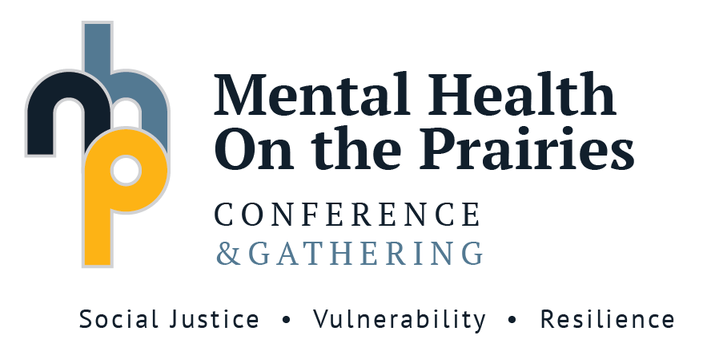
April 29 – May 1, 2020
Brandon University, Brandon,
Manitoba, Canada

PRESENTATION SPECIFICS

PRESENTER(s):
Name:
Title:
Organization:
Email:
Phone:

ADDITIONAL AUTHORS:

SUBMISSION:
Title:

Type (please choose one):
Oral
20 minutes
40 minutes
Symposium (80 minutes)
Display board presentation
Other (please specify):

Relevant Conference Themes (check those that are relevant for your presentation):
Living better: mental health and addictions
Furthering the goals of the Truth and Reconciliation Commission and decolonizing mental health practices
Creating systems that support care and self-care
Working with diverse communities

Presentation Outline (250-300 words)
The abstracts and presentation outlines review committee is a multidisciplinary team. Please ensure that the outline is written using comprehensible terms for all disciplines.

For symposium: submit a summary of the symposium based on the theme.

Please answer the following guide questions in your summary:
- What do people need to know?
- Why is this presentation important?
- How can this presentation be used?

Biographical Statement (50-75 words per author)

Presentation outlines are to be submitted by NOVEMBER 1, 2019 (Extended Deadline) by email to PrairieHealthConference@brandonu.ca
Abstracts/Presentation Outlines Reviewing:
If you are willing to complete a blind review of Abstracts/Presentation Outlines for this conference, please fill in the following items:
Willing to review Conference Abstracts/Presentation Outlines:
Yes
No

If yes, which of the following themes best fit with your areas of expertise (choose all that apply):
Living better: mental health and addictions
Furthering the goals of the Truth and Reconciliation Commission and decolonizing mental health practices
Creating systems that support care and self-care
Working with diverse communities

For more information, please visit the conference website at Brandonu.ca/mhp/

