Word Set-up Recommendations for Using Bid Templates and Documents

File>Options
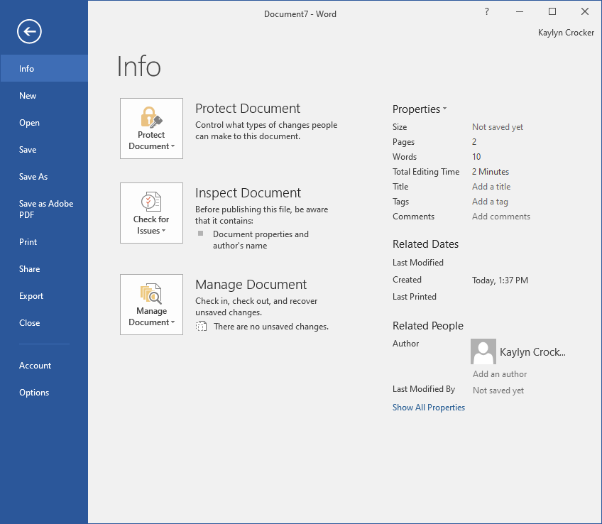

Select Display > Always show these formatting marks on the screen >Show all formatting marks
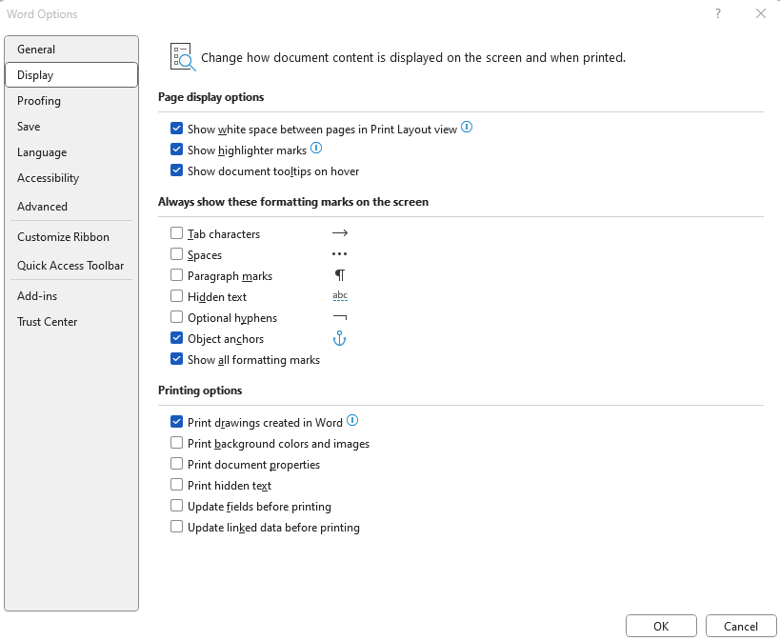

Select Advance > Editing Options >Typing replaces selected text
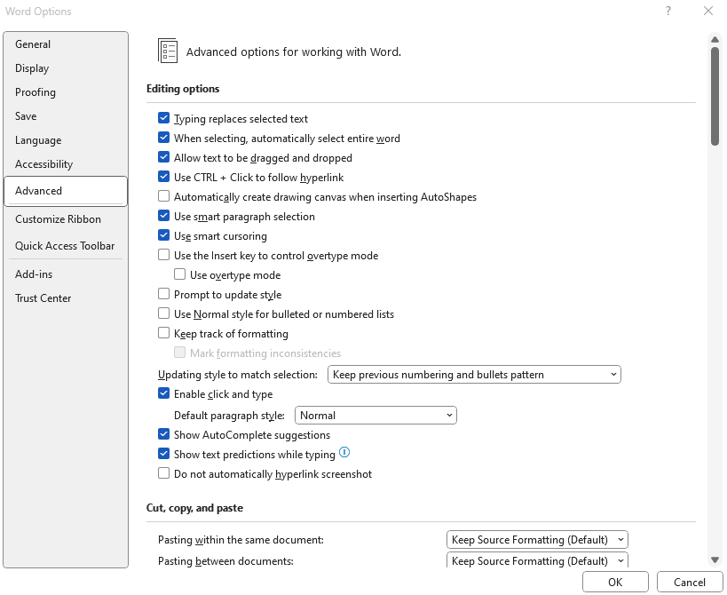

Advanced > Show document control > Show bookmarks & Field shading: Always

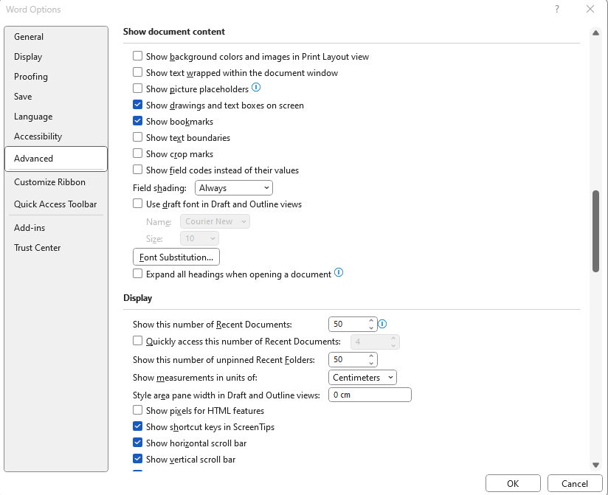

Table Tools Setup
Click inside any table to access Table Tools (table included below for set-up purposes)
Table Tools > Layout > View Gridlines
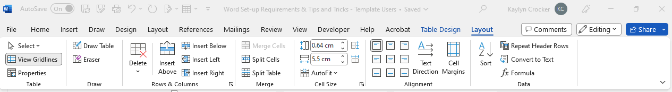

- GENERAL INFORMATION FOR USING BID DOCUMENT TEMPLATES
- The template is saved as a Word Template (.dotx). Do not change or alter any Templates (.dotx). Double-click the .dotx file to open the document as a .dot file.
- Do not delete Section Breaks in the documents unless it is the end of the document.
- Do not use Page Layout to format pages; this may change settings for the whole document or insert Section Breaks.
- If you need to start information on a new page, do not use returns to get to the next page. Use a page break (Ctrl + Enter).
- Do not delete any Bookmark indicator brackets [ ] that may be in the document; they will not print unless selected in Print options.

- PREPARING THE BID SOLICITATION DOCUMENT
- Double click to open the template as a document. Do not right-click and select “Open” for .dotx documents.
- Save As a document under a new name.
- Toggle Paragraph ¶ (Show/Hide) to show paragraph marks and other hidden formatting symbols. Until you are familiar with the formatting of the template(s), it is strongly recommended you work in the document with the Show/Hide button toggled on.
- The following are used throughout the document to indicate areas that require the business unit to provide/enter information:
  - Fields: These shaded fields will indicate what information is to be entered. Double-click within the shaded section to start typing the requested information.
  - Highlighted text:Used to indicate where a numerical value is required.
  - Instructions: Italicized red text provides instruction/direction as to how to complete the section of the bid document. Ensure this text is deleted when the section is complete.
  - Indicates a date picker drop down field. Click to select the applicable date.
- FILLING IN THE BID DOCUMENT
- Cover Page
  - Fill in the project title
  - Issue Date, Enquiries Deadline & Closing Date & Time: these will be filled in on the date of bid issue.
    - Closing Date & Time: generally competitive bids are issued for a minimum of 2 weeks. More complex projects may require a 3-4 week posting period.
    - Enquiries Deadline: generally 1 week (7 calendar days) prior to the Closing Date & Time.
- Do not change any of the clauses in the document, unless it is a field or section requiring information as indicated in B.4 above.
- If a site visit/pre-bid meeting, is not required, indicate N/A.
- Appendix A – Solicitation Particulars
  - Scope of Work/Deliverables Required – if the scope is long/complex and/or has a separate specifications package, attach as an additional appendix to the document
  - Material Disclosures & Delivery or Completion Date – complete these sections as per instructions in the template.
  - Mandatory Submission Requirements – add additional information required as part of the bid submission, keeping in mind it must be relevant to the evalation and that if it is not included with the bid submission, the bid will be non-compliant.
- Appendix B – Tender Form
  - Item a.i. – enter the delivery/job site location address. If work is taking place at various locations around campus, indicate “Various Locations”.
  - Item b. – Pricing structure will be dependent on the bid. Tables can be used for multi-year or unit price contracts. Consult with the Purchasing Officer for format/layout of this section.
  - If delivery/completion date is firm (i.e., deliverables must be delivered/completed by XX date), indicate it in the delivery/completion statement. If it is flexible (i.e., we are leaving it up to the bidders to tell us when they can deliver/complete the deliverables), leave the line for bidders to fill in.
- Appendix C – No changes shall be made to this section unless approved by the Purchasing Officer.
- After all the relevant information has been added for the bid document, go to the Table of Contents, right-click and select “Update Field” to update the page numbers for the various sections.
- Don’t forget to save your changes!

Word Tips & Tricks
Common Shortcuts
- Ctrl + C: Copy
- Ctrl + X: Cut
- Ctrl + V: Paste
- Ctrl + Z: Undo action
- Ctrl + Y: Redo action
- Ctrl + B: Bold
- Ctrl + I: Italics
- Ctrl + U: Underline
- Ctrl + E: Center
- Ctrl + L: Left align
- Ctrl + R: Right align
- Ctrl + J: Justify
- Ctrl + Enter: Insert Page Break
- Ctrl + F: Find
- Ctrl + H: Find & Replace
- Ctrl + Shift + 8: Turn Formatting marks on and off

Document Navigation
- Ctrl + ←→↑↓: Move one word/line left or right/up or down text
- Home: Move to beginning of current line
- Ctrl + Home: Takes you to the beginning of document
- End: Move to current end of line
- Ctrl + End: Takes you to the end of the document

Selecting Text
- Ctrl + A: Selects all the text in the document
- Shift + ←→: Extend current selection by one character to left or right
- Shift + ↑↓: Extend current selection up or down one line
- Ctrl + Shift + ←→: Extend current selection by one word left or right
- Ctrl + Shift + ↑↓: Extend selection to beginning or end of paragraph
- Shift + End: Extend selection to end of the line
- Shift + Home: Extend selection to beginning of the line

Formatting Symbols
Formatting symbols can be useful when troubleshooting a document (i.e., pages not breaking properly or items not aligning properly) and for general proofreading (i.e., removing unnecessary spacing or line breaks). Toggle formatting symbols on/off by clicking the Show/Hide button (or Ctrl + Shift + 8) in the Home tab of the ribbon.
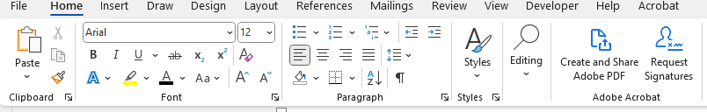

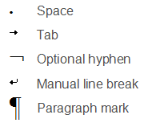

Pagination Breaks

Cell Markers

