Safe Work Procedure | Physical Plant  General  _____(insert title)_____ | Approved by:  Michael McCormick  Author: Michelle Augustyn  Reviewed by:  WSH Committee Member
Version 1.0 PP-SWP-GEN-??? | First Approved: DRAFT | Updated: January 2022

Potential Hazards: |  |  |  |  | Equipment/Devices or PPE Required:
H | M | L | Risk for Injury |  | ☐ Head Protection | ☐ Body Protection
☐ | ☐ | ☐ | Awkward / sustained postures |  | ☐ Eye Protection | ☐ Hand Protection
☐ | ☐ | ☐ | Biological pathogens |  | ☐ Ear Protection | ☐ Foot Protection
☐ | ☐ | ☐ | Chemicals |  | ☐ Face Protection | ☐ High Visibility Wear
☐ | ☐ | ☐ | Combustibles / flammables |  | ☐ Other Protection - ______________________
☐ | ☐ | ☐ | Electrical hazards
☐ | ☐ | ☐ | Extreme heat / cold
☐ | ☐ | ☐ | Forceful exertions
☐ | ☐ | ☐ | Material falling |  | Required / Pre-requisite Training:
☐ | ☐ | ☐ | Moving machinery / parts |  | ☐ WHMIS etc.
☐ | ☐ | ☐ | Noise |  | ☐
☐ | ☐ | ☐ | Pinch points
☐ | ☐ | ☐ | Repetitive motions
☐ | ☐ | ☐ | Sharp points / edges
☐ | ☐ | ☐ | Skin compression
☐ | ☐ | ☐ | Surfaces causing falls
☐ | ☐ | ☐ | Traffic – Vehicle or pedestrian |  | All employees shall be trained on required Safe Work Procedures (SWP) until competent. This will include a review of SWP documentation and hands-on training as required. Employees are responsible for performing the task in accordance with training, established health and safety regulations/guidelines, policies, and procedures. Managers, supervisors, or delegates will ensure all duties are performed in accordance with training, established health and safety regulations/guidelines, policies, and procedures.
☐ | ☐ | ☐ | Two Person Job
☐ | ☐ | ☐ | Vibration
☐ | ☐ | ☐ | Violence / Psychological Hazard
☐ | ☐ | ☐ | Other - __________________
Risks: Signs and symptoms of a musculoskeletal injury (MSI) can include pain, burning, swelling, stiffness, numbness/tingling, and/or loss of movement or strength in a body part. Report these to your manager or supervisor immediately.

NOTE: Additional Potential Hazards

Steps to Perform This Task Safely:

Instructions Photo
Pre-use
1.
2.
3.
4.
5.
6.
7.
8.
9.
10.
11.
12.
13.
NOTE:
Prohibited activities

If an emergency situation or equipment malfunction occurs while using the equipment, shut the unit off immediately and report to your supervisor. Report any hazardous situation to your supervisor / WSH Advisor.

Author: | Approved By: | Reviewed By: WSH Committee
 | 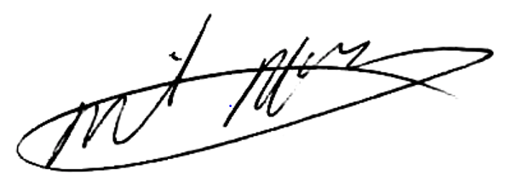

RELATED MATERIAL - TBD

REFERENCES - WSH Act/Regulations - https://www.gov.mb.ca/labour/safety/pdf/whs_workplace_safety_act_and_regs.pdf

