Pow Wow - Campus Map
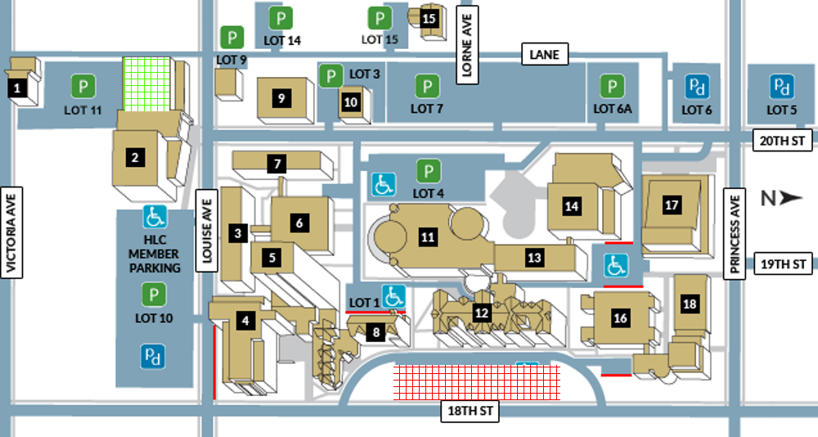
12. Pow Wow on Clark Hall front lawn
2. Healthy Living Centre (in case of rain)
Pay & Display Parking
$0.60 per hour, up to 8 hours
Metered Parking
$0.01 per min., up to 100 min.
BU Staff/Student Permit Parking Only
8:00 a.m. – 4:30 p.m., Mon- Fri.

