Brandon University Status of Women Review Committee

A REVIEW OF THE STATUS OF WOMEN AT BRANDON UNIVERSITY

Marnie Wilson, M.A.

Brandon University

August, 2004

Subcommittee Members

Kathleen Nichol Dr. Shannon Gadbois Dr. Lisa Robson

Acknowledgements

- The Status of Women Review Committee would like to thank the President’s Office and the Brandon University Faculty Association for funding this research.

- The primary researcher and subcommittee members would also like to thank the following people for their invaluable help throughout the course of this research:
Brenda Bull, Human Recourses Officer
Barbara Smith, Director of Human Resources
Alison McNeill-Hordern, Coordinator of Research Services
Maureen Barrett, Executive Secretary of BUFA

- The primary researcher would like to thank the following people for their support and advice throughout the project: Dr. Dennis Oleson, Dr. Nicole Conrad, and Ms. Florence Paton.

- Finally, the primary researcher would like to acknowledge Mrs. Kathleen Nichol, Dr. Shannon Gadbois, and Dr. Lisa Robson for their tremendous commitment to this project which was evident throughout the many meetings, discussions, and revisions.

Table of Contents

List of Tables …………………………………………………………………………. 5
List of Graphs …………………………………………………………………………. 6

Executive Summary …………………………………………………………………… 7

Summary of Recommendations ……………………………………………………… 11

Introduction …………………………………………………………………………… 14

Current Study ………………………………………………………………………… 15

Section 1 – Archival Data

Method ………………………………………………………………………………… 16
Procedure and Population ……………………………………………………… 16

Results: Descriptive Statistics ………………………………………………………. 16
Gender Distribution at Brandon University …………………………………… 16
Gender Distribution by Faculty ……………………………………………….. 17
Gender Distribution in Years of Service ……………………………………… 18
Salary ………………………………………………………………………….. 19
Gender Distribution by Rank …………………………………………………. 19

Is There a Trend Towards Equality in Salary and Rank? ………………………… 20
- Number of Men and Women Hired ………………………………………... 21
- Highest Degree Attained …………………………………………………... 24
- Starting Rank ………………………………………………………………. 25
- Starting Salary ……………………………………………………………… 26
- Promotions …………………………………………………………………. 27
Summary ……………………………………………………………………….. 29

Other Questions of Equality for Faculty Members ………………………………… 30
Type of Appointment …………………………………………………………... 30
Years Before Tenure …………………………………………………………… 31
Sabbaticals ……………………………………………………………………… 31
Termination …………………………………………………………………….. 33
BURC Grants …………………………………………………………………... 33

Section 2 – Questionnaire

Method ………………………………………………………………………………… 34
Procedure ………………………………………………………………………. 34
Measures ……………………………………………………………………….. 34
Participants …………………………………………………………………….. 35

Results: Job Satisfaction …………………………………………………………….. 36
Job Satisfaction for Overall Sample …………………………………………… 36
Gender and Job Satisfaction …………………………………………………… 38
Other Demographics …………………………………………………………… 38
Workload ………………………………………………………………………. 39

Gender Discrimination ……………………………………………………………….. 40
Extent of Gender Discrimination ………………………………………………. 40
Perpetrators of Gender Discrimination ……………………………………….... 41
Response and Outcome of Gender Discrimination …………………………….. 42

Racial Discrimination ………………………………………………………………… 43
Extent of Racial Discrimination ……………………………………………….. 43
Perpetrators of Racial Discrimination …………………………………………. 43
Response and Outcome of Racial Discrimination ……………………………... 44

Intimidation …………………………………………………………………………… 45
Extent of Intimidation ………………………………………………………….. 45
Perpetrators of Intimidation ……………………………………………………. 46
Response and Outcome of Intimidation ……………………………………….. 46

Sexual Harassment …………………………………………………………………… 47
Extent of Sexual Harassment ………………………………………………….. 47
Perpetrators of Sexual Harassment ……………………………………………. 48
Response and Outcome of Sexual Harassment ………………………………... 49

Summary ……………………………………………………………………………… 49

Conclusion …………………………………………………………………………….. 51

References …………………………………………………………………………….. 52
Appendices …………………………………………………………….……………… 54
Appendix A: Questionnaire …………………………………………………… 55
Appendix B: Satisfaction Ratings of Job Satisfaction Items ………………….. 67
Appendix C: Demographic Differences on Specific Job Satisfaction Items ….. 68
Appendix D: Summary of Open-Ended Responses …………………………… 72
List of Tables

Table 1 Percentage of Women by Faculty ………………………………………. 18
Table 2 Percentage of Women by Rank ………………………………………… 19
Table 3 Number of Applicants and Hires by Faculty and Gender (2000-2004) ... 22
Table 4 Success Rate of Applicants by Faculty and Gender (2000-2004) ……… 23
Table 5 Hierarchical Regression Predicting Starting Salary …………………….. 27
Table 6 Success Rate of Promotion Applicants by Gender (2001-2004) ……….. 28
Table 7 Success Rate of Tenure Applicants by Gender (2001-2004) ………..…. 31
Table 8 Hierarchical Regression Predicting Number of Sabbaticals …………… 32
Table 9 Success Rate of Sabbatical Applicants by Gender (2001-2004) ………. 32
Table 10 Number of BURC Grants by Date and Gender ………………………… 33
Table 11 Distribution of Faculties in the Questionnaire Sample Compared to
Faculty Distribution at BU ……………………………………………… 36
Table 12 Aspects of Job with which Respondents are Most and Least Satisfied … 37
Table 13 Extent of Specific Acts of Gender Discrimination by Gender …………. 41
Table 14 Extent of Specific Acts of Racial Discrimination …………………….... 43
Table 15 Extent of Specific Acts of Intimidation by Gender …………………….. 45
Table 16 Extent of Specific Acts of Sexual Harassment by Gender ………….…. 48
Table 17 Satisfaction Ratings of Job Satisfaction Items …………………………. 67
Table 18 Satisfaction Differences by Type of Appointment …………………….. 69
Table 19 Satisfaction Differences by Length of Employment …………………… 70
Table 20 Differences in Satisfaction Between On-Campus and Off-Campus
Faculty …………………………………………………………………. 71
Table 21 Differences in Satisfaction Between Those with Young Children
and Those Without …………………………………………………….. 71

List of Graphs

Graph 1 Percentage of Full-Time Female Faculty Since 1989/90 ………………. 17
Graph 2 Current Proportion of Men and Women by Salary Scale ……………… 20
Graph 3 Trends in the Proportions of Newly-Hired Men and Women …………. 22
Graph 4 Highest Degree Attained by Gender …………………………………… 25
Graph 5 Type of Appointment by Gender ………………………………………. 30
Graph 6 Comparison of Current and Ideal Distribution of Time ……………….. 39
Graph 7 Who is Committing Gender Discrimination? ………………………….. 42
Graph 8 How Often Responses to Gender Discrimination Have Led to
Satisfying Outcomes …………………………………………………… 42
Graph 9 Who is Committing Racial Discrimination? …………………………… 44
Graph 10 How Often Responses to Racial Discrimination Have Led to
Satisfying Outcomes …………………………………………………… 44
Graph 11 Who is Intimidating Faculty Members? ……………………………….. 46
Graph 12 How Often Responses to Intimidation Have Led to Satisfying
Outcomes ………………………………………………………………. 47
Graph 13 Who is Committing Sexual Harassment? ……………………………… 48
Graph 14 How Often Responses to Sexual Harassment Have Led to
Satisfying Outcomes …………………………………………………… 49

Executive Summary

The Current Study

- The current study was conducted as part of the ongoing review of the status of women at Brandon University. It involved two parts:

- Archival data was collected from the offices of Human Resources and the Vice-President Academic, and from the hiring, tenure, promotion, and sabbatical Data Collection Forms from the past four years. The goal was to compare the status of women and men with regard to salary, rank, years of service, highest degree attained, type of appointment, date of tenure, promotion history, sabbatical history, and BURC grants, in order to determine if BU is making positive steps toward a more equitable workplace.

- A questionnaire was developed and distributed to all faculty members in order to examine the following issues related to work climate: (a) job satisfaction, (b) gender discrimination, (c) racial discrimination, (d) intimidation, and (e) sexual harassment.

- Archival data was collected for all 232 current members of BUFA (91 women and 141 men; including PA, AA, and IA ranks, but with the exception of sessional instructors). The final sample of questionnaire respondents consisted of 32 women and 36 men, for a total of 68 respondents.

Results of Archival Data

- There has been a very small increase in the proportion of female full-time faculty over the past four years, from 35% in 2000 to 38% in 2004.

- There continues to be an unequal gender distribution in each faculty at BU. There is a significantly higher proportion of men in the faculties of Education, Music, and Science. Alternatively, there continues to be a significantly higher percentage of women (77%) in the Faculty of Health Studies. Women and men are approaching parity, however, within the Faculty of Arts (40%) and in Student and Library Services (57%). Several faculties continue to fall short of the gender goals they established almost fifteen years ago.

- BU continues to hire more men (58%) than women (42%). This proportion of women is reaching parity with the proportion of females in the overall pool of recent graduates. However, women make up only 24% of the applicants for BU positions. Short-listed male candidates are far more likely to be hired than short-listed female candidates.

- Among the traditional academic ranks, there is a roughly equal proportion of newly-hired women (56%) and men (59%) who have attained Doctorates.

- There is a much greater tendency for men to be hired at the two highest ranks (8 men compared to 1 woman). Furthermore, when holding starting salary scale and starting year constant, men are still starting at higher “steps” within their ranks than women.

- Male faculty continue to show an advantage in salary, making an average of $14,117 more than women. This is partially explained by the fact that they have been employed longer at BU, and are extremely over-represented in the highest paid BUFA ranks (88% of Full Professors and PA IVs are men), while women are over-represented in the lowest-paid ranks (75% of IA positions are held by women).

- Women who actively pursue promotions do so after a similar length of service as men, and are as successful as their male counterparts. However, almost half (44%) of the women hired between 1994 and 1999 are taking longer than men to apply for their first promotion, or are simply not actively pursuing promotion.

- Currently, 65.3% of women hold tenured or continuing appointments (up 10% from 2000), and 70% of men hold these appointments (down 5%). Over the past four years, more women applied for tenure (22 women and 18 men) and were more successful than their male counterparts (100% of women and 83% of men). There is no difference between women and men in the number of years before being granted tenure.

- Once accounting for years of service, there is no significant difference between women and men in terms of the number of sabbaticals taken, years before first sabbatical, or success rate of application for sabbatical.

- Over the past four years, 63% of BURC grants were awarded to men, while 37% were awarded to women. These proportions are commensurate with the overall gender distribution at BU. Furthermore, there was no gender difference in the average amount of BURC grants.

Questionnaire Results

- The mean satisfaction score of all survey respondents was 74.31/100, indicating that respondents are generally satisfied with their jobs at BU. It seems that teaching and interacting with students are sources of satisfaction for almost all respondents. Many respondents are satisfied with the benefits and retirement policies, and are satisfied with the independence that an academic position offers. However, roughly 30% to 40% of respondents are dissatisfied with the support and opportunity for research, feel overloaded with work, and feel that the requirements for promotion and tenure are not clear.

- All respondents are equally as satisfied with their job regardless of gender, faculty, type of appointment, or length of employment. Job satisfaction is also similar for those who work on- and off-campus, and for those who do and do not have young children.

- Two gender differences did emerge, however, when examining the specific job satisfaction items. Women are far less satisfied (M = 4.34/6) than men (M = 5.28/6) with their job security. Women are also less satisfied (M = 3.69/6) than men (M = 4.34/6) with the interest other colleagues have in their work.

- Most respondents are dissatisfied with their conflicting occupational demands. Fully 68% of respondents wish to spend less time teaching, and 80% wish to spend more time on research. On average, respondents feel that it would be ideal to spend approximately one-third of their time conducting research.

- Of those who completed the questionnaire, 29% reported being treated differently because of their gender over the past four years; 7% of respondents reported being treated differently because of their race; more than half (54%) reported feeling threatened or intimidated; and 18% reported experiencing unwanted sexual advances.

- Overall, women reported experiencing more discrimination, intimidation, and harassment within the last four years than men.

- Fully 50.0% of the female respondents reported being treated differently because of their gender, while this was true for only 11.1% of male respondents. For women, the most common forms of differential treatment at BU included: being ignored, being expected to do more work, having their work devalued, and having their abilities questioned.

- Although the reports of intimidation were high for both genders, there was a greater percentage of women (63%) than men (47%) who reported feeling intimidated or threatened. Common forms of intimidation include: overt intimidation from another, and implicit pressure to comply with another. Many women also reported being yelled at and feeling concerned for their physical safety.

- Men (14%) were almost as likely as women (22%) to experience some form of sexual harassment. The most common unwanted sexual experiences are: hearing or receiving (via e-mail) offensive sexual jokes, and hearing offensive remarks or innuendos about one’s body.

- The overwhelming majority of these acts of discrimination, intimidation, and harassment are perceived to come from fellow faculty members, and many are perceived to come from administrators. The most common response is simply to handle these negative incidents on one’s own. The second most common response is to ignore the incident.

- With the exception of cases of sexual harassment, an average of 54% of respondents answered “not usually” when asked how often their responses led to satisfying outcomes. This statistic suggests that whether a person ignores or personally handles incidents of discrimination and intimidation, these responses are not adequately addressing the problem.

Summary of Recommendations

Theme | Specific Issues | Recommendations
Gender Distribution and Hiring Trends | Outside of the period between 1995 and 1999, there has been no change in the hiring trends at BU for the past two decades.  Most faculties continue to fall short of gender parity and all faculties (with the exception of Student and Library Services) continue to fall short of the gender goals they established in 1990.  Despite women representing 41% of the overall pool of recent Doctoral graduates, women represent only 24% of applicants for BU positions. | Have faculties state new (or restate old) goals regarding gender distribution.  Hiring committees need to insure they are reaching potential female candidates through targeted advertisements.  More research is needed to determine if there is any way that BU could be appealing specifically to women.
Short-Listed Candidates | Short-listed male candidates are far more likely to be hired than short-listed female candidates. | Instigate a more systematic procedure for collecting information regarding the number of female as well as male applicants who decline interviews and positions, and why these applicants decline.
Starting Salary Scale | There is a tendency for men to be hired at higher starting ranks (most often as Associate Professors).  Men are starting at higher ‘steps’ within their ranks than women. | Instigate a systematic procedure for (1) recording hiring committees’ rationale for the rank and steps offered to new hires; and (2) comparing the initial contract offer to the final negotiated contracts of new hires.  Seek to establish representation of the SWRC on search committees and in salary negotiation meetings.
Theme | Specific Issues | Recommendations
Promotions and Job Security | Almost half of the women hired between 1994 and 1999 are taking longer than men to apply for promotions, or are simply not actively pursing promotions.  Women continue to feel less secure in their jobs than men. | Make female faculty members aware that many women are taking longer than men to apply for promotions.  Make female faculty aware that women who actively pursue promotions after a similar length of service as men, are as successful as their male counterparts.  Survey women on campus regarding the reasons for their delays in applying for promotion. The SWRC could then plan ways to encourage and/or aid women in their application process.
Teaching Load and Research Time | Many respondents are dissatisfied with the support and opportunity for research.  Faculty members at BU wish for lower teaching loads and more time for research. | Actively find solutions to reduce teaching loads and create more opportunities for research throughout the academic year.  Reduce the necessity for overload teaching.
Interest of Colleagues | Women are less satisfied than men with the interest other colleagues have in their work. | Promote women’s research through colloquiums and/or profiles of female faculty’s research projects.

Theme | Specific Issues | Recommendations
Discrimination, Intimidation, and Harassment | Overall, women reported experiencing more discrimination, intimidation, and harassment than men.  Far more women reported experiencing gender discrimination than men.  There is an overwhelming percentage of both men and women who feel they are experiencing threat and intimidation at BU.  The overwhelming majority of these acts of discrimination, intimidation, and harassment are reportedly being perpetrated by fellow faculty members, and many are being perpetrated by administrators.  When experiencing discrimination, intimidation, or harassment, the vast majority of faculty members are either handling these negative incidents on their own, or are ignoring the incidents altogether.  Many of these faculty members were not usually satisfied with the outcome of their responses to the incidents. | Provide advocacy by the SWRC in individual cases of discrimination and sexual harassment.  Provide gender, race, intimidation, and sexual harassment sensitivity and awareness workshops to all faculty.  Advocate for a conflict resolution mechanism to be put in place at BU.  Promote training for deans and directors regarding conflict management and administration issues.  Increase the visibility of the Harassment and Discrimination Advisors on campus.

Introduction

The Status of Women Review Committee (SWRC) was established in February of 1988 in response to Article 30 in the Brandon University Faculty Association (BUFA) Collective Agreement. The members of the SWRC are committed to ensuring equal opportunities for female faculty in the Brandon University (BU) community. The committee is responsible for conducting ongoing reviews “to ensure that there is no discrimination based on sex in salaries, the process of securing tenure, promotion, the granting of sabbaticals or research grants” (Collective Agreement, April 2002 – March 2005, p. 77). In other words, the SWRC is responsible for identifying and tracking any barriers impeding women’s career advancement at BU.
Within the general academic community, such barriers unfortunately endure. Although there is some evidence of improvement to the status of women in Canadian universities, there is also evidence that inequities persist (Benschop & Brouns, 2003; Hannah, Paul, & Vethamany-Globus, 2002; Kite, et al., 2001). On average, women continue to earn less than men, are employed in lower numbers and in lower ranks than men, and receive fewer promotions and tenured contracts than men (CAUT, 2004). Thus, by relatively ‘objective’ measures, there continues to be a lack of parity among male and female academics.
Furthermore, other research suggests that a “chilly climate” is prevalent within universities across the world (Hannah, Paul, & Vethamany-Globus, 2002, see also Benschop & Brouns, 2003; Finch, 2003). To put it simply, a “chilly climate” involves a “daunting, unsupportive working environment” for women (Hannah, Paul, & Vethamany-Globus, 2002, p. 3). Such an environment is thought to result from deeply entrenched attitudes (Hannah, Paul, & Vethamany-Globus, 2002) and the subtle, covert forms of discrimination and harassment which have replaced the more overt behaviours of the past (Hannah, Paul, & Vethamany-Globus, 2002; Kite, et al., 2001). Measuring climate and discrimination is therefore a more complicated, subtle, and subjective task than ever before. The bottom line, however, is that even when barriers appear to have vanished, “the career advancement of the immense majority of women academics stops below the level attained by most men” (Hannah, Paul, & Vethamany-Globus, 2002, p. 8). Therefore, the challenge for the Status of Women Review Committee is to research both the concrete and the more subtle signs of inequality at BU.

Current Study

The current study was conducted as part of the ongoing review of the status of women at Brandon University. The first purpose of the study was to determine the present working status of female faculty* members at BU. This process involved collecting archival data from the offices of Human Resources and the Vice-President Academic. This data was then analysed to determine whether any inequities currently exist between women and men. Where possible, the current findings were compared with those of the 2000 SWRC study and the national statistics report of Canadian Universities (CAUT, 2004) in order to determine if Brandon University is making positive steps toward a more equitable workplace.
The second purpose of the study was to examine the working climate at Brandon University in order to capture the day-to-day experiences of BU faculty. The primary researcher, with the assistance of the SWRC Subcommittee members, constructed and disseminated a questionnaire which measured job satisfaction, gender and race discrimination, and experiences with intimidation and unwanted sexual advances. The survey was used for determining whether women and men differ in their level of satisfaction, and whether women are more likely to experience discrimination, intimidation, or unwanted sexual advances at BU.

* Faculty refers to all members of BUFA, including all PA, AA, and IA ranks, but with the exception of sessional instructors. Sessional instructors were not included in the current research in order to be consistent with previous studies, and also because these instructors are in the process of conducting their first study.

Section 1 – Archival Data

Method

Procedure & Population
Frequency statistics for all BUFA members were drawn from the offices of Human Resources and the Vice-President Academic regarding starting and current salary, starting and current rank, years of service, highest degree attained, type of appointment, date of tenure, promotion history, sabbatical history, and BURC grants. This data was collected for all 232 current* members of BUFA (91 women and 141 men). Statistics were not gathered, however, for sessional instructors or for faculty members who no longer work at BU. We also drew data from the hiring, tenure, promotion, and sabbatical Data Collection Forms that were submitted to the SWRC over the past four years. All this data was collected in order to examine the issues related to employment equity on campus and to compare the data to those collected in 2000. Some of this data was also compared with the most recent data available from the national statistics report of Canadian Universities, data which reflects the academic situation in 2000/01 (CAUT, 2004).

* On April 30, 2004

Results: Descriptive Statistics

Gender Distribution at Brandon University
Over the past four years at Brandon University, there has been a very small increase in the proportion of female faculty. As reported in the 2000 SWRC survey, women represented 35% of all full-time faculty members in 1999/00. As of April 30, 2004, women represented 37.9% (or 83/232) of full-time BU faculty*. This proportion is higher than the 2000/01 national percentage, in which women comprised 28.7% of full-time Canadian faculty members** (CAUT, 2004). As the following graph shows, the percentage of female faculty at BU increased significantly between 1990 and 2000, but has leveled off somewhat in the past four years.

Graph 1
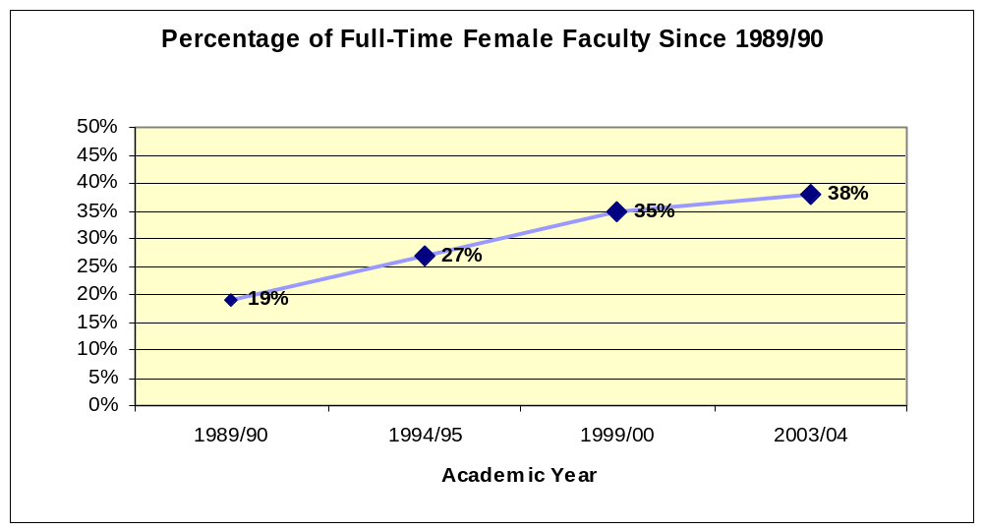

* When including part-time faculty, the percentage of women is 39%.
** The CAUT statistic (28.7%) seems to include only the ranks of Full Professor, Associate Professor, Assistant Professor, and Lecturer. When examining the gender distribution at BU in those ranks alone, women make up 33.1% of the population.

Gender Distribution by Faculty
There continues to be an unequal gender distribution in each faculty at Brandon University (see Table 1). A chi-square test was performed to determine which faculties have a significantly disproportionate amount of men or women. There is a significantly higher proportion of men in the faculties of Education, Music, and Science. Women constitute only 21% of the Music Faculty, 24% of the Science Faculty, and 36% of the Education Faculty. Alternatively, there continues to be a significantly higher percentage of women (77%) in the Faculty of Health Studies. Women and men are approaching parity, however, within the Faculty of Arts (40%) and in Student and Library Services (57%).
Table 1 also compares the faculty’s current percentage of women to the national percentages in 2000/01. Compared to national standards, Brandon University has a greater proportion of female faculty members in the faculties of Arts and Science. However, BU falls behind the total national proportion of women in the faculties of Education and Music.
It was noted in the SWRC’s 2000 report that improvements were made toward a more equal gender distribution in all faculties between 1990 and 2000 (except in the Faculty of Science). Since 2000, however, there has been little further improvement toward gender equality. Therefore, several faculties continue to fall short of the gender goals they established in 1990 (see Table 1).

Table 1
Percentage of Women by Faculty
Faculty | 2000 | 2004 | BU Goal | National % in 00/01
Arts | 44 % | 40 % | 46 % | 32 %
Education | 33 % | 36 % | 50 % | 41 %
Health Studies | 82 % | 77 % | N/A | 94 % (Nursing)
Music | 33 % | 21 % | 29 %* | 29 %
Science | 22 % | 24 % | 32 % | 18 %
Student Services & Library | 57 % | 57 % | 50 % | N/A
* The goal for the School of Music was to hire a female candidate, when there was clearly no superior candidate, until the percentage of women reflected the ratio between men and women enrolled in Doctoral music programs in major universities. The goal reported here is the 2001 ratio of men and women Doctoral graduates in music programs across Canada (CAUT, 2004).

Gender Distribution in Years of Service
Male faculty have been employed at BU for an average of 14.9 years, whereas female faculty have been employed at BU for an average of 9.5 years. A t-test was performed to test whether there is a significant difference between these two means. Indeed, a significant difference was found between men and women in their years of service at BU (t = 3.73, p < .001*), indicating that male faculty have, on average, been employed for longer periods of time.
This finding replicates those from previous studies and is therefore not very surprising. One highly probable reason for this finding is that men were hired in greater numbers several years ago, and/or have continued employment at BU longer than have women. The implication of the greater average years of service among men is that they are more likely to have higher salaries and hold higher ranks.
* When a probability value (p) falls below .05, the result is considered to be statistically significant.

Salary
Male faculty at Brandon University make an average of $73,459, whereas female faculty at BU make an average of $59,342. A t-test was conducted in order to determine whether this difference was significant. Indeed, there is a significant salary discrepancy at Brandon University, with female faculty making $14,117 less on average than male faculty (t = 5.73, p < .001). Any salary discrepancy must be interpreted cautiously, however. Salary, in and of itself, is only one indicator of gender inequality. Male faculty will continue to show an apparent advantage in salary because they have been employed longer at BU and also hold higher ranks.

Gender Distribution by Rank
Men continue to be over-represented in the higher ranks of academic positions, and women are more likely to hold lower-rank positions.

Table 2

Percentage of Women by Rank
Rank | National % in 00/01 | % at BU in 2000 | % at BU in 2004
Professor | 15 % | 9 % | 13 %
Associate | 32 % | 23 % | 33 %
Assistant | 41 % | 54 % | 44 %
Lecturer | --- | 44 % | 56 %
Professional Associate* | --- | --- | 36 %
Administrative Associate* | --- | --- | 67 %
Instructional Associate* | --- | --- | 71 %
* Complete data from the 2000 report and from CAUT was not available for PA, AA, and IA ranks.

The effect of rank on the salary discrepancy of men and women is even more pronounced when we consider how these various ranks are distributed into salary scales. Graph 2 clearly shows that men are extremely over-represented (88%) in the highest paid BUFA ranks, while women are over-represented in the lowest-paid ranks (59% and 75%). These numbers are even more striking when we remember that women make up 39% of the faculty members at BU. It is worthwhile repeating, therefore, that male faculty continue to show an advantage in salary (at least partly) because they have been employed longer at BU, and hold a greater percentage of the highest-paid ranks.

Graph 2
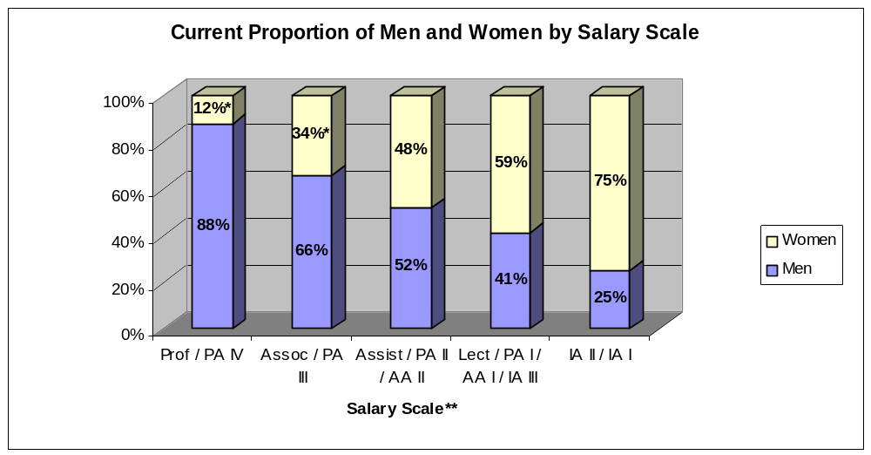
* Denotes a significant difference between men and women, p < .01.
** The floor salaries for each of the salary scales are: $81,274; $65,078; $49,684; $41,626; 37,631; $33,645.

Is There a Trend Towards Equality in Salary and Rank?

Despite the well-documented gender inequalities of the past, it is important to determine whether specific acts and cases of inequality are being repeated in the present or whether Brandon University is beginning to see a trend toward greater equality for all faculty. The current difference in the salary and ranks of male and female faculty should begin to diminish if the following trends emerge:
- BU hires equal numbers of women and men
- As many newly hired women have attained Doctorates as newly hired men
- Given equal qualifications and experience, newly-hired women and men are given the same starting rank
- Given equal qualifications and experience, newly-hired women and men are awarded the same starting salaries
- Both genders apply for promotions at roughly the same point in their years of service at BU and are awarded promotions with an equal success rate.

Analyses were conducted to determine whether these trends are evident at BU.

Number of Men and Women Hired
The SWRC is particularly interested in whether there has been a shift in hiring practices in more recent years. The current faculty members were therefore divided into four groups: those who were hired within the past 5 years, those who were hired between 6 and 10 years ago, those who were hired between 11 and 20 years ago, and those who were hired more than 20 years ago. A chi-square analysis was then performed to determine at which point in history, if any, there has been an increase in the proportion of new female faculty. Graph 3 provides a summary of the findings.
As expected, there was a significantly greater number of men hired at BU more than 20 years ago (80.6% male and 19.4% female). Of those faculty who were hired between 11 and 20 years ago, 56.5% were male and 43.5% were female. Interestingly, of those faculty that were hired between 6 and 10 years ago, 65.0% were female and only 35.0% were male. This difference is explained at least in part by the establishment of the Faculty of Health Studies. The faculty members in these positions were mostly women. Most notably, when considering those faculty who were hired less than 5 years ago, 58.1% were men and 41.9% were women. These statistics suggest that, outside of the period between 1995 and 1999, there has been no change in the hiring trends at BU for the past two decades.

Graph 3 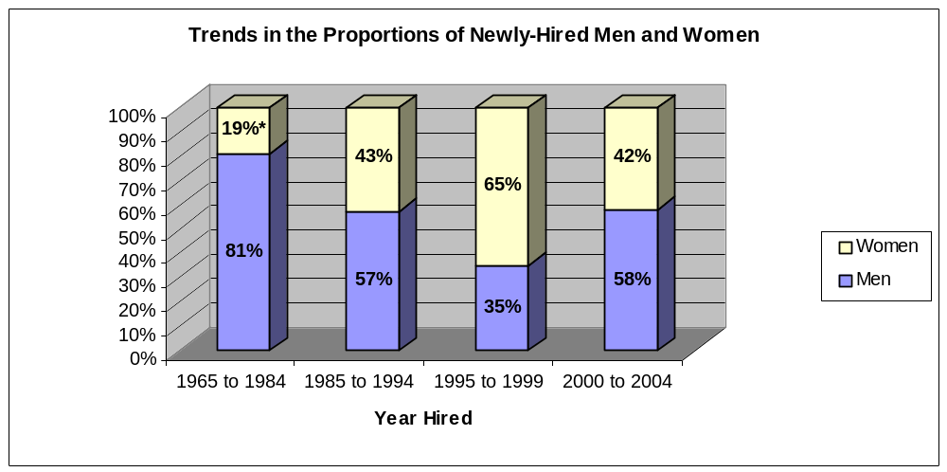
* Denotes a significant difference between men and women, p < .001.

Table 3 outlines the number of female and male applicants for BU positions over the past four years. Excluding the faculties of Education and Health Studies (data was not made available by these faculties), there were almost twice as many men as women hired at BU in the past four years. Table 3 also denotes the number of each gender who were short listed and who were hired. Table 4 then summarizes the success rate of male and female applicants. These tables show that short-listed male candidates are far more likely to be hired than short-listed female candidates.
Table 3
Number of Applicants and Hires by Faculty and Gender (2000-2004)
Faculty | # of Applicants* | # Female | # Male | # Short Listed | Gender of Hired
Arts | 251 | 73 | 158 | 20F / 24M | 7F / 10M
Education** | N/A | N/A | N/A | N/A | N/A
Health Studies** | N/A | N/A | N/A | N/A | N/A
Library | 37 | 18 | 19 | 3F / 4M | 2M
Music | 90 | 37 | 53 | 8F / 4M | 4F / 4M
Science | 605 | 91 | 514 | 36F / 78M | 10F / 25M
Student Services | 39 | 28 | 11 | 10F / 2M | 2F
Total # | 1022 | 247 | 755 | 77F / 112M | 23F / 41M
* # of applicants whose gender was unknown = 20.
** Statistics from these faculties were not made available.

Table 4
Success Rate of Applicants by Faculty and Gender (2000-2004)
Faculty | Success Rate of Applicants |  | Success Rate of Short Listed
Faculty | Female | Male | Female | Male
Arts | 10% | 7% | 35% | 42%
Education | N/A | N/A | N/A | N/A
Health Studies | N/A | N/A | N/A | N/A
Library | 0% | 11% | 0% | 50%
Music | 11% | 8% | 50% | 100%
Science | 11% | 5% | 28% | 32%
Student Services | 14% | 0% | 40% | 0%
Average | 9% | 6% | 31% | 45%

There are some positive trends emerging in BU hiring practices. For example, although women made up only 24.2% of the overall pool of applicants, 35.9% of those hired within the last four years were women. (Remember that these numbers exclude the faculties of Education and Health Studies.) It is also important to note that 40.7% of the Canadian Doctorates attained (across all disciplines) in 2000 were awarded to women (CAUT, 2004). Therefore, BU is hiring a proportion of women that is reaching parity with the proportion of females in the overall pool of recent graduates.
Yet a qualifier to these positive statistics is in order. If the goal at BU is to reach parity in terms of the gender distribution of faculty members, it must hire as many women as men, if not more. Women currently make up 39% of the BU faculty members. If the proportion of newly-hired faculty continues to be 35.9%, BU has little hope of reaching parity. Since the inception of the Faculty of Health Studies, the percentage of female faculty has risen, but we need to remember that all other faculties (with the exception of Student and Library Services) continue to fall short of parity, as well as the goals they established almost fifteen years ago (see Table 1).
There are at least two major difficulties being encountered at BU in terms of the number of men and women being hired. First, women make up only 24% of all applicants for positions at BU. If 41% of current Doctoral graduates are women, why is BU not attracting a similar proportion of female applicants? More research is needed to tackle this question. Furthermore, of the short-listed candidates, men are far more likely to be hired than women. Some of the comments on the selection committees’ Data Collection Sheets seem to suggest that several female applicants declined interviews or declined positions, often because they had already accepted a position at another university. It is not clear if men were as likely to decline interviews and positions as women. A more systematic procedure for collecting this information would potentially help to uncover the reasons for fewer successful female applicants.

Highest Degree Attained
A Doctorate is generally required in order to be promoted to the higher ranks (and therefore higher salary scales) at BU. The 2000 report stated that there was a higher percentage of male faculty who had attained a Doctorate (51.1%) compared with female faculty (32.9%). This finding is perhaps not surprising considering that (as discussed) women are over-represented in the IA, AA, and lower PA ranks, and these ranks do not require a PhD. Therefore, when examining the 2004 data for highest degree attained, we excluded these ranks, and only the traditional academic ranks were considered (Full Professor, Associate Professor, Assistant Professor, and Lecturer). When considering the current employees in academic ranks, there is actually a very similar percentage of men and women who have attained Doctorates (69.1% of men; 60.0% of women). The following graph summarizes these findings.

Graph 4
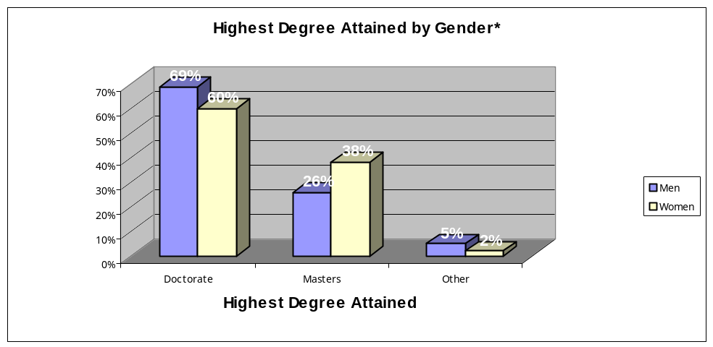
* These percentages do not include PA, AA, or IA ranks.

Furthermore, when considering only those faculty members who have been hired into the traditional academic ranks in the last 10 years, 59.1% of men hold Doctorates, compared with 55.6% of women.

Starting Rank
All lower ranks are roughly equal in terms of the number of men and women hired at each salary scale within the last 10 years. However, of those faculty hired in the top two salary scales within the last 10 years, 8 were men and 1 was a woman (i.e., these people were hired at the rank of Associate Prof, and one was hired as a Full Prof). Thus, there is a tendency for men to be hired at higher starting ranks. Further research should investigate why men are more likely to start at the Associate Professor rank. Do male applicants have much more years of experience than their female counterparts at the time of their application?

Starting Salary
The average starting salary of male faculty who began employment at BU in the last 10 years is $50,746, while the average starting salary for women is $44,796. A t-test was conducted to determine whether this difference was significant. This test revealed a significant discrepancy between the starting salaries of men and women at BU (t = 3.43, p < .01).
A linear regression analysis was conducted to explore further the reasons for this discrepancy. In this analysis, it was first necessary to include, and thus control for, those variables which most obviously influence a person’s starting salary. A person’s rank, or more accurately his or her starting salary scale, should explain most of the variance in salary. The year during which a person began his or her employment at BU will also influence his or her starting salary because the floor salaries change almost yearly according to the Collective Agreement. Starting salary scale was therefore entered into the first block of the regression model, and starting year was entered into the second block. Gender was then entered into the third block to test whether it accounted for variance in starting salary above and beyond what was already accounted for by the first two variables. Table 5 summarizes the results from this regression analysis.
Indeed, starting salary scale accounted for a significant proportion of the variance in starting salary (F = 164.28, p < .001). Starting year was also significant (F = 35.03, p < .001). Despite the large amount of variance explained by these first two variables (R² = .68), however, gender also contributed significantly to the model (F = 10.91, p < .01). Therefore, even after we control for starting salary scale and starting year, men still start at a higher salary on average than women. Because we have accounted for salary scale in this model, the results suggest that men are starting at higher “steps” within their ranks than women.
The reason for this finding is not known. It could be that male applicants have more years of experience at the time of their BU application. It is also possible that men negotiate more steps within their starting rank than do women. Further exploration is needed in order to determine the exact cause of this gender difference.

Table 5
Hierarchical Regression Predicting Starting Salary
 |  | R² | β | R²_{change} | F | p
Step 1
 | Starting Salary Scale | .59 | -10912.10 | .59 | 164.28 | <.001
Step 2
 | Starting Salary Scale |  | -10271.47
 | Starting Year | .68 | 1148.14 | .10 | 35.03 | <.001
Step 3
 | Starting Salary Scale |  | -10042.72
 | Starting Year |  | 1046.72
 | Gender | .71 | -3329.51 | .03 | 10.91 | <.01

Promotions
When looking at those faculty members who have received one promotion at Brandon University, both women and men are granted that first promotion after an average of 5 years of service at BU. In other words, of those that have already attained a first promotion, there is no significant difference between women and men in years of service before that promotion. However, when considering those faculty members who have received a second promotion, a gender difference actually emerged in favour of female faculty members. On average, women have fewer years of service than men between their first and second promotions (5.58 years for women, and 8.94 years for men; t = 2.35, p < .05). Furthermore, we considered the Promotion Data Collection Forms completed each year by the President. The following table shows that male and female promotion applicants share similar success rates. All of these findings suggest that women who actively pursue promotions (1) do so after a similar length of service as men, and (2) are as successful as their male counterparts.

Table 6
Success Rate of Promotion Applications by Gender (2001-2004)
Gender | Applied | Granted | Appealed |  | Denied | Total Success Rate
 |  |  | Decision Overturned | Decision Upheld
Female | 24 | 19 | 1 | 1 | 4 | 83.3 %
Male | 30 | 26 | 1 | 3 | 3 | 90.0 %

On the other hand, it is also important to examine those eligible faculty* who have not yet applied for a promotion. Of those faculty members with 5 or less years of service, or with more than 10 years of service at BU, there is a very similar proportion of men and women who have not yet applied for a promotion. However, a different pattern emerged for those faculty members who have between 5.5 and 10 years of service. In this particular cohort of faculty, there is a large difference in the number of men and women who have not yet applied for a promotion. Fully 43.8% (or 7/16) of these women have not yet applied, while only 8.3% (1/12) of these men have not (χ² = 4.50, p < .05). Therefore, although many faculty members at BU receive their first promotion after 5 years, for those who began their employment between 1994 and 1999, five times as many women compared to men have not yet applied **. These findings suggest that one group of women in particular is taking longer than men to apply for their first promotion, or is simply not actively pursing promotion.
Furthermore, we examined those eligible faculty who have not yet applied for a second promotion. Overall, there is a greater percentage of women (59.4%) than men (45.3%) who have not yet applied for a second promotion (although this difference is not statistically significant). However, this difference could be explained by the fact that men have generally been employed at BU longer than women.

* Eligible faculty does not refer to AAs and IAs because their change in status is considered a “reclassification”. This data also excludes Full Professors and faculty members on term or continued appointments because they cannot receive promotions.
** It is important to note that this phenomenon is not related to the relative influx of female Health Studies faculty.

Summary
So is there a trend towards equality in salary and rank? Here is a summary of the results:
- Although there are some positive efforts being made in terms of hiring practices, BU continues to hire more men (58%) than women (42%). (These numbers are even bleaker when excluding the faculties of Health Studies and Education; 64% men and 36% women.) This trend is exacerbated by the fact that women make up only 24% of the applicants.
- Among the academic ranks, there is a roughly equal proportion of newly-hired women and men that have attained Doctorates.
- There is a much greater tendency for men to be hired at the two highest salary scales than women. It is not clear whether this difference is due to better qualification from male applicants, or if gender discrimination exists within BU hiring practices.
- When holding starting salary scale and starting year constant, men are still starting at higher “steps” within their ranks than women. It is not clear whether this difference is due to better qualifications and greater experience, or if gender discrimination exists within BU hiring practices.
- Women who actively pursue promotions do so after a similar length of service as men, and are as successful as their male counterparts. However, almost half of the women hired between 1994 and 1999 are taking longer than men to apply for their first promotion, or are simply not actively pursing promotion.

Some positive trends are emerging at BU. Women hired into the academic ranks at BU are just as likely as men to hold a Doctorate. BU is also granting an equal proportion of promotions to both genders. There are some areas that need to be addressed, however. BU needs to consider ways to promote itself to a greater number of potential female applicants. Also, more research is needed to examine the reasons why men are beginning their employment at BU at higher ranks and in higher salary increments. We also need to uncover the reasons why some women are waiting longer to apply for promotions. These negative trends need to be addressed before BU will begin to see gender parity in salary and ranks.

Other Questions of Equality for Faculty Members

Type of Appointment
Men and women are roughly equal in terms of the type of appointment they hold at BU (see Graph 5). Currently, 65.3% of women hold tenured or continuing appointments. This is 10% higher than the data collect in 2000, when 55.2% of female faculty held these appointments. On the other hand, the percentage of men in tenured or continuing appointments has dropped slightly from 75% in 2000, to 70% in 2004. This decline is likely due in part to the relatively high number of men that have retired over the past four years (nine of the twelve retirees were men).

Graph 5
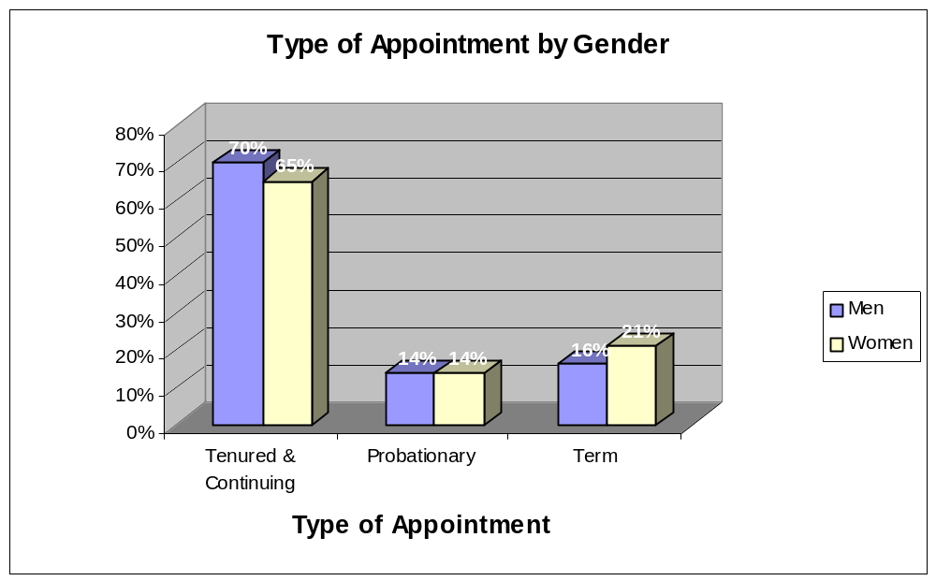

Also, Table 7 shows that more women applied for tenure than men over the past four years. Furthermore, women were slightly more successful in their tenure application than their male counterparts (83.3% success rate for men and 100% success rate for women). These statistics are somewhat the reverse of those reported in 2000. During 1997 to 2000, only 70% of women were approved for tenure, compared with 91% of men.

Table 7
Success Rate of Tenure Applications by Gender (2001-2004)
Gender | Applied | Granted | Appealed | Denied | Total Success Rate
Female | 22 | 22 | 0 | 0 | 100 %
Male | 18 | 15 | 0 | 3 | 83.3 %

Years Before Tenure
Men and women differ with respect to how many years they have worked at BU before being granted tenure. Men have an average of 4.1 years of service before tenure, while women have an average of 5.4 years. A t-test was conducted and this difference was found to be statistically significant (t = -2.04, p < .05). However, when we conducted the same t-test for only those faculty members who have less than 20 years of service at BU, there was no significant difference in the years of service before being granted tenure. Thus, over 20 years ago, women worked longer than men before being granted tenure, but this gender difference is no longer evident.
It is also important to examine those eligible faculty* who have not yet received tenure. When examining these faculty members and holding years of service constant, there is no significant difference between the proportion of men and women who have not yet been granted tenure.
*These include Full Professors, Associate Professors, Assistant Professors, PA’s IV, III, and II.

Sabbaticals
There are more male than female faculty members who have been granted sabbaticals (46% of men and 30% of women). Also, of those who have had at least one half sabbatical, males have taken significantly more sabbaticals on average than their female counterparts (M_{men} = 1.83, M_{women} = 1.24, t = 2.30, p < .01). Although these sabbatical statistics may seem to favour men over women, we must keep in mind that men have been employed at BU longer than women. A linear regression was therefore performed in order to determine if this gender difference continued to exist once accounting for years of service (see Table 8). Indeed, once accounting for years of service, there was no significant difference between women and men in terms of the number of sabbaticals they have taken.
Table 8
Hierarchical Regression Predicting Number of Sabbaticals*
 |  | R² | β | R²_{change} | F | p
Step 1
 | Years of Service | .20 | .044 | .20 | 22.76 | <.001
Step 2
 | Years of Service |  | .038
 | Gender | .22 | -.294 | .02 | 2.15 | >.05
* Includes only those faculty members who have taken at least one sabbatical.

It is also important to examine male and female tenured faculty members who have not yet taken their first sabbatical. A t-test was conducted to see if, once tenured, women waited longer than men to attain a sabbatical. In fact, no significant difference was found. Finally, we considered the Sabbatical Data Collection Forms completed each year by the President. Table 9 summarizes the success rate of male and female applicants. Evidently, women and men share similar success rates with their applications for sabbatical.

Table 9
Success Rate of Sabbatical Applications by Gender (2001-2004)
Gender | Applied | Granted | Denied | Comments | Total Success Rate
Female | 18 | 17 | 1 | Had only 5 years of service credit | 94.4 %
Male | 45 | 44 | 1 | Resigned before sabbatical approved | 97.8 %

Although more men have been granted sabbaticals than women, and men have taken a greater number of sabbaticals on average compared to women, these advantages appear to be explained by men’s longer years of service at BU. Furthermore, male and female faculty members have shared the same success rate in the granting of sabbatical leaves over the past four years.

Termination
From 2000-2003, there were 67 people whose employment ceased at BU; 69% were men and 31% were women. Of these 67 people, 48% left because their term ended and their contract was not renewed, 34% resigned, and 18% retired (including one deceased). Importantly, there were no significant differences between men and women in their reasons for leaving. For example, there was an equal percentage of both genders (48% of men and women) who left because their term had ended.

BURC Grants
Since the spring of 2000, one hundred BURC grants have been awarded to BU faculty members. While 63% of these grants have been awarded to men, 37% were awarded to women (see Table 10). These proportions are commensurate with the overall gender distribution at Brandon University. Furthermore, there was no gender difference in the average amount of BURC grants. Men received an average of $3004 per grant, while women received an average of $2997. These findings replicate the 2000 findings which also showed that the genders were equal in terms of the average monies awarded.

Table 10
Number of BURC Grants by Date and Gender
Date | # of Men | # of Women | Total #
March 2000 | 8 | 4 | 12
November 2000 | 11.5* | 4.5* | 16
April 2001 | 6.5* | 0.5* | 7
November 2001 | 14.83* | 5.16* | 20
November 2002 | 16 | 2 | 18
November 2003 | 6 | 21 | 27
Total | 62.83 | 37.16 | 100
* Decimals resulted from joint proposals.

Section 2 – Questionnaire

Method

Procedure
The questionnaire was developed by the primary researcher and the SWRC Subcommittee (see Appendix A for questionnaire). The questionnaire was designed to address the following areas relevant to employment at BU: (a) job satisfaction, (b) gender discrimination, (c) racial discrimination, (d) intimidation, and (e) sexual harassment. The questionnaire asked Likert-scale, forced-choice, and open-ended questions.
Questionnaires were sent to 232 faculty members (91 women and 141 men), on and off campus. Included with each questionnaire was a self-addressed envelope (including pre-paid postage for all off-campus members). Respondents mailed back the survey through interoffice or regular mail. There were no identifying marks or numbers on the questionnaire or return envelope; therefore, all respondents remained anonymous and the survey results were completely confidential. Participation in the questionnaire was voluntary.

Measures
Job Satisfaction. Respondents completed a 25-item job satisfaction scale that measured how satisfied or dissatisfied they are with their current position at BU. They rated their level of satisfaction/dissatisfaction with each item on a 6-point scale, from very dissatisfied (1) to very satisfied (6). Respondents were also given a “not applicable” response option. This scale was based on dimensions and items from several published job satisfaction scales, two of which specifically target college faculty positions (Brewer & Clippard, 2002; Hagedorn, 1996; Hill, 1986-1987; Koeske, Kirk, Koeske, & Rauktis, 1994; Rentsch & Steel, 1992; Sousa-Poza, 2000; Yoder & McDonald, 1998). No one published scale adequately reflected the faculty responsibilities at Brandon University. An original scale was therefore created, borrowing several items from published scales. The final scale included items about teaching, research, recognition, autonomy, administration, financial resources, workload, etc.

Discrimination, Intimidation, and Harassment. Respondents were presented with a list of possible acts of gender discrimination and were asked to place a check beside each behaviour that they had experienced in the past four years. They were also asked who perpetrated these acts, how they responded, and if they were satisfied with the outcome of their responses. The survey continued with this same pattern of questions, using acts of racial discrimination, then intimidation, then sexual harassment. In all sections, the list of negative behaviours were compiled using a combination of items from scales of discrimination and harassment (Franklin, Moglen, Zatlin-Boring, & Angress, 1981; Hegarty & Dalton, 1995; James, Lovato, & Cropanzano, 1994; Klonoff & Landrine, 1995; Stark, Chernyshenko, Lancaster, Drasgow, & Fitzgerald, 2002; Canadian Human Rights Commission, 1983; Ontario Women’s Directorate, 1993).

Participants
Of the 232 faculty, 69 responded (32 women and 36 men) to the questionnaire. One respondent did not declare his or her gender. Because our primary interest was gender, this respondent was excluded from all analyses. The final sample was therefore comprised of 68 respondents. Of these respondents, 52 work on-campus and 10 work off-campus (6 people did not report their location). Twenty-seven (40%) of the respondents have worked at BU for under five years, 9 (13%) for five to ten years, 15 (22%) for eleven to twenty years, and 16 (24%) for longer than twenty years. Faculty with tenured or continuing appointments represent 65% of the respondents, while 18% hold probationary contracts, and 16% hold term contracts. The following table shows the distribution of faculties represented in the sample and compares them with the overall distribution of faculties at BU.

Table 11
Distribution of Faculties in the Questionnaire Sample Compared to
Faculty Distribution at BU
Faculty | Frequency in Sample | % of Sample | Faculty Distribution at BU
Arts | 15 | 22.1 % | 22 %
Education | 18 | 26.5 % | 24 %
Health Studies & FNAC | 7 | 10.3 % | 10 %
Music | 5 | 7.4 % | 8 %
Science | 12 | 17.6 % | 24 %
Student Services & Library | 10 | 14.7 % | 12 %
Undeclared | 1 | 1.5 % | ---

The reasons for a fairly low response rate are unknown. The questionnaire was distributed in the latter half of June, when unfortunately many faculty members are away or work off campus. The next time research is conducted, it is advised that faculty members receive the questionnaire during a regular term. It is also possible that those faculty members who had no concerns regarding discrimination or harassment were less likely to complete the questionnaire.

Results

Job Satisfaction

Job Satisfaction Scores for Overall Sample
A satisfaction score was calculated for each respondent by adding the satisfaction score for all items, dividing that digit by the number of items completed, and multiplying this number by 100. This percent-score was necessary instead of a total score because some items were not applicable to the job descriptions of all respondents; for example, faculty who are not required to conduct research would indicate “NA” beside the “support for research” item. Thus, job satisfaction scores that approach 100 indicate a satisfied employee.
The mean satisfaction score of all survey respondents was 74.31, indicating that respondents are generally satisfied with their jobs at BU. We also examined the individual items of the job satisfaction scale to determine which aspects of the job respondents are most satisfied and least satisfied with (see Table 12; but for a list of all items, see Appendix B). It seems that teaching and interacting with students are sources of satisfaction for almost all respondents. Many respondents are satisfied with the benefits and retirement policies, and are satisfied with the independence that an academic position offers. However, roughly 30% to 40% of respondents are dissatisfied with the support and opportunity for research, feel overloaded with work, and feel that the requirements for promotion and tenure are not clear.

Table12
Aspects of the Job with which Respondents are Most and Least Satisfied
Job Satisfaction Item | % of respondents who rated being satisfied to some degree* | % of respondents who rated being dissatisfied to some degree**
Most Satisfied
Interaction with your students | 100 % | 0 %
Opportunities for making a difference through your teaching | 94.8 % | 5.2 %
Retirement policies | 90.4 % | 9.6 %
Amount of authority and autonomy you have been given in your job | 89.7 % | 10.3 %
Benefits (i.e., health insurance) | 88.2 % | 11.8 %
Least Satisfied
Freedom from conflicting occupational demands | 68.7 % | 31.3 %
Funding for research | 67.3 % | 32.7 %
Workload | 64.1 % | 35.9 %
The research environment for your students | 60.0 % | 40.0 %
Clarity, consistency of institutional requirements for promotion & tenure | 60.0 % | 40.0 %

* The percentage of respondents who rated being “somewhat satisfied”, “satisfied”, or “very satisfied” with
each item.
** The percentage of respondents who rated being “somewhat dissatisfied”, “dissatisfied”, or “very
dissatisfied” with each item.

Gender and Job Satisfaction
There was no significant difference between the average job satisfaction scores of male (75.57) and female (72.87) respondents (t = 1.00, p > .05). This means that, overall, men and women are equally as satisfied with their jobs at BU.
Two gender differences did emerge, however, when examining the specific job satisfaction items. The largest discrepancy between men and women with respect to job satisfaction is that men are more satisfied than women with their job security. The mean score (on a 6-point scale) for men was 5.28 and for women was 4.34 (t = 2.67, p < .01). It should be noted that the most common response to the job security item was “very satisfied” for both genders. However, when examining the percentage of each gender that reported being dissatisfied to some degree (“somewhat dissatisfied”, “dissatisfied”, or “very dissatisfied”), the gender difference is evident; 5.6% of men, compared to 25.0% of women. The 2000 study also found that men felt more secure in their positions at BU, indicating that this gender discrepancy has not changed.
Women are also less satisfied than men with the interest other colleagues have in their work. The mean score for male respondents was 4.34, compared to a mean score of 3.69 for female respondents (t = 2.38, p < .05). The most common response to this item by men was “satisfied”, while the most common response by women was “somewhat satisfied”. Fully 37.5% of female respondents indicated that they were dissatisfied to some degree with the interest of their colleagues (compared with 20% of male respondents).

Other Demographics
Several statistical analyses were conducted to determine if overall satisfaction scores were influenced by the various demographics collected in the survey, and no significant differences were found. All respondents were equally as satisfied with their job regardless of faculty, type of appointment, or length of employment. Job satisfaction was also similar for those who work on- and off-campus, and for those who do and do not have young children. However, various differences did emerge when examining the specific job satisfaction items. These differences are summarized in Appendix C.

Workload
The results of two of the items on the job satisfaction scale suggest that respondents are unhappy with their workload. Specifically, 35.9% of respondents reported being at least somewhat dissatisfied with the workload at BU. Furthermore, when asked about their level of satisfaction with the various conflicting occupational demands, 31.3% were at least somewhat dissatisfied.
Following the job satisfaction scale, respondents were asked to estimate the percentage of time they generally devote to (1) teaching (including preparation, class, marking, and student consultations), (2) research, and (3) community service and committee work. They were also asked what would be an ideal distribution of their time in order for them to attain their professional and educational goals. Graph 6 summarizes the results from these two questions. No matter one’s gender, type of appointment, faculty, teaching location, or years at BU, the message is the same: faculty members at BU wish for lower teaching loads and more time for research. Fully 68.4% of respondents wish to spend less time teaching, and 80.4% wish to spend more time on research. Furthermore, it is important to note that respondents’ expectations for time spent on research is not unrealistic; they wish to spend approximately one-third of their time conducting research.

Graph 6
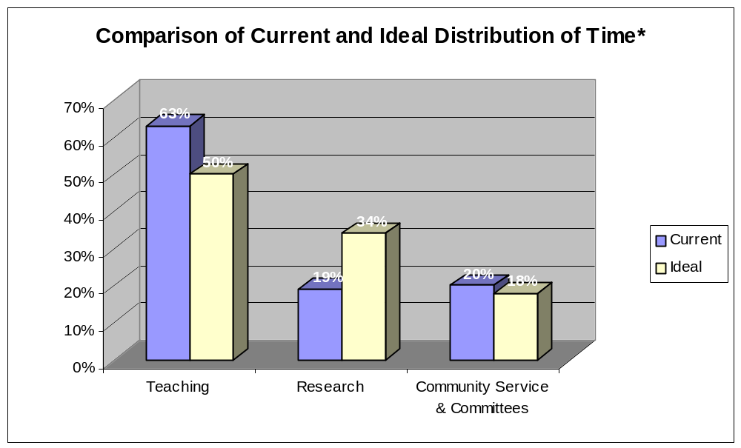
* These are the mean (average) percentages of time distribution.
The message reflected in this graph was echoed in the comments several respondents made within the questionnaire. Workload and conflicting occupational demands was the single most common complaint among those who provided additional comments about their job satisfaction at BU (11/21, or 52%)*. Many respondents agreed that the teaching workload is “onerous” and impedes progress “in all other areas of the job”. Specifically, these faculty members are finding it most difficult to meet the expectations regarding research. Respondents noted that class sizes are growing, that they must teach a wide variety of courses, that overload teaching is far too common, and that the distribution of tasks throughout a year (i.e., research subordinated to summer activity) allows “no opportunity for continuity in research”. Furthermore, when respondents were asked how their working environment at BU could be improved, the most common response dealt once again with lowering teaching load to allow more time for research (12/38, or 32%)*.
* A summary of open-ended responses can be found in Appendix D.

Gender Discrimination

Extent of Gender Discrimination
Of those who completed the questionnaire, 29.4% (20/68) reported being treated differently because of their gender over the past four years. In 2000, it was reported that 27.3% of respondents had experienced differential treatment due to their gender. Therefore, it seems that there are slightly more faculty members experiencing gender discrimination than previously. This statistic is especially disconcerting considering that, in contrast to the 2000 questionnaire, this year’s questionnaire asked faculty members to respond to the questions based on their experiences over the last four years only.
There continues to be a significant difference between the number of men and women who report experiencing gender discrimination. Fully 50.0% of the female respondents reported being treated differently because of their gender, while this was true for only 11.1% of male respondents (χ² = 12.34, p < .001). One of these male respondents made it clear that he experienced positive discrimination, saying, “As a male, I have noticed how others have deferred to me over my female co-workers.” And one woman indicated that she has sometimes experienced “reversed discrimination in (her) unit”. Table 13 shows the percentage of women and men who reported experiencing specific forms of gender discrimination. For women, the most common forms of perceived differential treatment at BU include: being ignored, being expected to do more work, having their work devalued, and having their abilities questioned.

Table 13
Extent of Specific Acts of Gender Discrimination by Gender
Gender Discrimination Item | % of Female Respondents | % of Male Respondents
I have been ignored. | 31 | 6
More work is expected of me. | 25 | 3
My work has been devalued. | 22 | 6
My abilities have been questioned. | 22 | 3
I have been excluded from decision-making. | 19 | 6
Instead of using my name or title, someone has referred to me using terms I find derogatory. | 16 | 0
I have been given less interesting or less challenging tasks. | 6 | 0
Greater leniency is expected of me. | 3 | 0
Other* | 9 | 6

* Other forms of gender discrimination included:
- “Female students sometimes give me the impression that they don’t trust me because I’m male.”
- “Certain senior members in department ‘uncomfortable’ with my role as Chair.”

Perpetrators of Gender Discrimination
Respondents who reported experiencing gender discrimination were asked from whom they feel they received this treatment. They were given three choices – faculty member, administrator, student – and were asked to check all that applied. Graph 7 shows that the overwhelming majority of gender discrimination is perceived to come from faculty members and administrators.

Graph 7
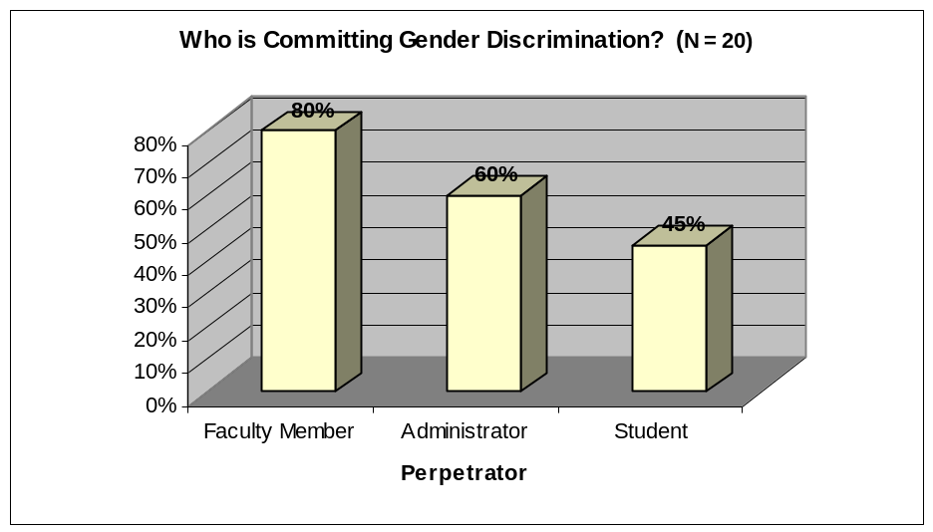

Response and Outcome of Gender Discrimination
Of those who reported experiencing differential treatment because of their gender, 12 (63.2%) ignored the incidents, 14 (73.7%) handled the incidents on their own, 12 (63.2%) sought informal assistance, and only 3 (15.8%) reported seeking formal assistance. Importantly, when asked if their responses led to satisfying outcomes, more than half (55.6%) of those who reported experiencing gender discrimination were “not usually” satisfied with the outcomes of their responses (see Graph 8).
Graph 8
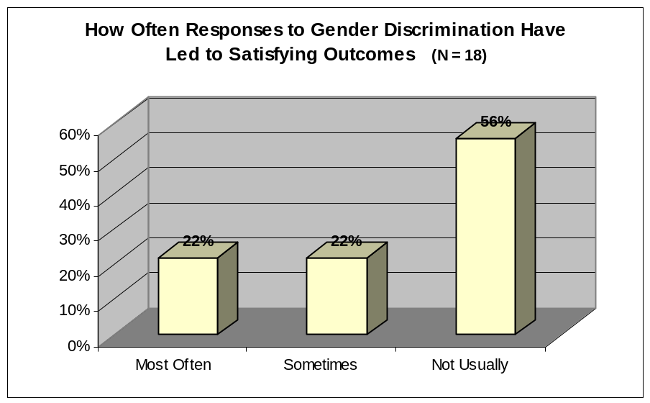

Racial Discrimination

Extent of Racial Discrimination
Of those who completed the questionnaire, 7.4% (5/68) reported being treated differently because of their race over the past four years. Although this percentage may seem low, the reader should keep in mind the overall proportion of racial minorities among BU faculty. Table 14 shows the number* of respondents who reported having experienced specific forms of racial discrimination.
Table 14
Extent of Specific Acts of Racial Discrimination
Racial Discrimination Item | # of Respondents *
My work has been devalued. | 2
I have been ignored. | 2
My abilities have been questioned. | 2
More work is expected of me. | 2
Greater leniency is expected of me. | 1
I have been excluded from decision-making. | 1
Instead of using my name or title, someone has referred to me using terms I find derogatory. | 1
Other** | 4

* This table is not separated by gender because the numbers were so small. Numbers, as opposed to percentages, are reported for the same reason.
** Other forms of racial discrimination:
- “My knowledge or experience was not included in research/writing projects by Caucasian (‘white’) authors”.
- “My co-worker was given permission to do something I asked to do and got refused to do six months ago.”

Perpetrators of Racial Discrimination
Respondents who reported experiencing racial dissemination were asked from whom they feel they received this differential treatment. They were given three choices – faculty member, administrator, student – and were asked to check all that applied. Once again, the overwhelming majority of racial discrimination is perceived to come from faculty members and administrators (see Graph 9).

Graph 9
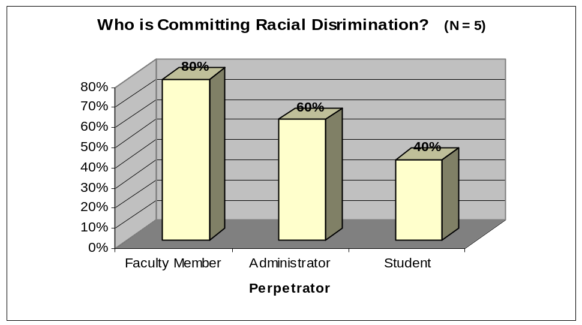

Response and Outcome of Racial Discrimination
Of the 5 respondents who reported experiencing differential treatment because of their race, 3 ignored the incidents, 4 handled the incidents on their own, 1 sought informal assistance, and 1 reported seeking formal assistance. One respondent expressed the inability to discuss the issue of racism with anyone at the university, and therefore this person tries to “pretend it’s not happening”. When asked if their responses led to satisfying outcomes, almost two thirds (60.0%) of those who reported experiencing racial discrimination were “not usually” satisfied with the outcomes of their responses.
Graph 10
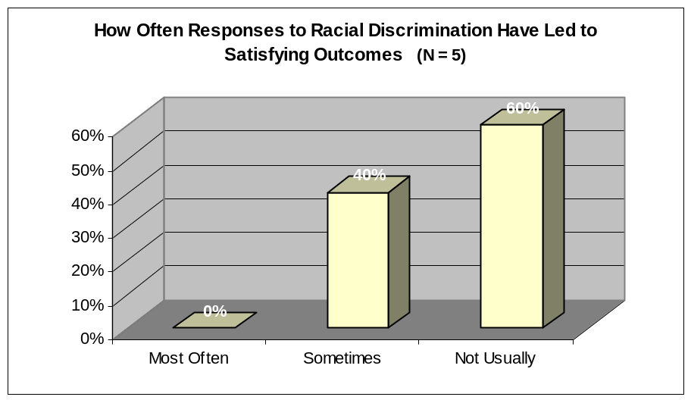

Intimidation

Extent of Intimidation
Of those who completed the questionnaire, more than half (54.4%, or 37/68) reported feeling threatened or intimidated over the past four years. Although the reports of intimidation were high for both genders, there was a greater percentage of women who reported feeling intimidated or threatened (62.5% of women compared to 47.2% of men; although this difference is not significant, χ² = 1.59, p > .05). Table 15 shows the percentage of women and men who reported experiencing specific forms of intimidation. Almost half (44%) of the female respondents and almost a third (28%) of the male respondents reported that someone attempted to overtly intimidate them within the past four years. Another common experience for both genders was feeling implicit pressure to comply with another person (28% for both men and women). Women were more likely than men to report being yelled at or feeling concerned for their physical safety. Five of the twelve respondents who offered additional comments regarding intimidation pointed to the urgency of the problem and/or the fact that this problem is not taken seriously at BU. (A summary of open-ended responses can be found in Appendix D).

Table15
Extent of Specific Acts of Intimidation by Gender
Intimidation Item | % of Female Respondents | % of Male Respondents
Someone has attempted to overtly intimidate me. | 44 | 28
I have felt implicit pressure to comply with another person. | 28 | 28
I have been concerned for my physical safety. | 28 | 3
Someone has yelled at me, making me feel uncomfortable. | 25 | 8
Other* | 6 | 3

* Other forms of threat or intimidation include:
- “A person super-solicitous to your face, but talking about you behind your back to others (as reported by others)”
- “I have been harassed at home; my children have been stalked; I have been followed to my car and out shopping etc.”

Perpetrators of Intimidation
Respondents who reported experiencing threats or intimidation were asked from whom they received this treatment. They were given three choices – faculty member, administrator, student – and were asked to check all that applied. Graph 11 reveals that administrators and students are accused of intimidation, but that the greatest amount of intimidation is perceived to come from fellow faculty members.

Graph 11
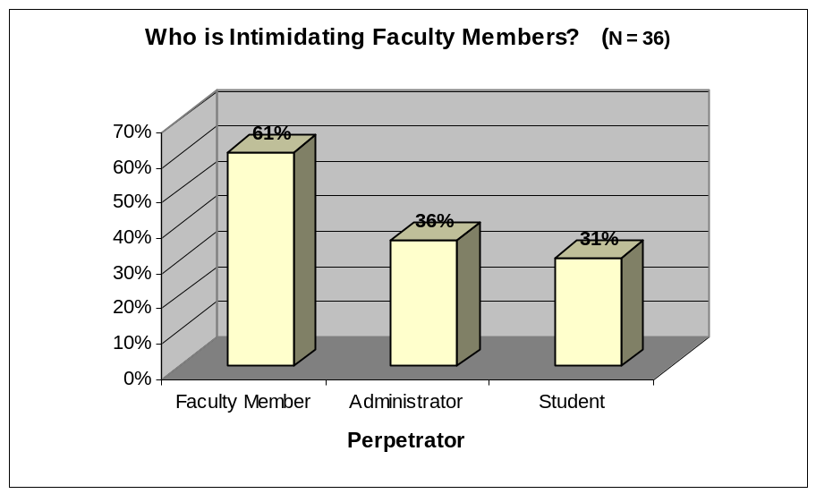

Response and Outcome of Intimidation
Of those who reported experiencing threats or intimidation, 12 (33.3%) ignored the incidents, 21 (58.3%) handled the incidents on their own, 19 (54.3%) sought informal assistance, and only 9 (25.0%) reported seeking formal assistance. Importantly, when asked if their responses led to satisfying outcomes, almost half (47.1%) of those who reported experiencing intimidation were “not usually” satisfied with the outcomes of their responses (see Graph 12).

Graph 12
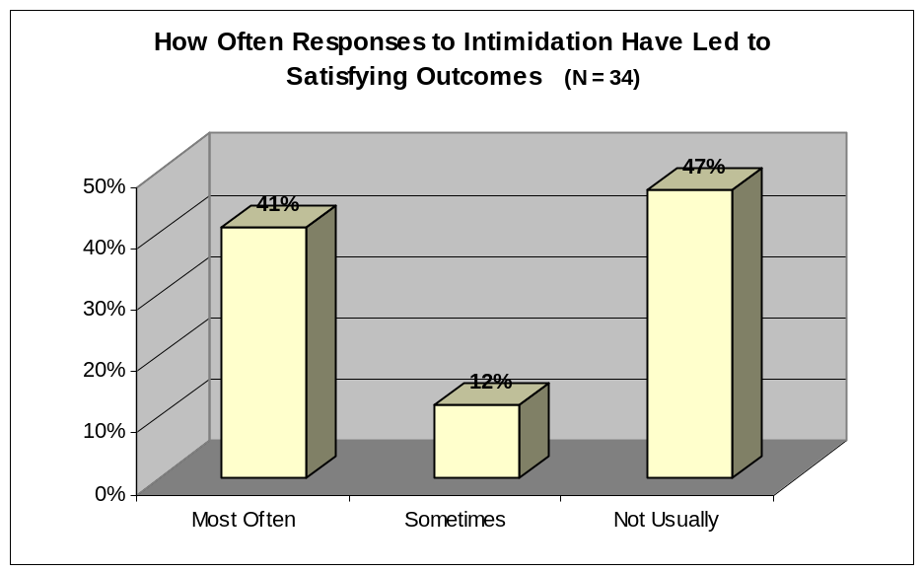

Sexual Harassment

Extent of Sexual Harassment
Of those who completed the questionnaire, 17.6% (12/68) reported experiencing unwanted sexual advances over the past four years. Men were almost as likely as women to report experiencing some form of sexual harassment (21.9% of women compared to 13.9% of men; χ² = 0.74, p > .05). Table 16 shows the number* of women and men who reported experiencing specific acts of sexual harassment. The most commonly reported unwanted sexual experiences were hearing or receiving (via e-mail) offensive sexual jokes, and hearing offensive remarks or innuendos about one’s body.

Table 16
Extent of Specific Acts of Sexual Harassment by Gender
Unwanted Sexual Experience | #* of Female Respondents | #* of Male Respondents
Jokes of a sexual nature (either verbal or through e-mail) which were offensive to me. | 4 | 2
Offensive remarks, innuendos, or taunting about my body or attire. | 3 | 0
Staring, gestures, or body language of a sexual nature which have embarrassed or offended me. | 1 | 0
Unwelcome sexual flirtations or advances. | 0 | 2
Unwanted physical contact such as touching, patting, or pinching. | 1 | 1
Other | 2 | 1

* Numbers, as opposed to percentages, are reported because the frequencies were so small.

Perpetrators of Sexual Harassment
Respondents who reported experiencing sexual harassment were asked from whom they feel they receive this treatment. They were given three choices – faculty member, administrator, student – and were asked to check all that applied. Graph 13 summarizes the results. Almost all unwanted sexual advances are perceived to come from fellow faculty members.

Graph 13
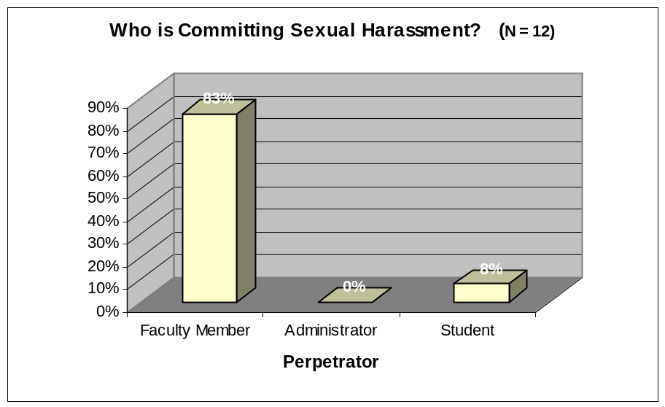

Response and Outcome of Sexual Harassment
Of the 12 respondents who reported experiencing unwanted sexual advances, 6 (50.0%) ignored the incidents, 8 (66.7%) handled the incidents on their own, only 2 (16.7%) sought informal assistance, and none reported seeking formal assistance. Furthermore, these respondents tended to be fairly satisfied with the outcomes of their responses (see Graph 14).
Graph 14
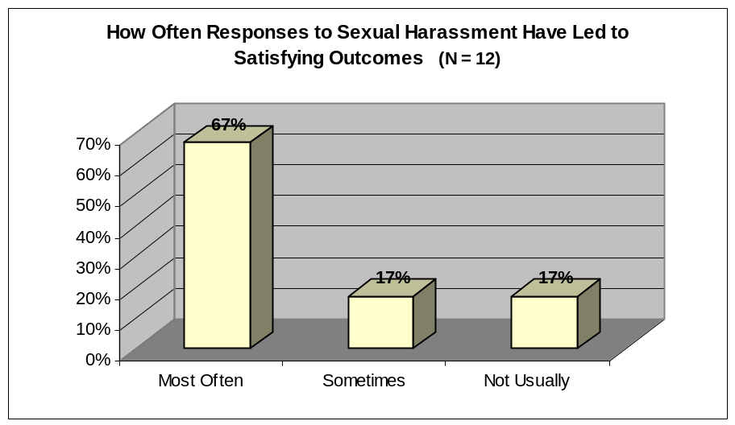

Summary

Overall, women reported experiencing more discrimination, intimidation, and harassment than men. The largest and most significant difference between women and men is in their experiences with gender discrimination, with far more women reporting this than men. It is perhaps a surprising finding that there is an overwhelming percentage of both men and women who feel they are experiencing threats and intimidation at BU.
The overwhelming majority of these acts of discrimination, intimidation, and harassment are perceived to come from fellow faculty members, and many are reportedly being perpetrated by administrators. These findings are especially disconcerting when we consider that the majority of daily interactions likely occur with students, not with colleagues, and certainly not with administrators.
The most common response is simply to handle these negative incidents on one’s own. An average of 70% of the respondents who experienced discrimination and/or harassment handled at least one incident on their own. The second most common response is to ignore the incident (52%). One might argue that the low number of formal responses (15%), such as reporting the incident to BUFA, reflects the fact that only severe forms of discrimination or harassment elicit such an official response. However, we encourage readers to consider the tremendous amount of respondents who indicated being dissatisfied with the outcome of their responses. With the exception of cases of sexual harassment, an average of 54% of respondents answered “not usually” when asked how often their responses led to satisfying outcomes. This statistic suggests that whether a person ignores or personally handles incidents of discrimination and intimidation, these responses are not adequately addressing the problem. It is also not clear that seeking formal assistance leads to satisfying outcomes. These numbers might suggest that when acts of discrimination, intimidation, and harassment do occur, victims generally feel powerless to do anything to change the situation.

Conclusion

This review of the status of women has revealed some positive trends. First, 41% of Doctoral graduates in Canada are women. This statistic is translating into a more equitable pool of candidates and a roughly equal proportion of newly-hired women and men with Doctorates at BU. Furthermore, once employed at Brandon University, women are generally as satisfied with their jobs as their male counterparts. Finally, women and men secure tenure, sabbaticals, and BURC grants with similar success at this university. These findings are indeed positive, and yet it is important that the Status of Women Review Committee keep a close eye on these trends. As Kite et al. (2001) have noted in their review of female academics in Canadian Psychology departments, “periods of progress for women … may be followed by periods of backsliding or backlash, a pattern that is widespread in the larger society” (p. 1134). Thus, a periodic review of the status of women at BU is a necessary component of monitoring women’s continued progress.
Unfortunately, this review has also revealed several persistent gender differences and barriers to women’s career advancement at BU. For example, there has been little change in the proportion of female faculty members over the past four years; for many faculties, there has been little change over the past twenty years. Women are often hired at lower ranks and at lower ‘steps’ than their male colleagues. Women also continue to experience gender discrimination in their day-to-day work at BU. Furthermore, some women are waiting longer than men to apply for promotions. Periodic research by the SWRC is therefore necessary in order to uncover some of the reasons behind these persistent inequities and to direct the university toward rectifying them.
The task of removing barriers to women’s career advancement and creating a positive work climate rests on multiple shoulders. Women are responsible for their own advancement at BU by applying for promotions, for example. All faculty members are responsible for creating a positive and collegial working environment free of discrimination, intimidation, and harassment. Administrators of all levels are responsible for creating this same environment, through equitable treatment of faculty members and effective conflict management. It is vital that all Brandon University academics concern themselves with the findings in this report because, “far from lagging behind many other organizations, higher education should be in the forefront of promoting diversity and equality of opportunity” (Finch, 2003, p. 135).

References
Andrews, F. M., & Withey, S. B. (1976). Social indicators of wellbeing: American’s
perception of life quality. New York, NY: Plenum Press.

Benschop, Y., & Brouns, M. (2003). Crumbling ivory towers: Academic organizing and
its gender effects. Gender, Work, and Organization, 10, 194-212.

Brewer, E. W., & Clippard, L. F. (2002). Burnout and job satisfaction among student
support services personnel. Human Resource Development Quarterly, 13, 169-186.

Burkard, A. W., Boticki, M. A., & Madson, M., B. (2002). Workplace discrimination,
prejudice, and diversity measurement: A review of instrumentation. Journal of Career Assessment, 10, 343-361.

Canadian Association of University Teachers (2004). CAUT Almanac of Post
Secondary Education in Canada.

Canadian Human Rights Commission (1983). Unwanted Sexual Attention and Sexual
Harassment: Results of a Survey of Canadians.

Collective Agreement with Brandon University Faculty Association (April 2002-March
2005).

Finch, J. (2003). Foreword: Why be interested in women’s position in academe? Gender, Work, and Organization, 10, 133-136.

Franklin, P., Moglen, H., Zatlin-Boring, P., & Angress, R. (1981). Sexual and gender
harassment in the academy: A guide for faculty, students, and administrators. New York, NY: The Modern Language Association of America.

Gelade, G. A. (2003). The impact of human resource management and work climate on
organizational performance. Personnel Psychology, 56, 383-404.

Hagedorn, L. S. (1996). Wage equity and female faculty job satisfaction: The role of
wage differentials in a job satisfaction causal model. Research in Higher Education,
37, 569-598.

Hannah, E., Paul, L., & Vethamany-Globus, S. (Eds.). (2002) Women in the Canadian
Academic Tundra. Montreal: McGill-Queen’s University Press.

Hegarty, W. H., & Dalton, D. R. (1995). Development and psychometric properties of the
Organizational Diversity Inventory (ODI). Educational and Psychological Measurement, 55, 1047-1052.

Hill, M. D. (1986-1987). A theoretical analysis of faculty job satisfaction/dissatisfaction.
Educational Research Quarterly, 10, 36-44.
James, K., Lovato, C., & Cropanzano, R. (1994). Correlational and known-group
comparison validation of a workplace prejudice/discrimination inventory. Journal of
Applied Social Psychology, 24, 1573-1592.

Kite, M. E., Russo, N. F., Brehm, S. S., Fouad, N. A., Hall, C. C. I., Hyde, J. S., & Keita,
G. P. (2001). Women psychologists in academe. American Psychologist, 56, 1080-1098.

Klonoff, E. A., & Landrine, H. (1995). The schedule of sexist events: A measure of
lifetime and recent sexist discrimination in women’s lives. Psychology of Women Quarterly, 19, 439-472.

Koeske, G. F., Kirk, S. A., Koeske, R. D., & Rauktis, M. B. (1994). Measuring the
Monday blues: Validation of a job satisfaction scale for human services. Social Work Research, 18, 27-35.

Ontario Women’s Directorate (1993). Employer’s Guide: A Time for Action on Sexual
Harassment in the Workplace.

Rentsch, J. R., & Steel, R. R. (1992). Construct and concurrent validation of the Andrews
and Withey job satisfaction questionnaire. Educational and Psychological Measurement, 52, 357-367.

Sousa-Poza, A. (2000). Taking another look at the gender/job satisfaction paradox.
Kyklos, 53, 135-152.

Stark, S., Chernyshenko, O. S., Lancaster, A. R., Drasgow, F., & Fitzgerald, L. F. (2002).
Toward standardized measurement of sexual harassment: Shortening the SEQ-DoD using item response theory. Military Psychology, 14, 49-72.

Status of Women Review Committee (1996). Report on the Status of Women at Brandon
University

Status of Women Review Committee (2000). Report on the Status of Women at Brandon University

Streiner, D. L., & Norman, G. R. (1995). Health measurement scales: A practical guide
to their development and use (2nd ed.). New York: Oxford University Press.

Vaicys, C., & Barnett, T. (1996). An analysis of the factor structure of the ethical climate
questionnaire. Psychological Reports, 79, 115-120.

Yoder, J.D., & McDonald, T. W. (1998). Measuring sexist discrimination in the
workplace. Psychology of Women Quarterly, 22, 487-491.

APPENDICES

Appendix A: Questionnaire

Appendix B: Satisfaction Ratings of Job Satisfaction Items

Appendix C: Demographic Differences on Specific Job
Satisfaction Items

Appendix D: Summary of Open-Ended Responses

Appendix A: Questionnaire

Section A – Job Satisfaction & Workload

Section B – Gender Discrimination

Section C – Racial Discrimination

Section D – Intimidation

Section E – Unwanted Sexual Experiences

Section F – Demographics

Section G – Final Comments

SWRC Survey

Remember that all participation in this study is anonymous and voluntary. You may decline to answer any question or questions. No data will be released in such a way as to reveal the identity of an individual respondent.

Section A – Job Satisfaction & Workload

- We would like to ask you some questions about your level of satisfaction or dissatisfaction with various elements of your work at Brandon University. Using the scale provided, rate your level of satisfaction/dissatisfaction with each of the following aspects of your job. Please be as candid as possible. Remember, all your responses will remain strictly anonymous.

VD -- VERY DISSATISFIED
D -- DISSATISFIED
SD -- SOMEWHAT DISSATISFIED
SS -- SOMEWHAT SATISFIED
S -- SATISFIED
VS -- VERY SATISFIED
NA -- NOT APPLICABLE

Please circle one answer for each.

- Amount of job security……………….. VD D SD SS S VS NA

- Opportunities for making a difference
through your research……………… VD D SD SS S VS NA

- The cooperation of your colleagues… VD D SD SS S VS NA

- Amount of authority and autonomy
you have been given in your job……… VD D SD SS S VS NA

- Interaction with your students…..……. VD D SD SS S VS NA

- Support for research………………… VD D SD SS S VS NA

- Freedom from conflicting
occupational demands…………………VD D SD SS S VS NA

- Benefits (i.e., health insurance)……… VD D SD SS S VS NA

- Chances for acquiring new skills……... VD D SD SS S VS NA

- The motivational level of your
students……………………………….. VD D SD SS S VS NA

- The interest which other colleagues
have in your work…………………….. VD D SD SS S VS NA

- The clarity and consistency of
institutional requirements for
promotion and tenure………………… VD D SD SS S VS NA

- Physical surroundings of work……….. VD D SD SS S VS NA

- Support for teaching innovation……… VD D SD SS S VS NA

- Clarity of guidelines to perform
your job………………………………. VD D SD SS S VS NA

- Salary…………………………………. VD D SD SS S VS NA

- The research environment for your
students………………………………. VD D SD SS S VS NA

- Recognition of scholarly
achievement………………………… VD D SD SS S VS NA

- Workload………………….………….. VD D SD SS S VS NA

- Opportunity for involvement in
decision-making…………………….…VD D SD SS S VS NA

- Office facilities……………………….. VD D SD SS S VS NA

- Funding for research………………….. VD D SD SS S VS NA

- Opportunity to associate professionally
with others in your field …………….. VD D SD SS S VS NA

- Retirement policies…………………… VD D SD SS S VS NA

- Opportunities for making a difference
through your teaching………………... VD D SD SS S VS NA

- Estimate the percentage of time you generally devote to the following tasks in an academic year.
______ % Teaching (prep, class, marking, student consultations)
______ % Research
______ % Community Service & Committee Work

- What would be an ideal distribution of your time in order to attain your professional and educational goals?
______ % Teaching (prep, class, marking, student consultations)
______ % Research
______ % Community Service & Committee Work

- If you have any other comments or concerns you would like to express regarding job satisfaction or workload, please do so here.

__________________________________________________________________________________________________________________________________________________________________________________________________________________________________________________________________________________________________________________________________________________________________________________

Section B – Gender Discrimination
**Please answer the following questions based on your experiences at BU within the LAST FOUR YEARS ONLY.

- The following is a list of ways in which a person might be treated differently because of his/her gender. Which of the following statements accurately reflect your experience over the past four years at BU?

BECAUSE OF MY GENDER, ……… (Check all that apply.)
- My work has been devalued.
- I have been excluded from decision-making.
- I have been ignored.
- My abilities have been questioned.
- I have been given less interesting or less challenging tasks.
- More work is expected of me.
- Greater leniency is expected of me.
- Instead of using my name or title, someone has referred to me using terms I find derogatory.
- Other. If you feel comfortable doing so, please specify: ________________ ______________________________________________________________

If you have not checked any of the boxes in question 1, skip to Section C.

- Have you experienced this differential treatment from: (check all that apply)
- Faculty member
- Administrator
- Student

- When you have been treated differently because of your gender, how have you responded? (Check all that apply.)
- Ignored the incident
- Handled the incident on my own
- Sought informal assistance (e.g., speaking with a friend and/or colleague)
- Sought formal assistance (e.g., reporting the incident to BUFA)

- Have your responses led to satisfying outcomes?
- Most often
- Sometimes
- Not usually

- If you have any other comments or concerns you would like to express regarding experiences with gender discrimination, please do so here.

__________________________________________________________________________
________________________________________________________________________________________________________________________________________________________________________________________________________________________________________________________________________________________________________

If you have encountered situations in which you felt harassed or discriminated against, you may wish to contact one of BU’s Harassment and Discrimination Advisors:
Roberta Graham 727-7487 grahamr@brandonu.ca
Patrick Morrissette 571-8531 morrissette@brandonu.ca

Section C – Racial Discrimination
**Please answer the following questions based on your experiences at BU within the LAST FOUR YEARS ONLY.

- The following is a list of ways in which a person might be treated differently because of his/her race. Which of the following statements accurately reflect your experience over the past four years at BU?

BECAUSE OF MY RACE, ……… (Check all that apply.)
- My work has been devalued.
- I have been excluded from decision-making.
- I have been ignored.
- My abilities have been questioned.
- I have been given less interesting or less challenging tasks.
- More work is expected of me.
- Greater leniency is expected of me.
- Instead of using my name or title, someone has referred to me using terms I find derogatory.
- Other. If you feel comfortable doing so, please specify: ________________ ______________________________________________________________

If you have not checked any of the boxes in question 1, skip to Section D.

- Have you experienced this differential treatment from: (check all that apply)
- Faculty member
- Administrator
- Student

- When you have been treated differently because of your gender, how have you responded? (Check all that apply.)
- Ignored the incident
- Handled the incident on my own
- Sought informal assistance (e.g., speaking with a friend and/or colleague)
- Sought formal assistance (e.g., reporting the incident to BUFA)

- Have your responses led to satisfying outcomes?
- Most often
- Sometimes
- Not usually

- If you have any other comments or concerns you would like to express regarding experiences with racial discrimination, please do so here.

__________________________________________________________________________
__________________________________________________________________________________________________________________________________________________________________________________________________________________________________________________________________________________________________________________________________________________________________________________

If you have encountered situations in which you felt harassed or discriminated against, you may wish to contact one of BU’s Harassment and Discrimination Advisors:
Roberta Graham 727-7487 grahamr@brandonu.ca
Patrick Morrissette 571-8531 morrissette@brandonu.ca

Section D – Intimidation
**Please answer the following questions based on your experiences at BU within the LAST FOUR YEARS ONLY.

- The following is a list of threatening situations. Which of the following statements accurately reflect your experience over the past four years at BU? (Check all that apply.)

- I have been concerned for my physical safety.
- Someone has yelled at me, making me feel uncomfortable.
- Someone has attempted to overtly intimidate me.
- I have felt implicit pressure to comply with another person.
- Other. If you feel comfortable doing so, please specify: ________________ ______________________________________________________________

If you have not checked any of the boxes in question 1, skip to Section E.

- Have you experienced intimidation from: (check all that apply)
- Faculty member
- Administrator
- Student

- When you have felt threatened, how have you responded? (Check all that apply.)
- Ignored the incident
- Handled the incident on my own
- Sought informal assistance (e.g., speaking with a friend and/or colleague)
- Sought formal assistance (e.g., reporting the incident to BUFA)

- Have your responses led to satisfying outcomes?
- Most often
- Sometimes
- Not usually
- If you have any other comments or concerns you would like to express regarding experiences with intimidation, please do so here.

____________________________________________________________________________________________________________________________________________________
______________________________________________________________________________________________________________________________________________________________________________________________________________________________

If you have encountered situations in which you felt harassed or discriminated against, you may wish to contact one of BU’s Harassment and Discrimination Advisors:
Roberta Graham 727-7487 grahamr@brandonu.ca
Patrick Morrissette 571-8531 morrissette@brandonu.ca

Section E – Unwanted Sexual Experiences
**Please answer the following questions based on your experiences at BU within the LAST FOUR YEARS ONLY.

- The following is a list of possible sexual experiences. Which of these behaviours have you experienced over the past four years at BU? (Check all that apply.)

- Jokes of a sexual nature (either verbal or through e-mail) which were offensive to me.
- Staring, gestures, or body language of a sexual nature which have embarrassed or offended me.
- Offensive remarks, innuendos, or taunting about my body or attire.
- Unwelcome sexual flirtations or advances.
- Unwanted physical contact such as touching, patting, or pinching.
- Continued attempts to establish a romantic relationship despite my efforts to discourage it.
- Negative treatment as a result of my not being sexually responsive.
- Overt requests or pressure for sex.
- Other. If you feel comfortable doing so, please specify: ________________ ______________________________________________________________

If you have not checked any of the boxes in question 1, skip to Section F.

- Have you experienced these sexual behaviours from: (check all that apply)
- Faculty member
- Administrator
- Student

- When you have felt threatened, how have you responded? (Check all that apply.)
- Ignored the incident
- Handled the incident on my own
- Sought informal assistance (e.g., speaking with a friend and/or colleague)
- Sought formal assistance (e.g., reporting the incident to BUFA)

- Have your responses led to satisfying outcomes?
- Most often
- Sometimes
- Not usually

- If you have any other comments or concerns you would like to express regarding unwanted sexual experiences at your job, please do so here.

______________________________________________________________________________________________________________________________________________________________________________________________________________________________
______________________________________________________________________________________________________________________________________________________________________________________________________________________________

If you have encountered situations in which you felt harassed or discriminated against, you may wish to contact one of BU’s Harassment and Discrimination Advisors:
Roberta Graham 727-7487 grahamr@brandonu.ca
Patrick Morrissette 571-8531 morrissette@brandonu.ca

Section F – Demographics

- What is your gender?
- Female
- Male

- Which of the following best describes your current position at BU?
- Tenured / Continuing
- Probationary
- Term

- For which faculty are you employed? (If you are employed with more than one faculty, list the one for which you have your primary contract, or for which you spend the most time.)
- Arts
- Education (including BUNTEP, PENT, & BUHEP)
- Health Studies or First Nations and Aboriginal Counselling
- Music
- Science
- Student Services or Library or Campus Manitoba

- Which of the following describes your teaching location?
- I teach on campus and/or distance education.
- I teach off campus.

- How many years have you been employed at BU?
- Under 5 years
- From 5 to 10 years
- From 11 to 20 years
- Greater than 20 years

- Do you currently have one or more children younger than 12 years of age?
- Yes
- No

Section G – Final Comments

- How could your work environment at BU be improved?

________________________________________________________________________________________________________________________________________________________________________________________________________________________________________________________________________________________________________________________________________________________________________________________________________________________________________________________________________________________________________________________________________________________________________________________________________________

- Throughout this survey we have inquired about perceptions of your job, and your experiences at work. If you have any additional comments, or would like to mention any other issues that pertain to your work experience, please do so here.

____________________________________________________________________________________________________________________________________________________________________________________________________________________________________________________________________________________________________________________________________________________________________________________________________________________________________________________________
______________________________________________________________________________________________________________________________________________________________________________________________________________________________

Please return your completed questionnaire in the envelope provided to:
Marnie Wilson
c/o Department of Psychology
Brandon University

~ The Status of Women Review Committee thanks you for your time! ~

Appendix B: Satisfaction Ratings of Job Satisfaction Items

Table 17
Satisfaction Ratings of Job Satisfaction Items

Job Satisfaction Item | % of respondents who rated being satisfied to some degree*
Interaction with your students | 100 %
Opportunities for making a difference through your teaching | 94.8 %
Retirement policies | 90.4 %
Amount of authority and autonomy you have been given in your job | 89.7 %
Benefits (i.e., health insurance) | 88.2 %
Chances for acquiring new skills | 87.7 %
Amount of job security | 85.3 %
Salary | 85.1 %
Opportunities for making a difference through your research | 84.9 %
The motivational level of your students | 84.6 %
Physical surroundings of work | 82.1 %
Clarity of guidelines to perform your job | 81.2 %
The cooperation of your colleagues | 80.9 %
Recognition of scholarly achievement | 80.3 %
Office facilities | 79.1 %
Support for teaching innovation | 75.9 %
Opportunity to associate professionally with others in your field | 75.8 %
Opportunity for involvement in decision-making | 72.7 %
Support for research | 72.7 %
The interest which other colleagues have in your work | 71.6 %
Freedom from conflicting occupational demands | 68.7 %
Funding for research | 67.3 %
Workload | 64.1 %
The research environment for your students | 60.0 %
Clarity and consistency of institutional requirements for promotion and tenure | 60.0 %

* The percentage of respondents who rated being “somewhat satisfied”, “satisfied”, or “very satisfied” with
each item.

Appendix C: Demographic Differences on Specific Job Satisfaction Items

Type of Appointment

Length of Employment at BU

On-Campus and Off-Campus Faculty

Those With and Without Children

Type of Appointment
Two differences emerged in the satisfaction scores of respondents with different types of appointments (see Table 18 for a summary of these findings). As one might expect, type of appointment significantly influenced how satisfied the respondents were with their amount of job security (F = 33.66, p < .001). Post-hoc analyses were not surprising; they revealed that respondents on term contracts were far less satisfied with their job security than respondents in probationary, tenured, or continuing appointments. Type of appointment also influenced how satisfied respondents were with their opportunities for involvement in decision-making (F = 3.37, p < .05). Post-hoc analyses revealed that respondents on term contracts were less satisfied with this aspect of their job, compared with those in the other type of appointments.

Table 18
Satisfaction Differences by Type of Appointment
Item | Type of Appointment | Mean | F | p
Amount of job security | tenured / continuing | 5.41
 | probationary | 4.83
 | term | 2.45 | 33.66 | < .001
Opportunities for involvement in decision-making | tenured / continuing | 4.38
 | probationary | 4.83
 | term | 3.45 | 3.37 | < .05

Length of Employment at BU
Length of employment at BU influenced the satisfaction ratings of three items on the Job Satisfaction Scale (see Table 19 for a summary of these findings). First, one’s satisfaction with the amount of authority and autonomy given in one’s job was influenced by how long the respondent had been employed at BU (F = 9.11, p < .001). Specifically, post-hoc analyses revealed that faculty members who have been employed at BU for between 5 and 10 years are significantly less satisfied with this aspect of their jobs than all other respondents. Second, and perhaps not surprising, respondents’ amount of job security was significantly impacted by their years of employment at BU (F = 4.49, p < .01). Specifically, respondents who have worked at BU for less than 5 years felt less satisfied with their job security than did those respondents who have been employed at BU for 11 years or more. Finally, how long respondents have been employed at BU influenced how satisfied they were with their interactions with students (F = 2.94, p < .05). For some reason, respondents who have been employed at BU for between 11 and 20 years were significantly less satisfied with this aspect of their job, compared to those that have been employed for 5-10 years or more than 20 years.

Table 19
Satisfaction Differences by Length of Employment
Item | Length of Employment | Mean | F | p
Amount of authority and autonomy you have been given in your job | Under 5 years | 5.26
 | 5 – 10 years | 3.67
 | 11 – 20 years | 5.47
 | 20 + years | 5.44 | 9.11 | < .001
Amount of job security | Under 5 years | 4.19
 | 5 – 10 years | 4.67
 | 11 – 20 years | 5.47
 | 20 + years | 5.56 | 4.49 | < .01
Interaction with your students | Under 5 years | 5.69
 | 5 – 10 years | 5.38
 | 11 – 20 years | 5.27
 | 20 + years | 5.81 | 2.94 | < .05

On-Campus and Off-Campus Faculty
Working on- or off-campus seems to influence one’s satisfaction with four aspects of the job (see table 20). The greatest difference emerged in terms of the satisfaction respondents felt with job security. Specifically, off-campus faculty feel significantly less secure than on-campus faculty (t = -3.22, p < .01). Despite this negative difference for off-campus workers, all other differences in job satisfaction actually favour off-campus faculty. First, off-campus faculty are more satisfied with their workload (t = 2.98, p < .01). They are also more satisfied with their opportunities for making a difference through their teaching (t = 2.10, p < .05). Finally, off-campus faculty are more satisfied with the motivational level of their students (t = 2.08, p < .05).

Table 20
Differences in Satisfaction Between On-Campus and Off-Campus Faculty
Item | Location | Mean | t | p
Amount of job security | on | 5.15
 | off | 3.60 | -3.22 | < .01
Workload | on | 3.71
 | off | 4.70 | 2.98 | < .01
Opportunity for making a difference through your teaching | on | 4.91
 | off | 5.56 | 2.10 | <.05
Motivational level of your students | on | 4.37
 | off | 5.10 | 2.80 | <.05

Those With and Without Young Children
Having children under the age of twelve seems to lower faculty members’ satisfaction with two specific aspects of their job (see table 21). Faculty members without young children are more satisfied than those with young children in terms of their opportunities for making a difference through their research (t = 2.13, p < .05). Also, parents of young children reported being less satisfied with their salaries (t = 2.12, p < .05).

Table 21
Differences in Satisfaction Between Those with Young Children and Those Without
Item | Have Child < 12 | Mean | t | p
Opportunities for making a difference through your research | no | 4.74
 | yes | 3.92 | 2.13 | < .05
Salary | no | 4.57
 | yes | 3.82 | 2.12 | < .05

Appendix D: Summary of Open-Ended Responses

- Additional Comments or Concerns Regarding Job Satisfaction

- Additional Comments or Concerns Regarding Gender Discrimination

- Additional Comments or Concerns Regarding Racial Discrimination

- Additional Comments or Concerns Regarding Intimidation

- How Could the Work Environment at BU Be Improved?

Additional Comments or Concerns Regarding Job Satisfaction*

Workload & Conflicting Occupational Demands 11/21 = 52%
- As is reflected in the job satisfaction scale, workload and conflicting occupational demands was the most common complaint among those who provided additional comments about their job satisfaction at BU. Many respondents agreed that the teaching workload is “onerous” and impedes progress “in all other areas of the job”. Specifically, faculty members are finding it most difficult to meet the expectations regarding research.
- Respondents noted that class sizes are growing, that they must teach a wide variety of courses, that overload teaching is far too common, and that the distribution of tasks throughout a year (i.e., research subordinated to summer activity) allows “no opportunity for continuity in research”.

No Voice Because No Job Security 3/21 = 14%
- Three respondents felt they had “no power to influence changes”. Some faculty feel that they must remain silent or jeopardize their employment.

Administration 3/21 = 14%
- Three respondents identified some level of administration as the cause of diminished satisfaction with their job.

Promotion/Tenure Criteria and Process 2/21 = 10%
- Two respondents indicated that the criteria for promotion and tenure are too vague and inconsistent. Specifically, one respondent felt that certain faculty members are not being assessed according to their job descriptions or qualifications by rank. One respondent also indicated that PA promotions committees should include at least one Professional Associate.

Money Issues 2/21 = 10%
- Desire that more money be allotted for professional development
- “We waste salary buying benefits we do not want.”

* There were 21 respondents who provided additional comments regarding job satisfaction.
- Additional Comments or Concerns Regarding Gender Discrimination

- When asked if there were any additional comments regarding gender discrimination, four female respondents commented that it is often difficult to determine exactly why they were treated differently. Specifically, they wondered if it might be their youth (or being a “junior faculty member”) that might account for the differential treatment.

- One respondent stated that hiring committees in the “hard sciences” should always explicitly address the lack of female professors in these disciplines.

- Additional Comments or Concerns Regarding Racial Discrimination

- One respondent suggested that non-aboriginal people in the Brandon University community should be educated on Aboriginal issues.

- One respondent felt that one’s culture influences one’s pedagogy and that his/hers has been questioned and devalued at BU.

- One respondent expressed the inability to discuss the issue of racism with anyone at the university. Therefore, the major response was to try and “pretend it’s not happening”.

- Additional Comments or Concerns Regarding Intimidation

Serious Problem which Remains Unaddressed 5/12 = 42%
- Five of the twelve respondents who offered additional comments regarding intimidation pointed to the urgency of the problem and/or the fact that this problem is not taken seriously at BU.

Code of Conduct or Harassment Policy 3/12 = 25%
- Three respondents mentioned that faculty members and administrators are behaving in unprofessional ways. The suggestion was to have a “code of professional conduct for faculty members” or “harassment policy and means for intervention”.

Security Issues 2/12 = 17%
- Two respondents indicated that the BU campus needs increased security during evenings and other “off-hours”. One respondent specifically mentioned the need for a “safewalk” program.
- How Could the Work Environment at BU Be Improved?*

Workload Issues 12/38 = 32%
- Lower teaching load
- More time for research
- Recognition of community service and committee work as workload

More Collegial and Friendly Atmosphere 11/38 = 29%
- More opportunities to collaborate and interact with colleagues beyond department meetings, etc.
- Positive teamwork environment
- “More honest communication between colleagues”
- Have mandatory “relating respectfully” workshops
- Promote closer ties between community-based and campus faculty

Administration Issues 8/38 = 21%
- Seven respondents indicated that the work environment at BU would be improved with more effective, knowledgeable, and sensitive leadership at all levels of administration.
- Administrators who have “the ability to create a positive team approach / environment.”
- However, one respondent (not counted in the 7/38) stated: “BU administration has offered me tremendous support for my research.”

More Financial Support 7/38 = 18%
- More funding for research, conference travel, and professional development
- More teaching money
- Increased salary
- “Higher salary in recognition of education, abilities, and effort contributed towards support of the department.”
- “More money for equipment and for scholarships.”

Improved Work Space / Facilities 2/38 = 5%
- “Better office space. Better, more comfortable ‘relations’ space. Better workout facilities.”
- Better science building

Other Responses
- “Mechanisms need to be in place to encourage and allow for innovative teaching proposals, especially at the first-year level. … Resistance to change is hurting BU and its students”
- “Safety and security are my #1 issue followed by stress.”
- “A place/forum/process that addresses racism.”

*There were 38 respondents who answered this question.

